**IBM Project**

**Report**

**On**

**Hypervisor-Based Cloud Anomaly Detection   
using Supervised Learning Techniques**

### Developed By: -

Rhythm Keyur Mendawala (18162101012)

Krutik Yogeshkumar Shah (18162121035) Dhruv Rohitbhai Gajjar (18162171003)

### Guided By: -

Prof. Sulabh Bhatt (Internal)

Mr. Anoj Dixit (External)

**Submitted to**

**Department of Computer Science & Engineering Institute of Computer Technology**



**Year: 2022**



# CERTIFICATE

This is to certify that the **IBM** Project work entitled **“Hypervisor-Based Cloud Anomaly Detection using Supervised Learning Techniques”** by Rhythm Keyur Mendawala (Enrolment No. 18162101012), Krutik Yogeshkumar Shah (Enrolment No. 18162121035) and Dhruv Rohitbhai Gajjar (Enrolment No. 18162171003) of Ganpat University, towards the partial fulfillment of requirements of the degree of Bachelor of Technology – Computer Science and Engineering, carried out by them in the CSE(CBA/BDA/CS) Department at IBM for Project. The results/findings contained in this Project have not been submitted in part or full to any other University / Institute for award of any other Degree/Diploma.

Name & Signature of Internal Guide

Name & Signature of Head

**Place: ICT - GUNI**

### Date:

**ACKNOWLEDGEMENT**

IBM Internship project is a golden opportunity for learning and self-development. I consider myself very lucky and honored to have so many wonderful people lead me through in completion of this project. First and foremost, I would like to thank Dr. Hemal Shah, Principal, ICT, and Prof. Dharmesh Darji , Head, ICT who gave us an opportunity to undertake this project. My grateful thanks to Prof. Sulabh Bhatt & Mr. Anoj Dixit (Internal & External Guides) for their guidance in project work Predicting Application Rating of Google Play Store, who despite being extraordinarily busy with academics, took time out to hear, guide and keep us on the correct path. We do not know where would have been without his/her help. CSE department monitored our progress and arranged all facilities to make life easier. We choose this moment to acknowledge their contribution gratefully.

### Krutik Yogeshkumar Shah (18162121035)

### Dhruv Rohitbhai Gajjar (18162171003)

### Rhythm Keyur Mendawala (18162101012)

**ABSTRACT**

In this project we are going to generate logs for several days and perform some attacks on it so that it will reflect on our logs like if we have done dos attack then the ip address will be shown repeatedly in application. And if we open some website then it will be reflected in our logs. After that we can analyze it as on which port it will be and using which connection, we have accessed it.

**INDEX**

### Title Page No

**CHAPTER 2: PROJECT SCOPE 03-04**

**CHAPTER1: INTRODUCTION 01-02**

**CHAPTER 3: SOFTWARE AND HARDWARE REQUIREMENT 05-06**

**CHAPTER 4: PROCESS MODEL 07-08**

CHAPTER 5: PROJECT PLAN 09-10

* 1. List of Major Activities 10
  2. Estimated Time Duration in Days 10

CHAPTER 6: IMPLEMENTATION DETAILS 11-17

* 1. Flow chart of Implementation 12

**6.2 Creating virtual Machine 13**

**6.3 Working on Logs 13**

**6.3.1 Required tools 13**

**6.3.2 Log Gathering and attacks 13-17**

**6.4 Log Analysis 17-28**

**6.5 Anomaly Detection on IBM Cloud 28-46**

**6.6 Anomaly Detection in AWS Cloud 46-80**

**6.7 Anomaly Detection in AWS for CPU Utilization 81-82**

**CHAPTER 7: CONCLUSION AND FUTURE WORK 83-84**

**CHAPTER 8: REFERENCE 60-61**

**CHAPTER: 1 INTRODUCTION**

**CHAPTER 1 INTRODUCTION**

This project is about to detect different logs and analyse it. Basically, anomaly detection is the recognition of suspicious activities like attacks on system. The act of reviewing, evaluating, and comprehending computer-generated details known as logs is known as log analysis. A log is a collection of messages in proper order that describe actions occurring within a system. From this file we have to find the solution so that in future there will be no anomaly in that system.

**CHAPTER: 2 PROJECT SCOPE**

### CHAPTER 2 PROJECT SCOPE

### Our project scope is to collect logs and analyze that log and explore the cloud version using IBM tool and AWS.

# CHAPTER: 3 SOFTWARE AND HARDWARE REQUIREMENTS

### CHAPTER 3 SOFTWARE AND HARDWARE REQUIREMENTS

**Minimum Hardware Requirements**

|  |  |
| --- | --- |
| **Processor** | 2.0 GHz |
| **RAM** | 4GB |
| **HDD** | 150GB |

*Table 3.1 Minimum Hardware Requirements*

**Minimum Software Requirements**

|  |  |
| --- | --- |
| **Operating System** | Windows |
| **Other tools & tech** | Snort , Splunk and Wireshark, Access to IBM and AWS cloud |

*Table 3.2 Minimum Software Requirements*

**CHAPTER: 4 PROCESS MODEL**

### CHAPTER 4 PROCESS MODEL

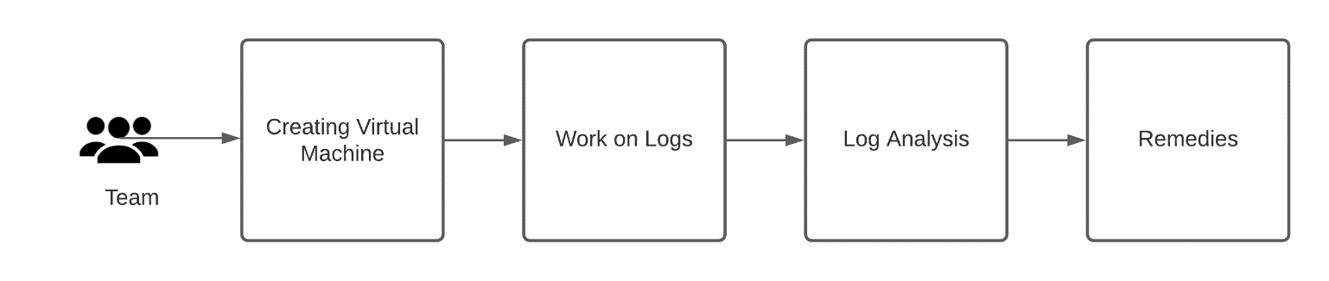

*Figure 4.1 Process Model of Project*

## **CHAPTER: 5 PROJECT PLAN**

### CHAPTER 5 PROJECT PLAN

### List of Major Activities

Task: - 1 Creating Virtual Machine

Task: - 2 Working on Logs

Task: - 3 Log Analysis

### Estimated Time Duration in Days

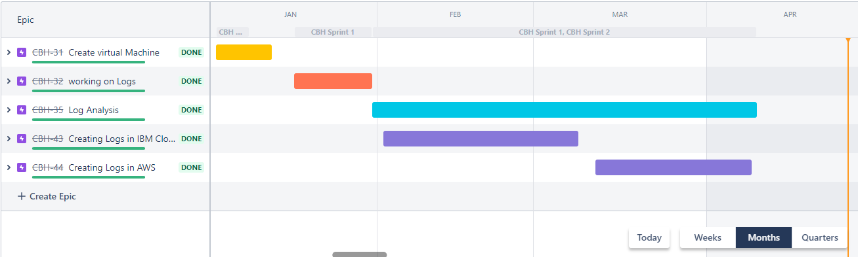

*Figure 5.1 Task Completion Estimated Time Duration in Days*

# CHAPTER: 6 IMPLEMENTATION DETAILS

### CHAPTER 6 IMPLEMENTATION DETAIL

### Flowchart of Implementation

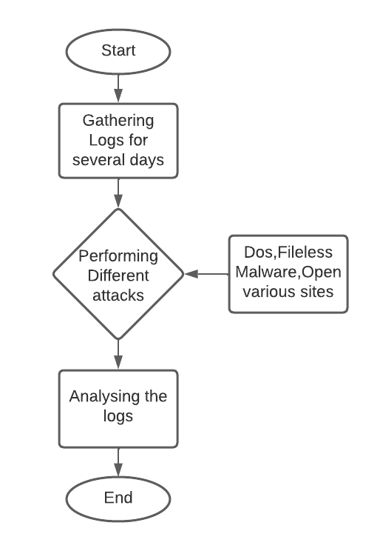

*Figure 6.1 Project Implementation Flowchart*

**6.2 Creating virtual Machine**

First of all, we have to create or configure the virtual machine to implement our project. So, we have configured Virtual Box for log gathering process.

**6.3 Working on Logs**

Now as the virtual box was configured, we can start our next task of log gathering.

**6.3.1 Required tools**

We have used Splunk and Snort for log management and log analysis. Basically, we have configured Splunk and snort for the log gathering and in between we have made attacks on it.

**6.3.2 Log Generation and attacks**

**DOS attack using LOIC tool**

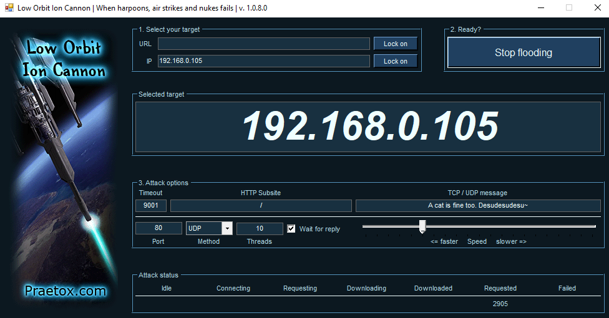

**Opening different type of websites: Legitimate as well as non-legitimate and trying to download some content.**

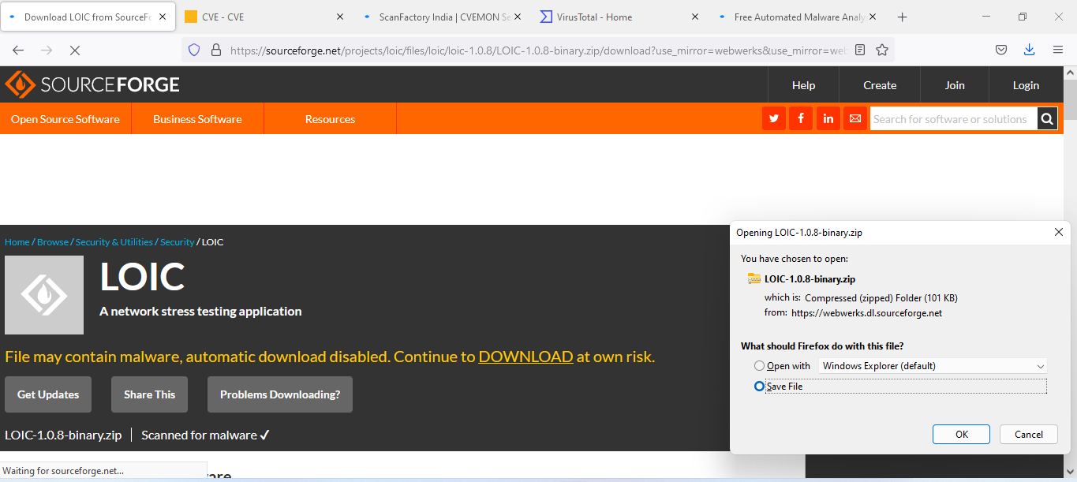

**Fileless malware attack using metaspolit tool of kali linux**

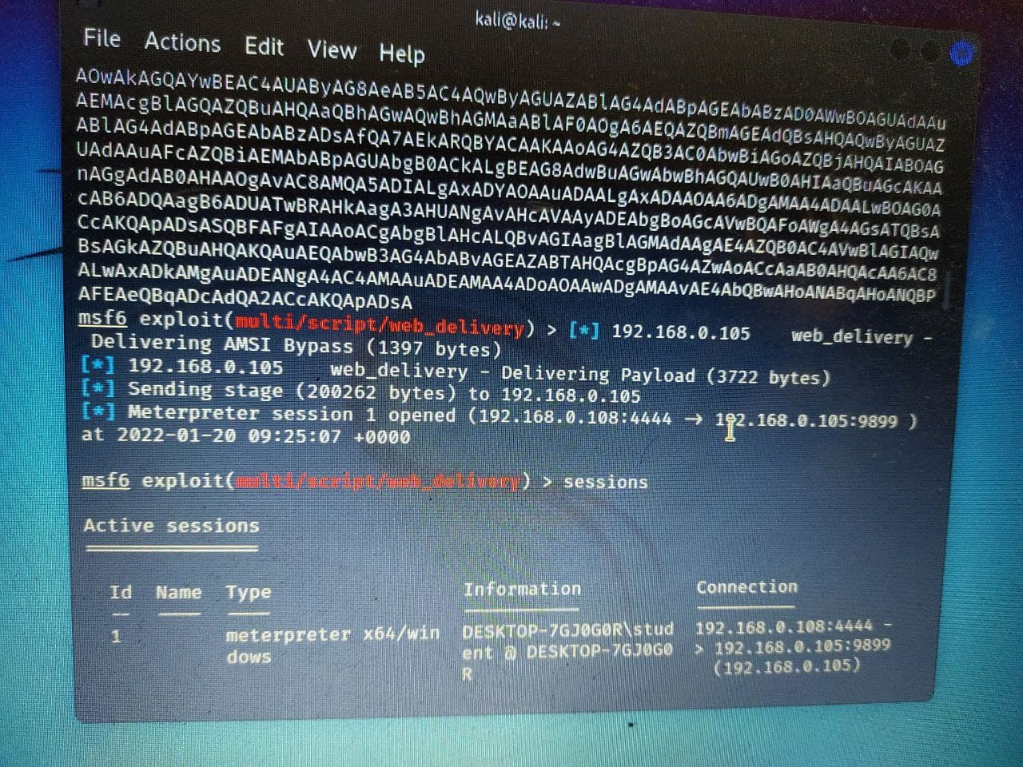

**Fileless malware system information**

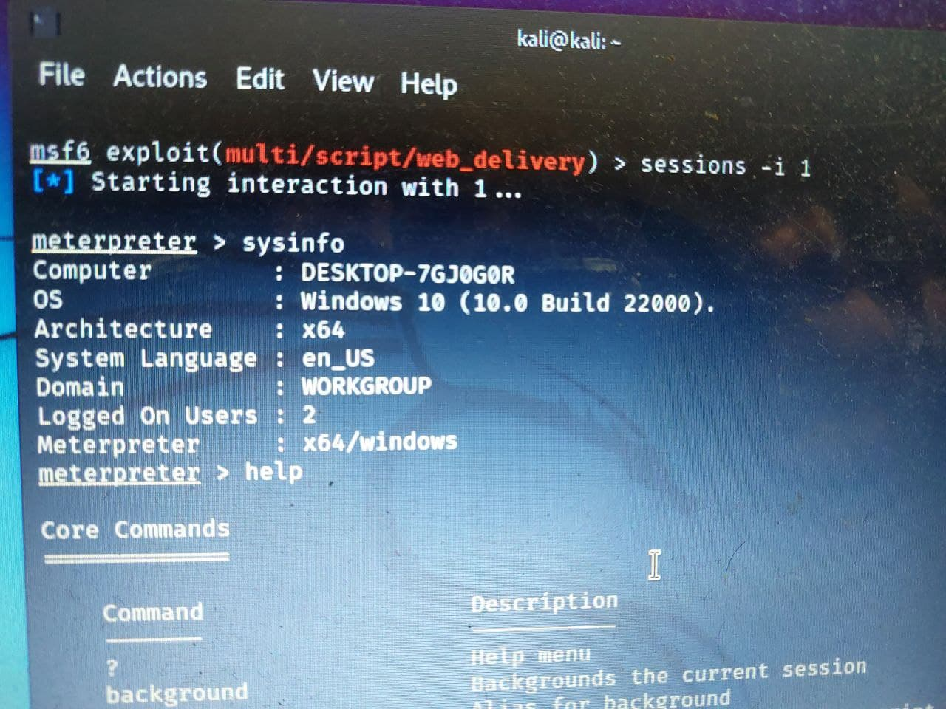

**Synflood dos attack using metaspolit tool of kali linux**

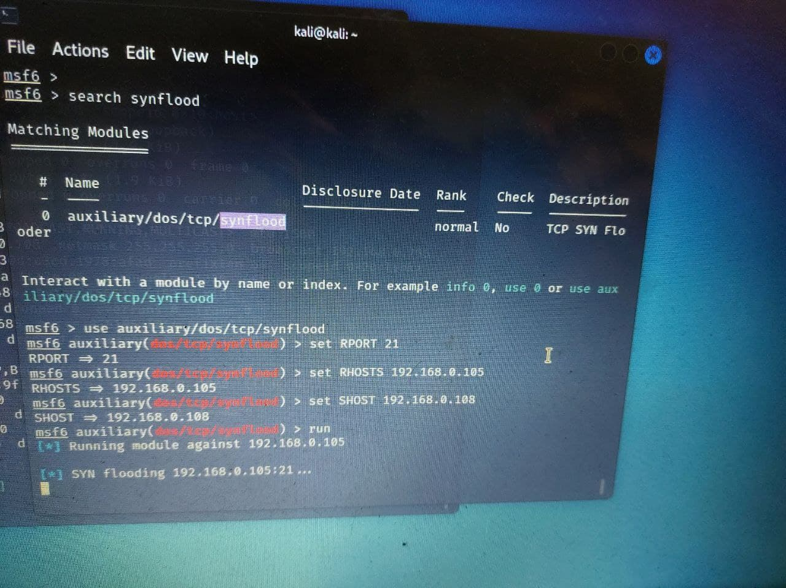

**Dos attack using hping3 tool of kali linux**

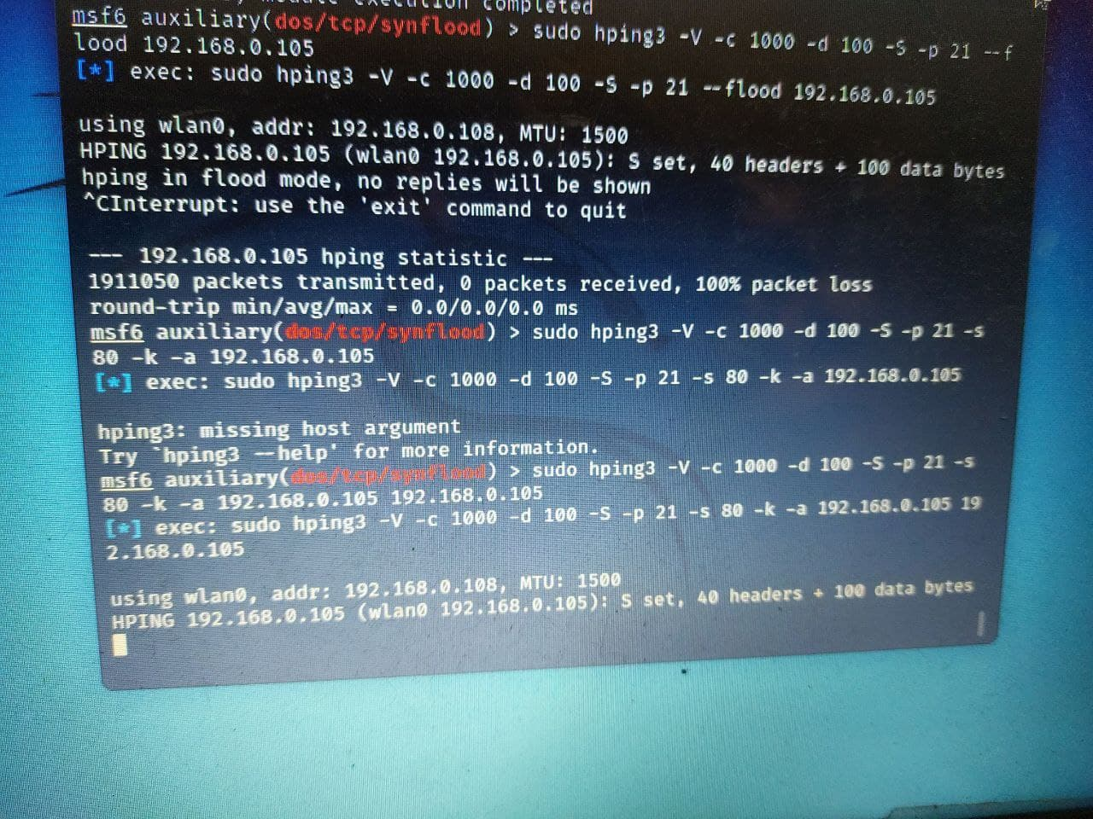



**Dos attack using hping3 tool of kali linux**

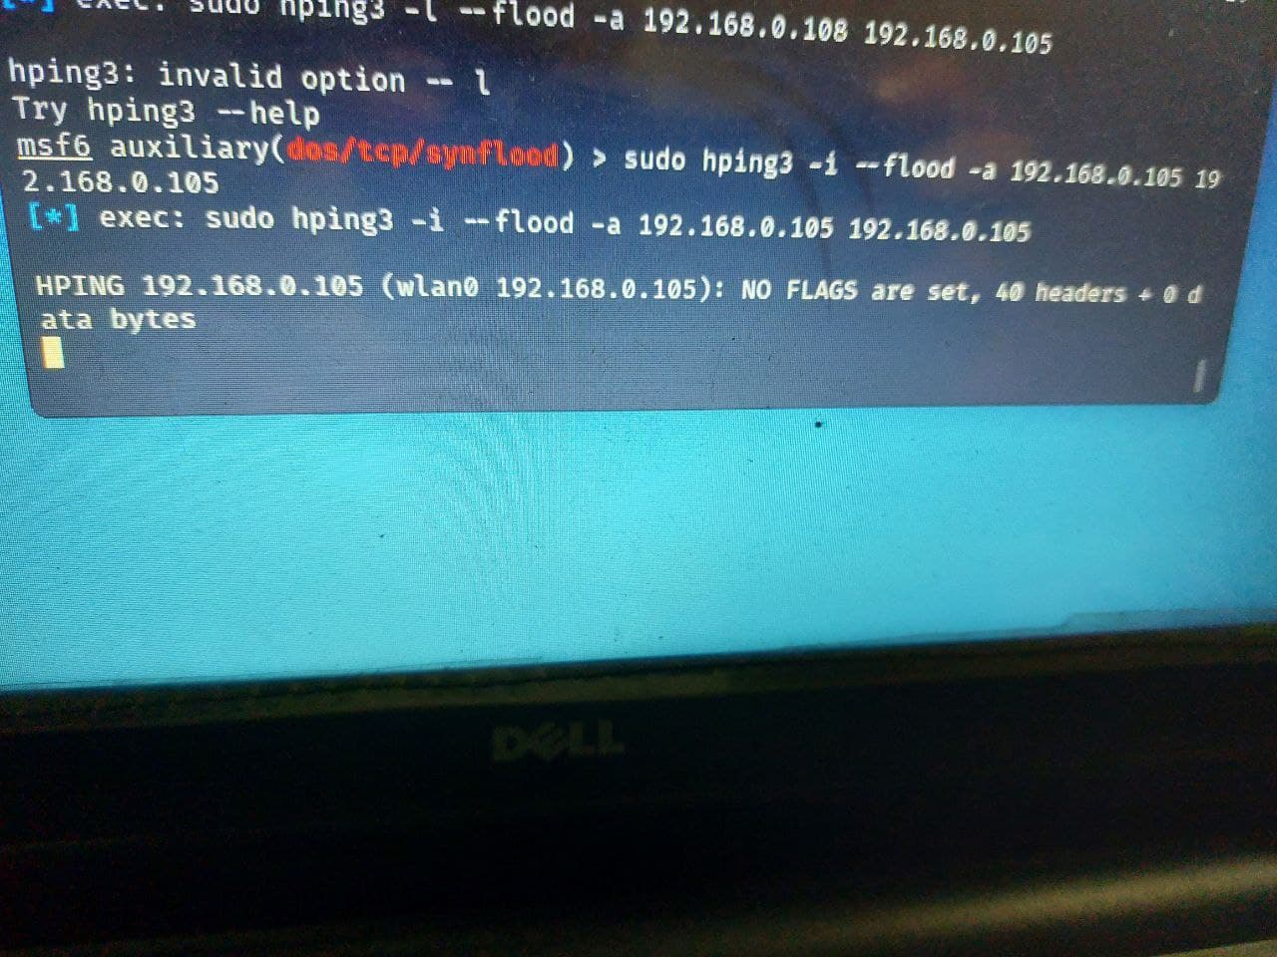

**Logs Gathered**

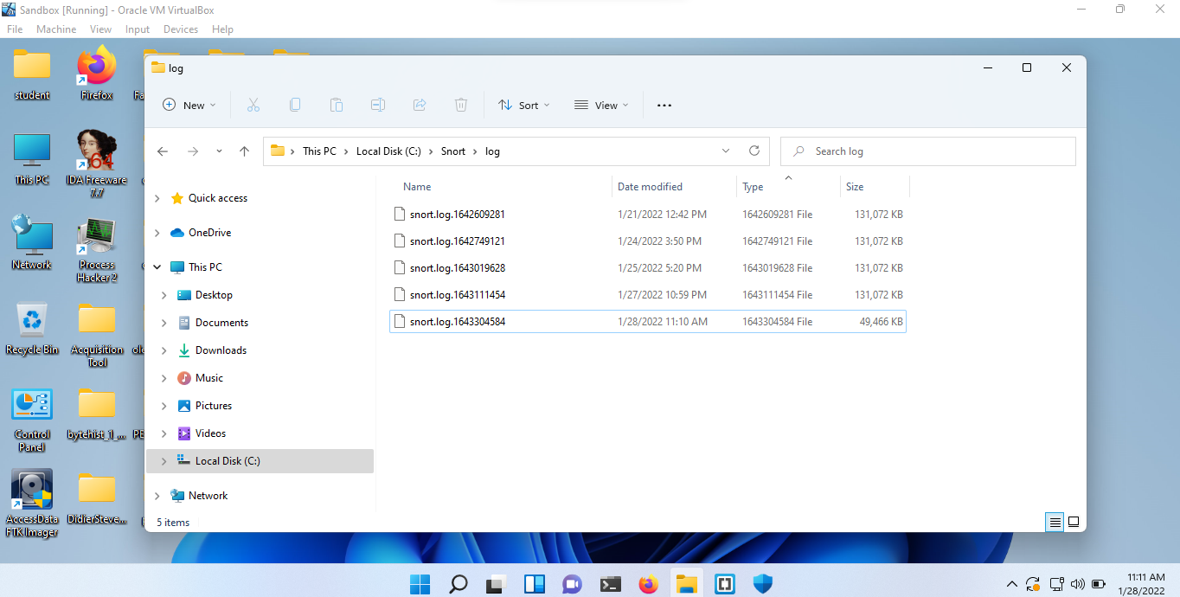

**6.4 Log Analysis**

In log analysis we have to analyze different types of logs and find different of patterns from the logs generated.

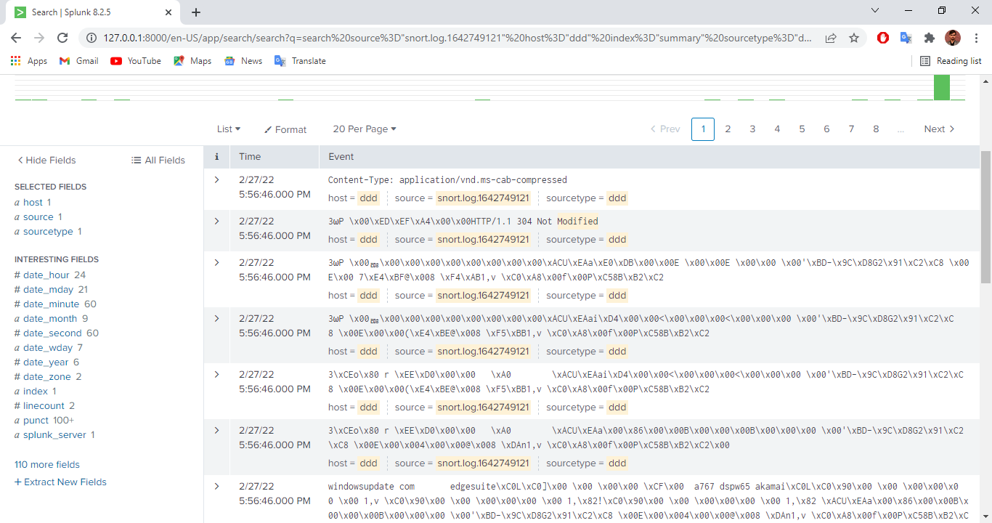

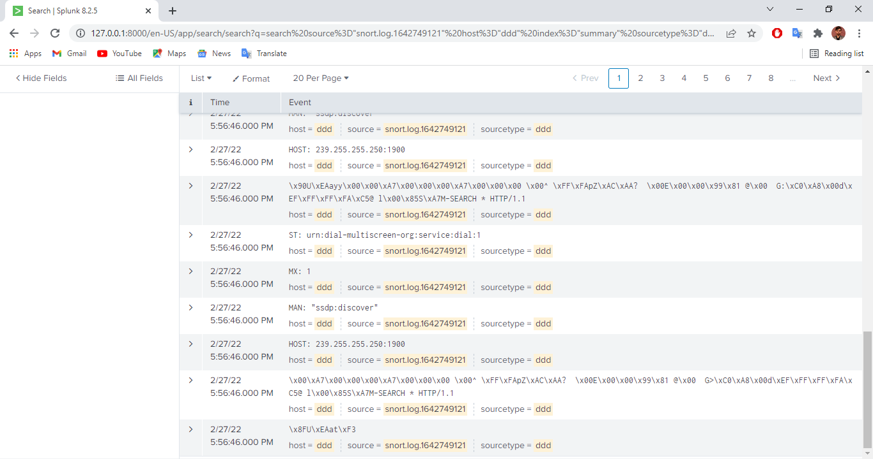

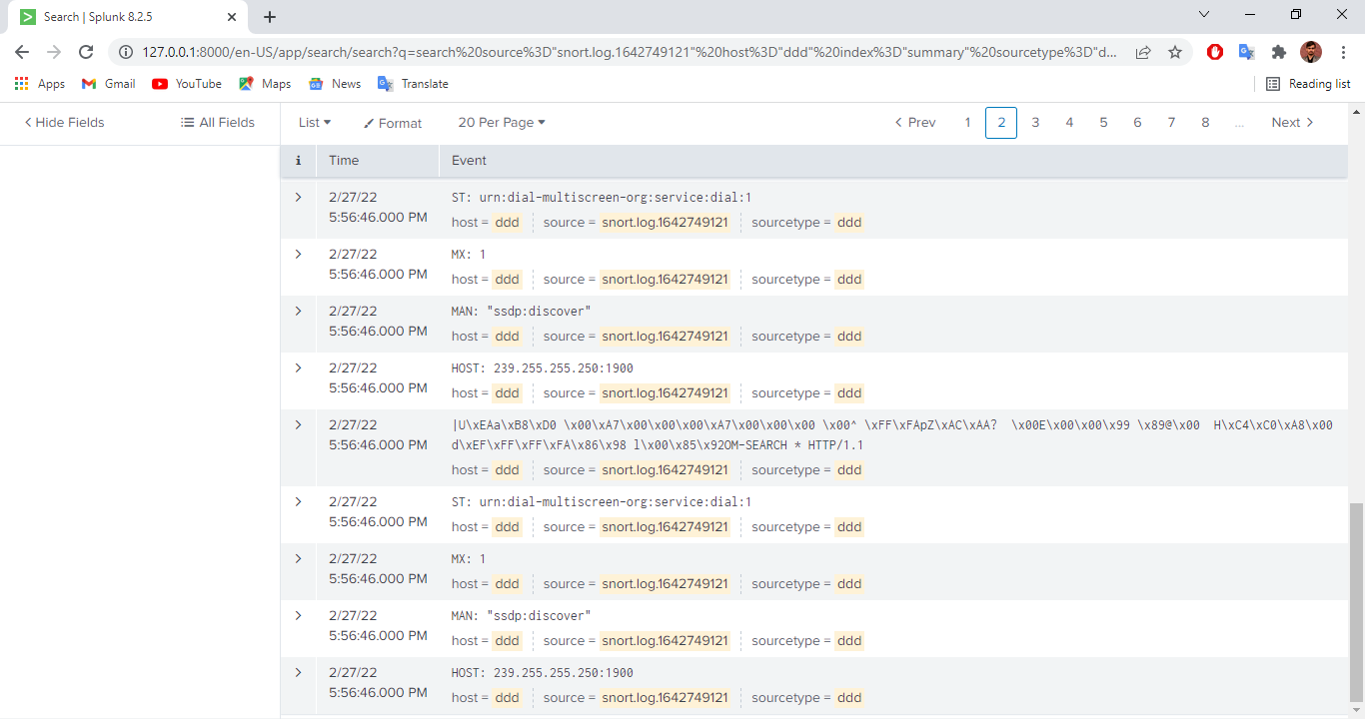

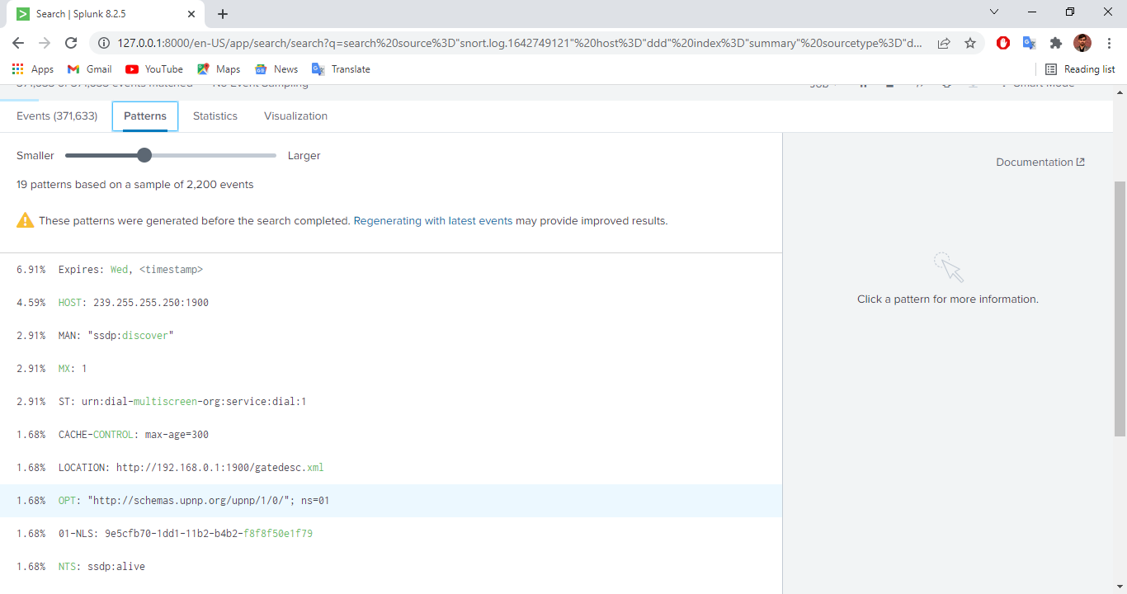

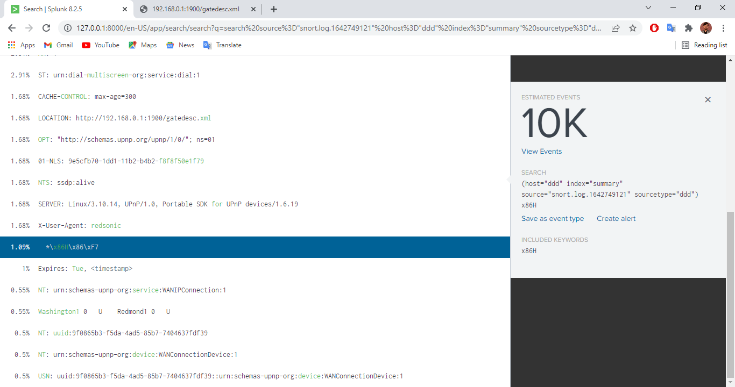

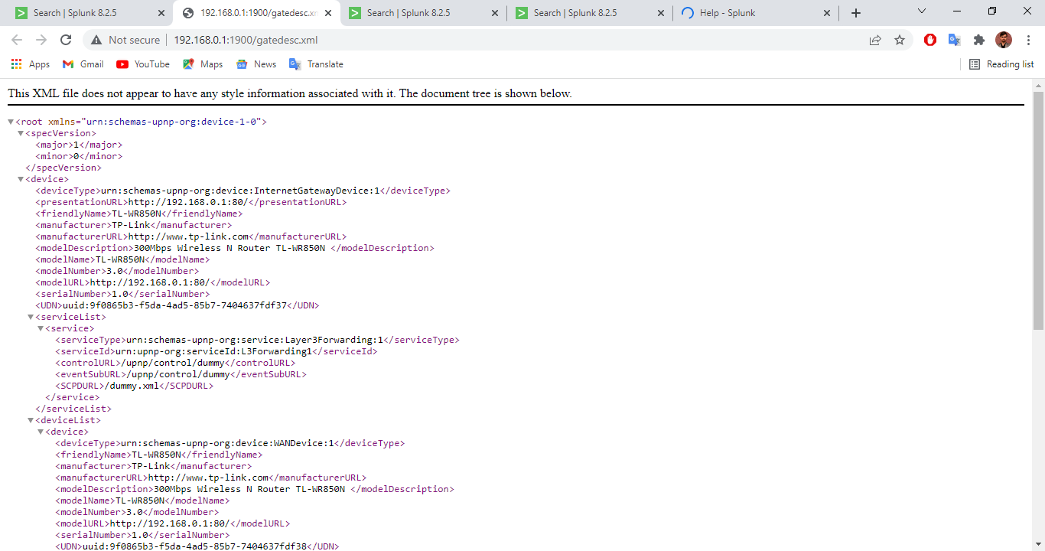

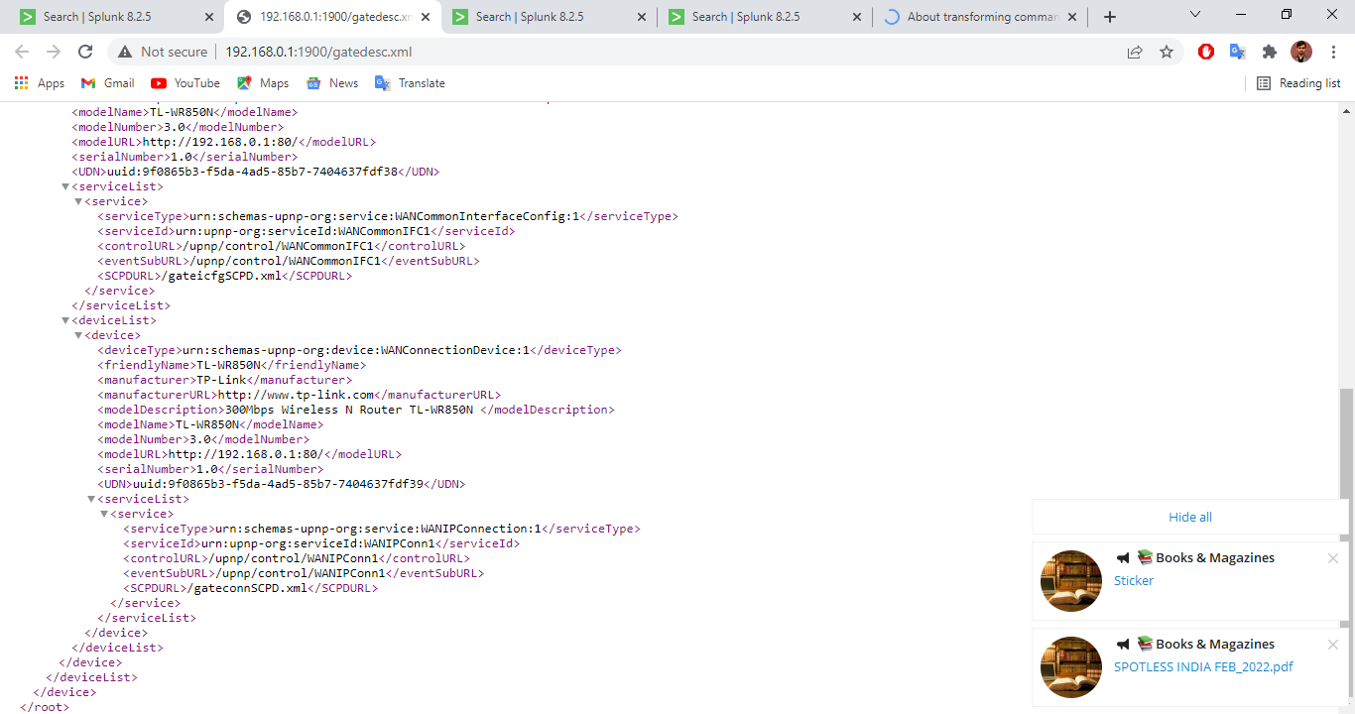

**Tools we have tried for log analysis**

Firstly, we have used Splunk tool for our log analysis but in Splunk as it shows on above screenshots that it doesn’t give correct format of our logs for the analysis so we have tried different tools.

We have tried **LogViewPlus** tool for our log analysis.

Here is the main page of LogViewPlus

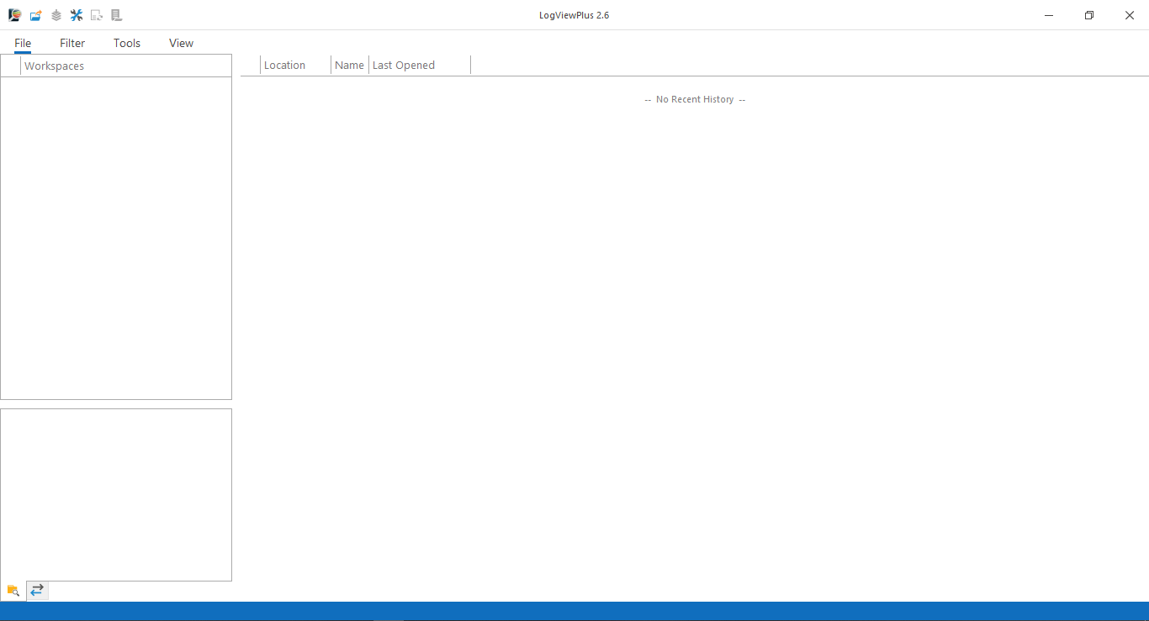

After this we have tried to add our logs into it.

We have first tried to insert snort logs into it.

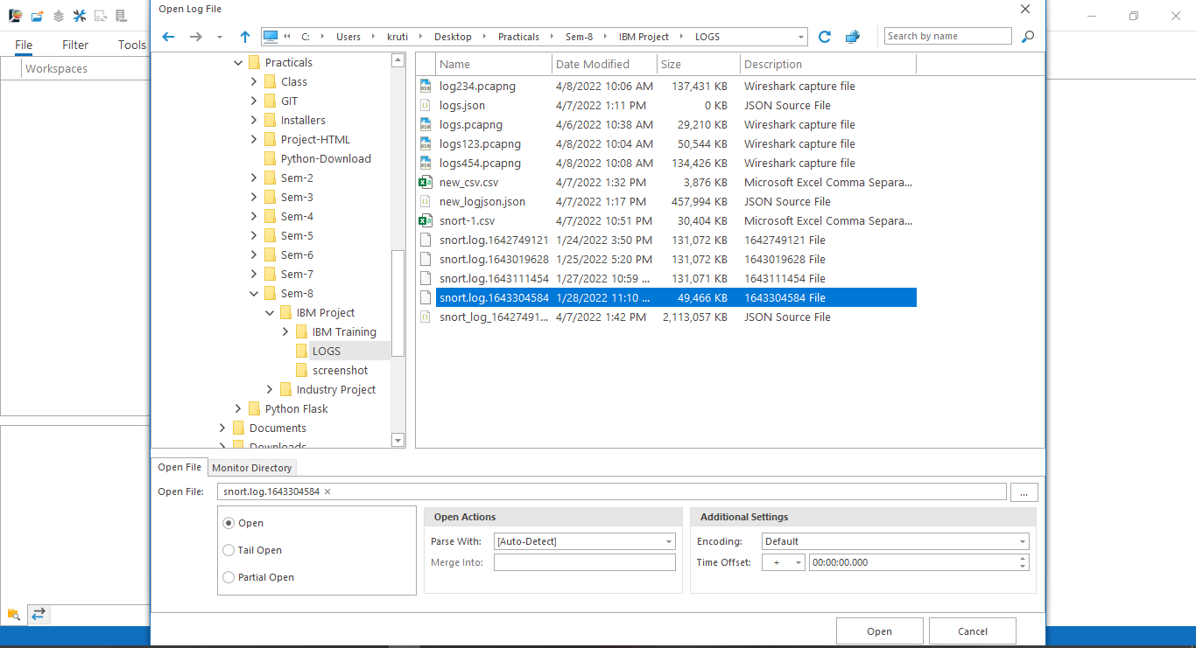

As we can see in the below image that it shows error as it doesn’t support our snort.log files. And we also tried with different settings like utf-8 and windows default but it shows error only.

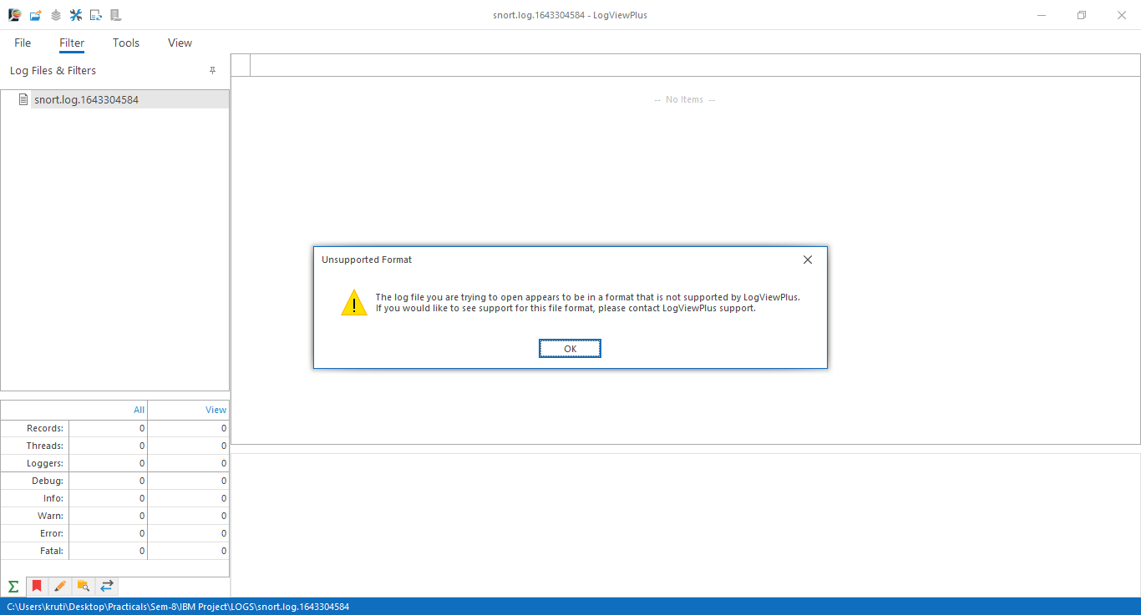

Then we have tried .pcapng format logs in it.

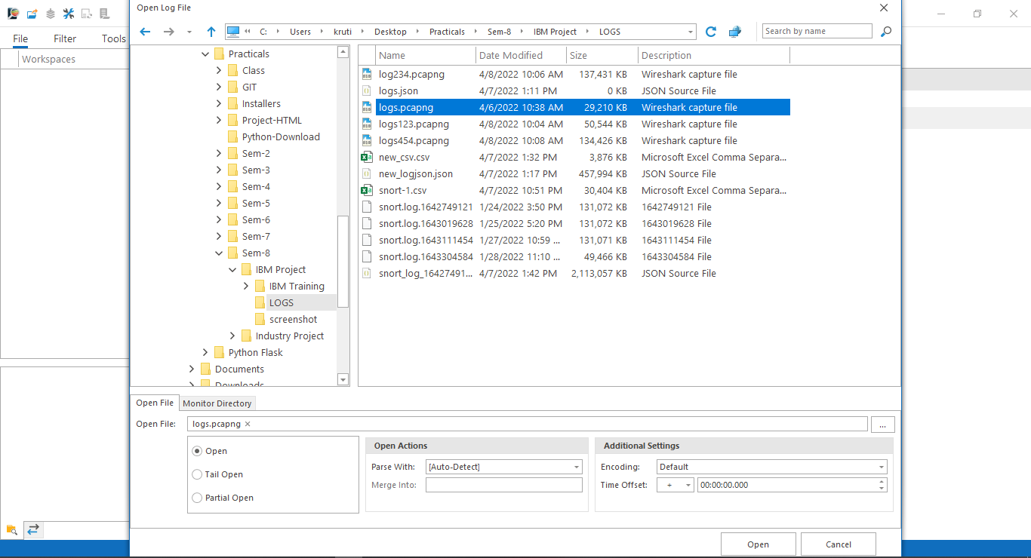

But result is same as snort.log file is not supported in this tool.

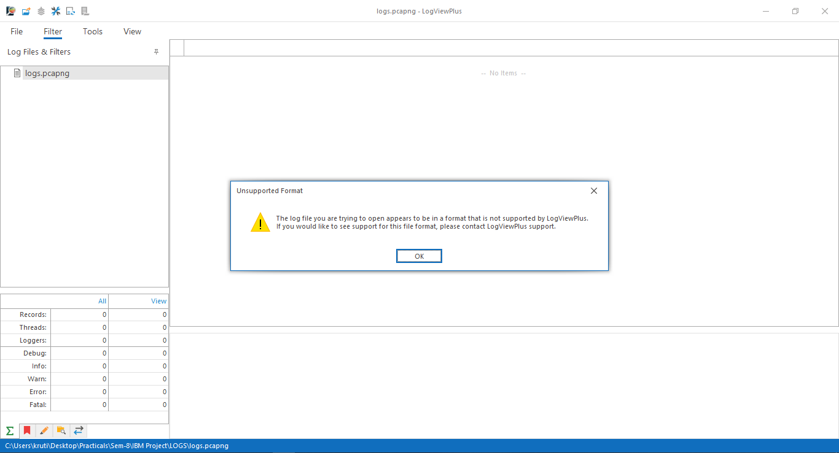

After this we have tried **GoAccess** tool for our log analysis

GoAccess is basically a terminal-based log analyzer in which we can insert our log files in it and it gives output on terminal as well as on localhost.

GoAccess dashboard looks like this for real time data

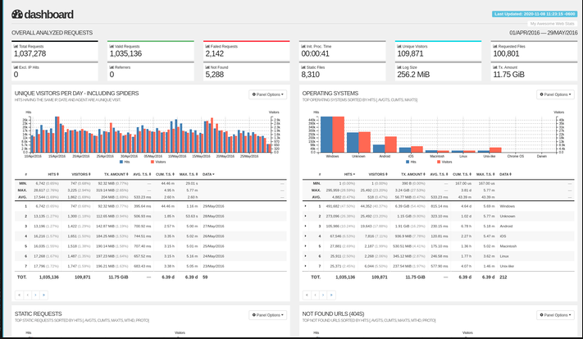

Accessing our logs in GoAccess terminal

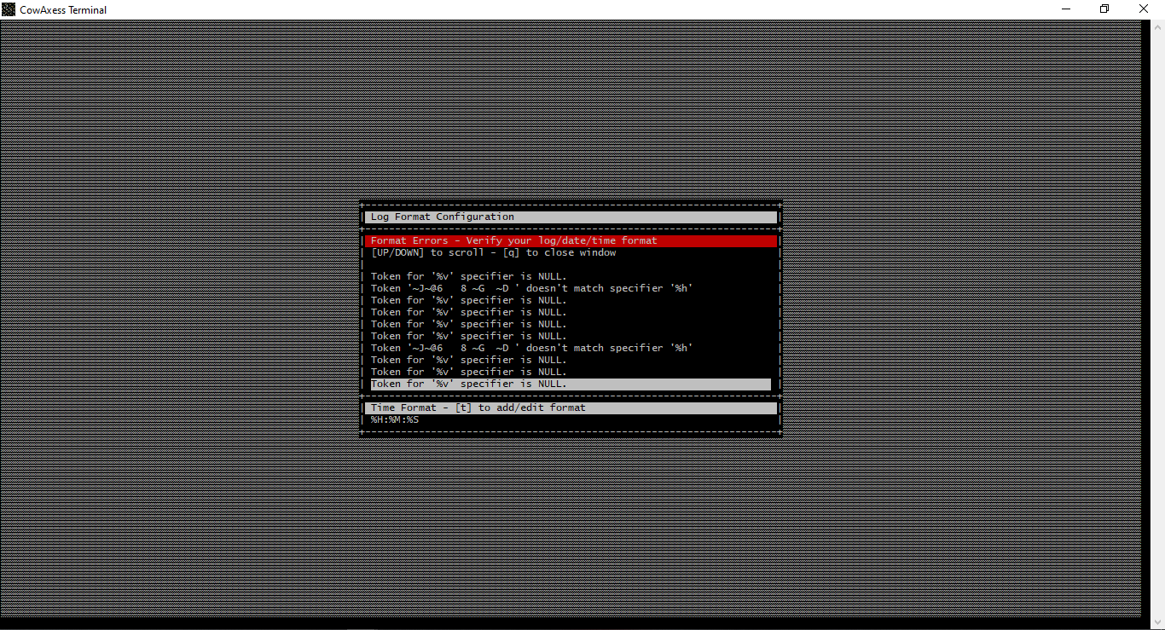

If we want our output in localhost statically

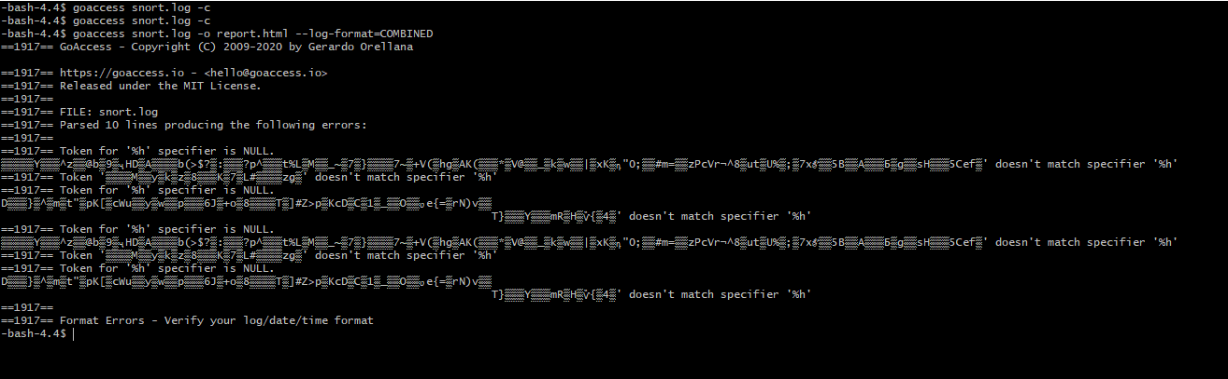

We can also do it for real-time but it gives same error as in static.

Using Fiddler, we have analyzed http request and we can see the sites that we have access during our log generation.

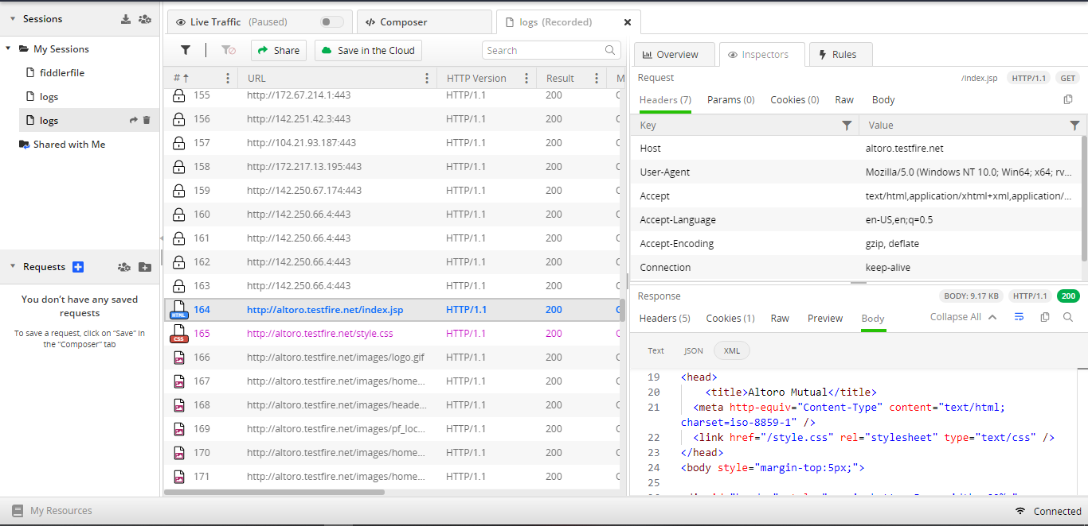

Fiddler is just used for the http request and it doesn’t show the tcp or udp or any other protocol.

So, after this we have used Wireshark for our log analysis and it support our log file and it shows all the details of the logs which we have generated.

Filtering Tcp protocol in Wireshark

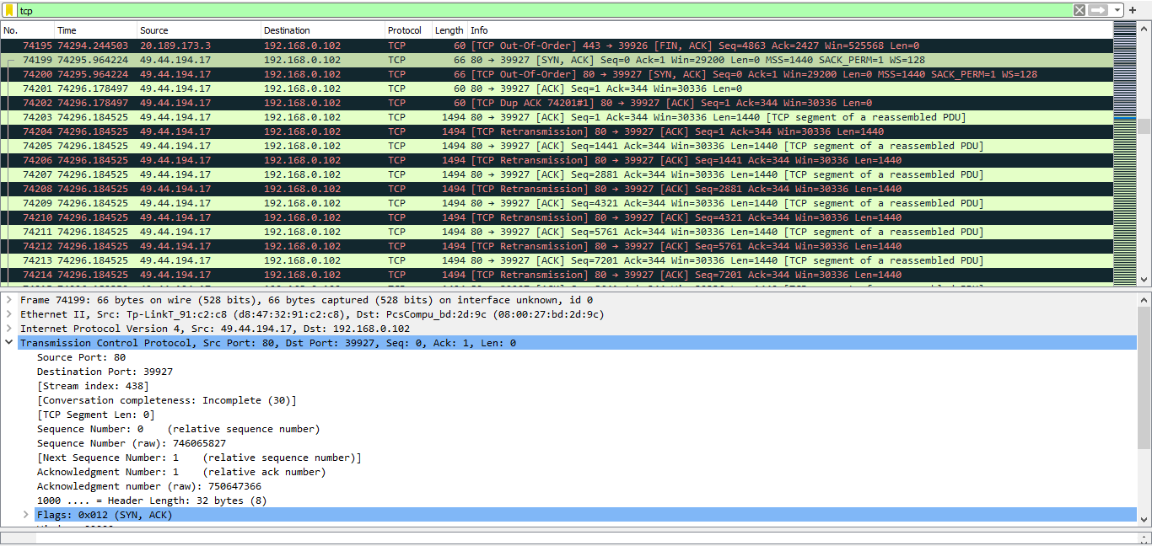

When we expand the details shown in second section, we can see the frames and which connection we have used and the flags during that process.

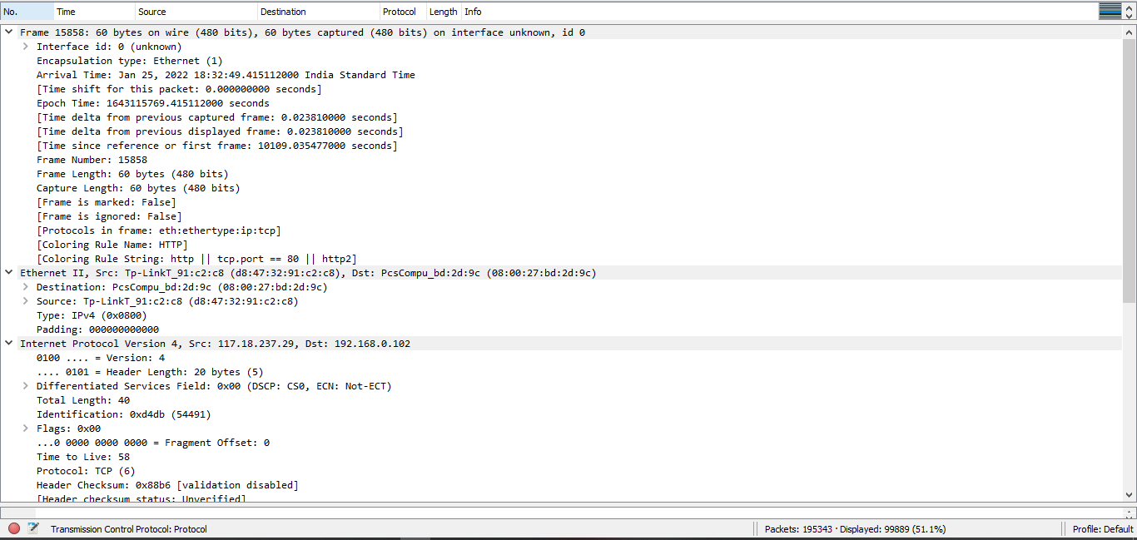

Filtering DNS protocol in Wireshark

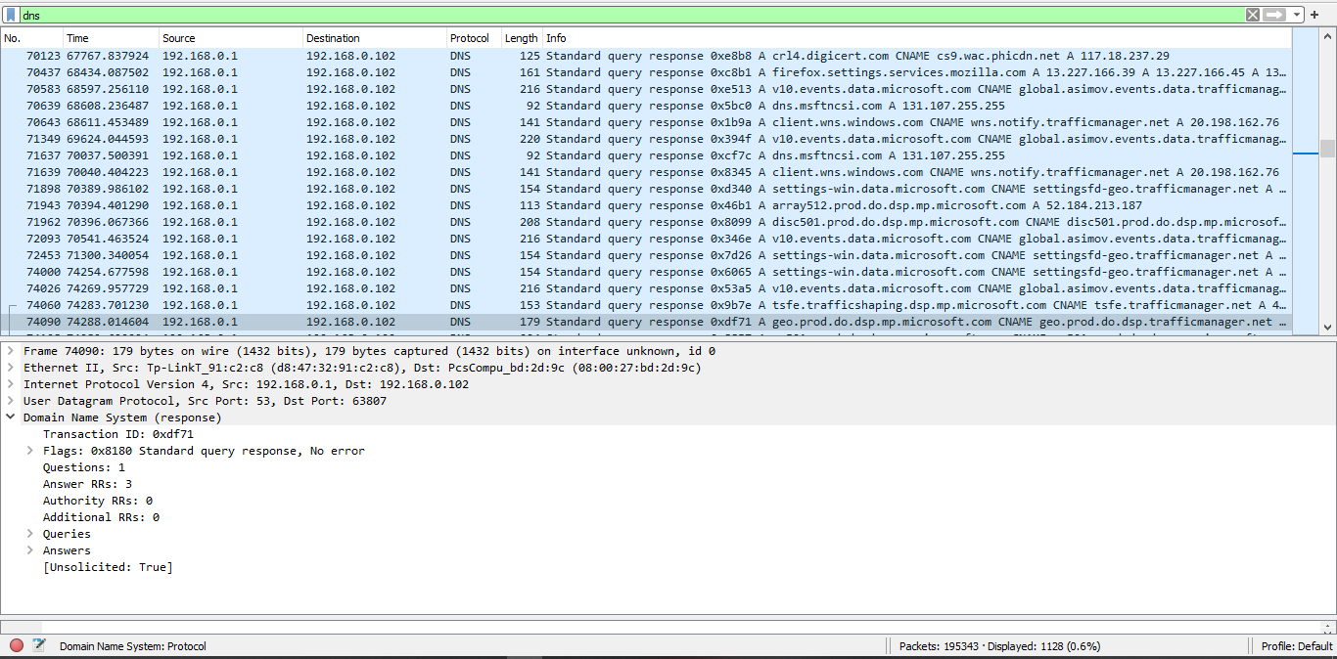

Same for DNS when we expand it gives clear idea about the information in logs.

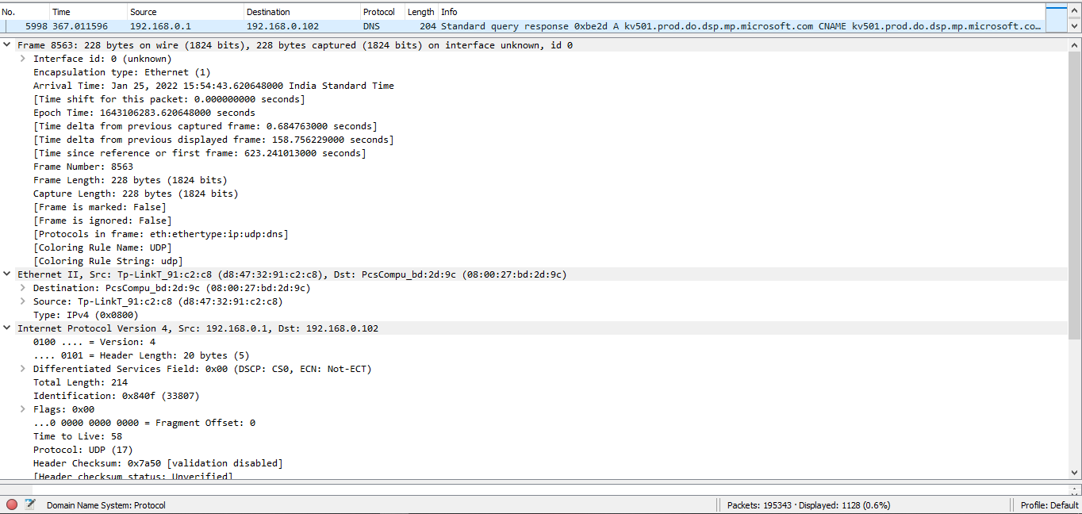

Filtering Http protocol in Wireshark

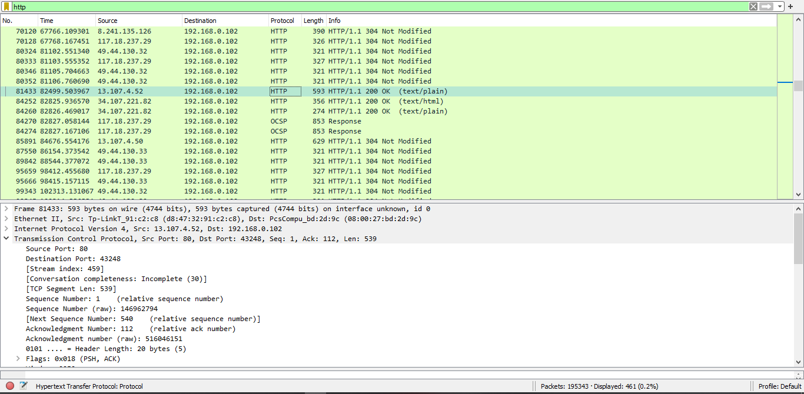

For http protocol

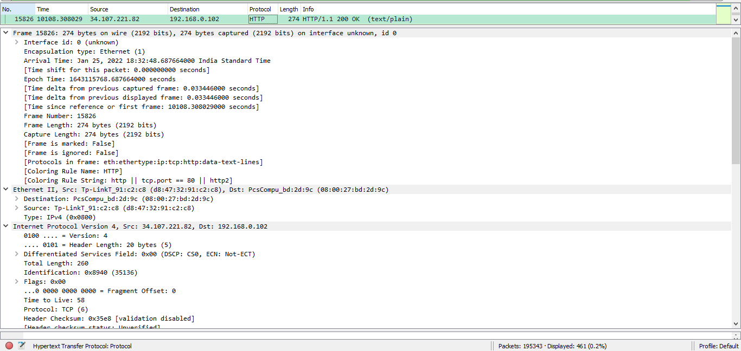

**6.5 Anomaly Detection on IBM Cloud**

* Types of Anomaly Detection can be classified into 3 types based on the availability of the data.

1. *Supervised Anomaly Detection targets* to construct a predictive model using labelled dataset which contains both normal and anomalous samples.
2. *Unsupervised Anomaly Detection targets* to construct a model using unlabelled dataset. It assumes that most data points in the dataset are normal and so it searches for the data points which are different from the normal data points.
3. *Semi Supervised Anomaly Detection* aims to utilize such labelled samples, but most proposed methods are limited to merely including labelled normal samples. Only a few method takes advantages of labelled anomalies.

* Anomaly Detection in Time series

1. Time series are the observations that have been recorded in an orderly manner and which are correlated in time.
2. When we are analysing time series data, we should make sure of the outliers the same way we do it for the static data.

* Anomaly Detection API’s

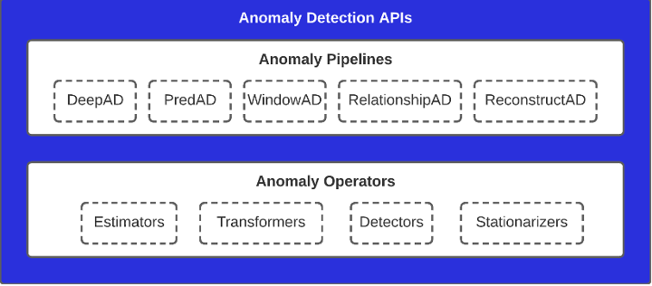

* Anomaly Operators

1. The lower layer consists of the Anomaly operators, which are the basic operations like Estimators, Transformers, Detectors and Stationarizers.
2. These components perform one specific task and hence are referred to as Operators.

* Anomaly Pipelines
  + The upper layer consists of Anomaly pipelines. It is used to implement advanced machine learning primitives in the form of an anomaly pipeline which connects the lower layer.
  + Types of anomaly pipelines 🡪

1. PredAD
2. DeepAD
3. RelationshipAD
4. WindowAD
5. ReconstructAD

* DeepAD uses an ensemble of time series forecasting model whereas PredAD uses single time series forecasting model. We can say that DeepAD is the plural form of PredAD.
* RelationshipAD has a pair wise relationship between the variables for the anomaly detection by comparing the behaviour of relationships between variables under normal operation with that of the relationships observed during a test period.
* WindowAD performs windowing on the time series data to generate sequential windows at each data point and performs anomaly detection on the tabular data that is generated by flattening the time series.
* ReconstructAD is an algorithm that performs anomaly detection based on the reconstruction of the original data and comparing the quality of reconstruction to detect anomalies.
* Also each pipeline is capable of generating anomaly labels(+1 for normal Sample and -1 for anomalous) in the form of Anomaly Thresholding.
* Anomaly labelling methods are of 2 types, Static and Dynamic.
* Static thresholding provides a single-value threshold for the entire range of anomaly scores, and all anomaly score values greater than this threshold are labeled as an anomaly.
* Dynamic thresholding provides changing or contextual thresholds throughout the range of the scores, and anomaly score values that are greater than their corresponding dynamic threshold values are labeled as an anomaly.

**Anomaly Detection ON UNIVARIATE DATA**

* **Steps 🡪**

1. Authentication 🡪 Here all API request requires the authentication information, which includes CLIENT ID and CLIENT SECRET. You can get this by clicking on get trial subscription, registering for free trial using your IBM ID. Go to the Dashboard. Then search for the Anomaly Detection API and click on it. Click on the dropdown arrow and you will see that those two credentials are available in the key management section.
2. Connection Check 🡪 Now the next task is to verify that the anomaly detection service is up or not. For that go to connection check tab, click on try this API button and give the CLIENT ID and CLIENT Secret values which you retrieved from step 1, click on run request. If the service is connected you will see a response message that the anomaly detection service is up. You can add the code snippets of different languages in your program by selecting your desired language in the code snippet session.
3. Create a dataset 🡪 For implementing our anomaly detection service, we need a CSV or JSON datafile. The data format for JSON file should be as follow 🡪

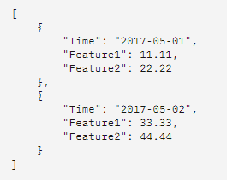

1. Create a dataset 🡪 For implementing our anomaly detection service, we need a CSV or JSON datafile. The data format for CSV file should be as follow 🡪

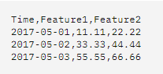

1. Submit an Anomaly Detection job 🡪 Navigate to the submit anomaly detection job tab and select Detect anomalies for univariate time series. Click on try this API, fill the CLIENT ID and CLIENT SECRET. Give the parameter values according to your choice and click on run request to send a request and submit a job. Once the job would run successfully, it will return a JOBID which is necessary for the next step.
2. Get Result 🡪 Once a job is successfully submitted, the service will perform data quality checks and run the anomaly detection on the data. The execution time is dependent on the data size, parameter selections, e.g. algorithm type, and the current number of job submissions. Navigate to get result tab, click on try this API and give CLIENT ID and CLIENT SECRET. Give the JOB ID you got from the last step and click on run request. If the job is done, the result of each sample will be returned with anomaly scores and other details.

**SOME SCREENSHOTS OF EXECUTION OF THE STEPS**

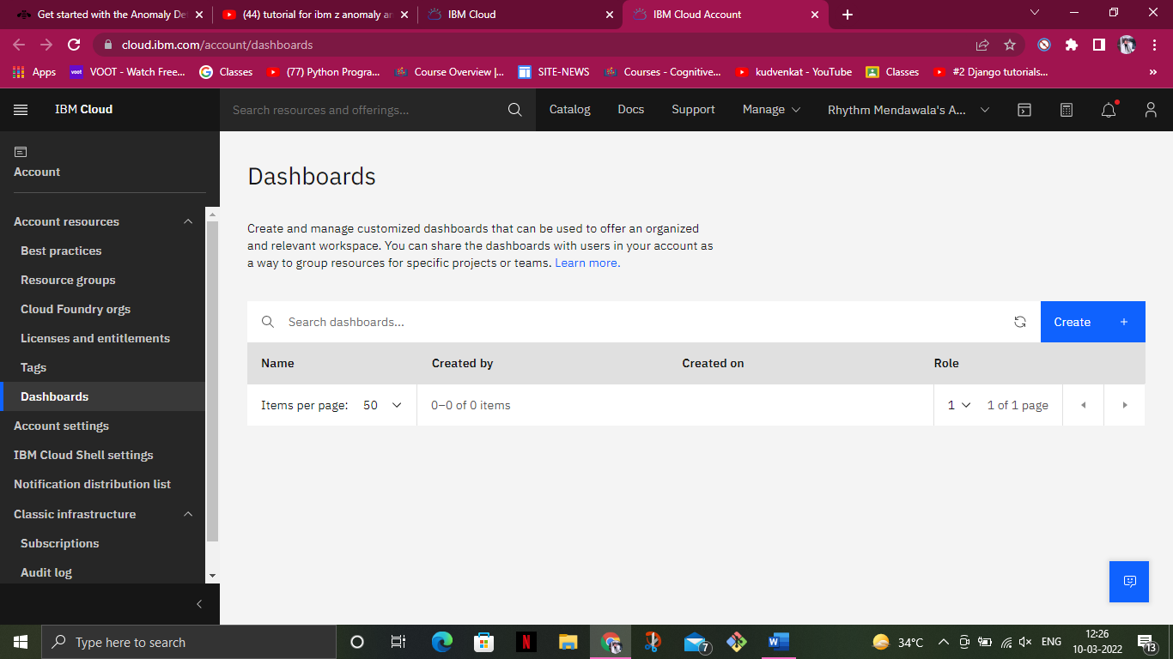

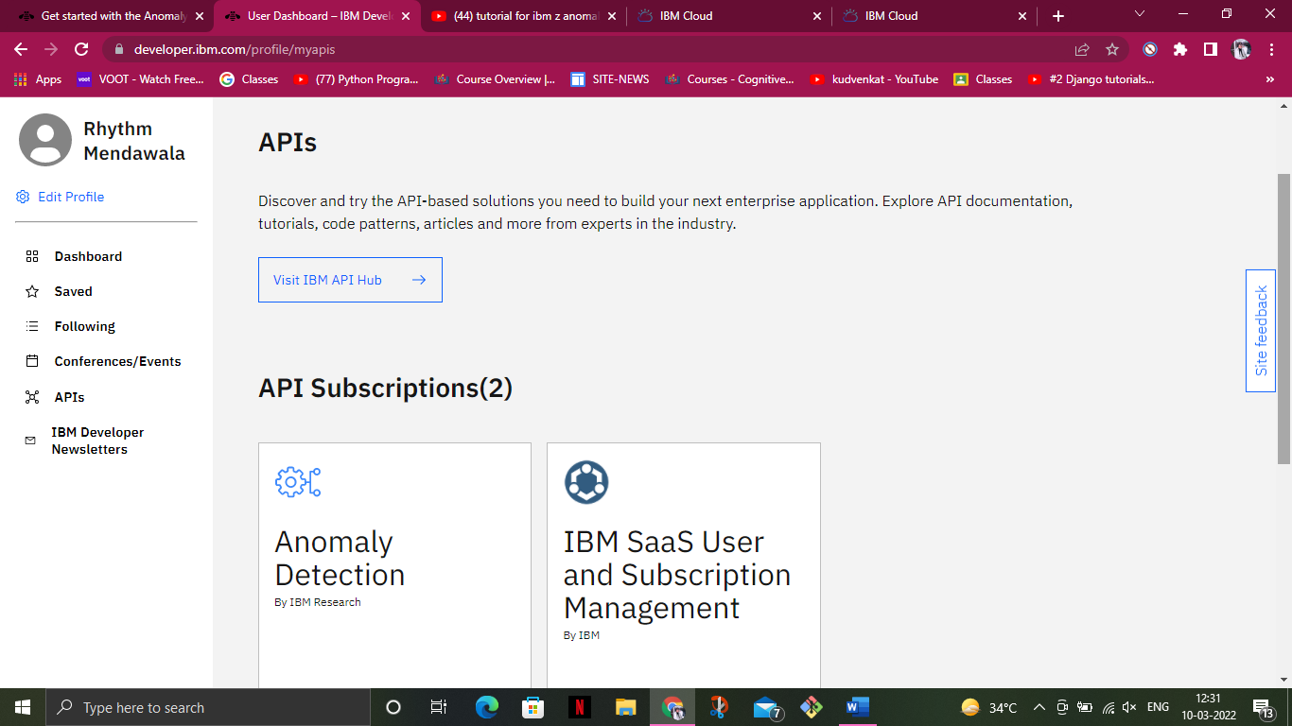

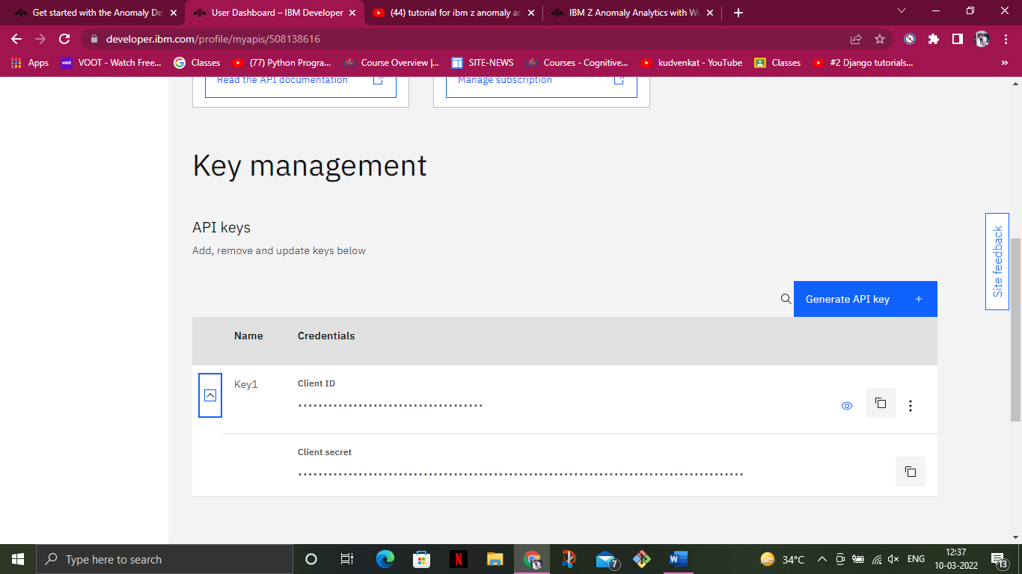

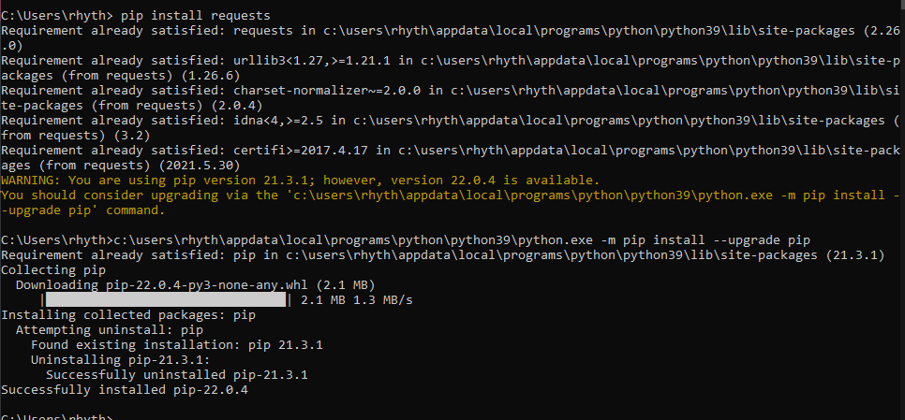

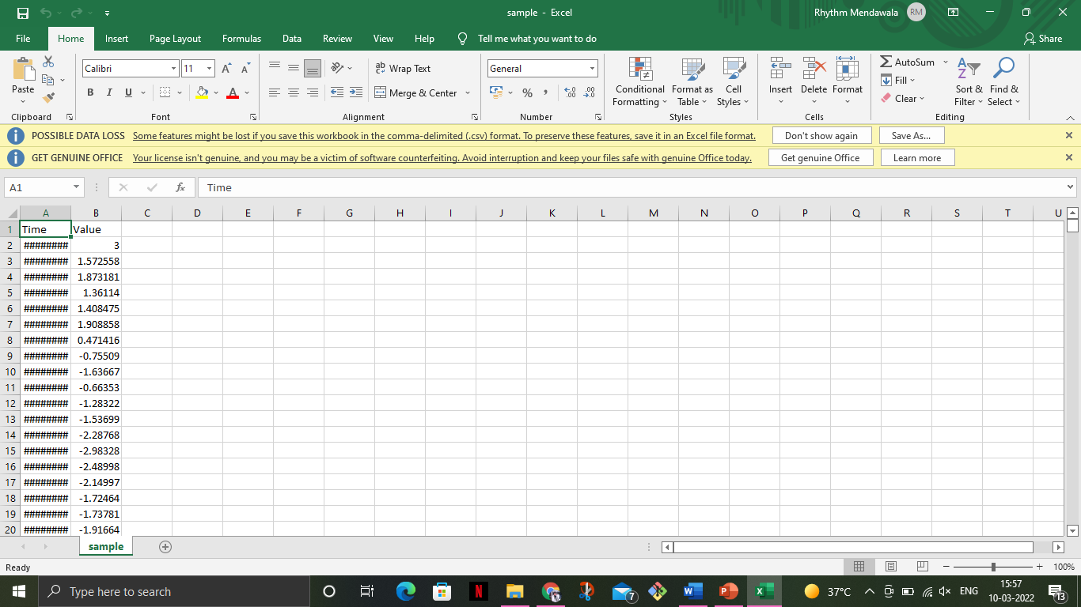

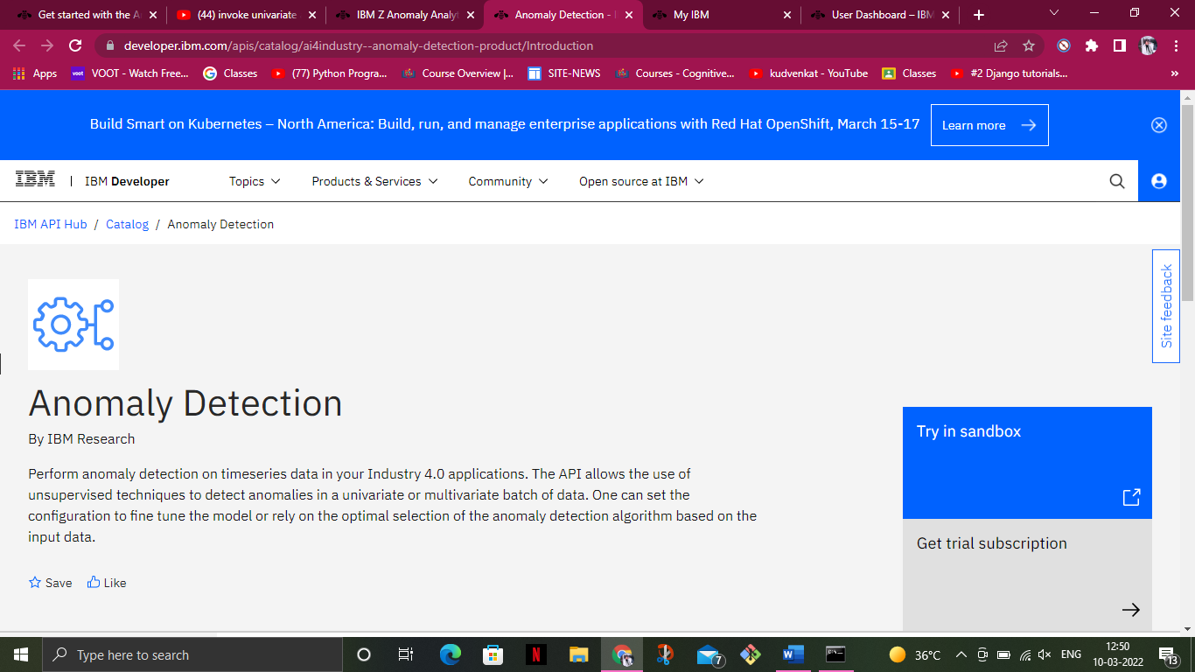

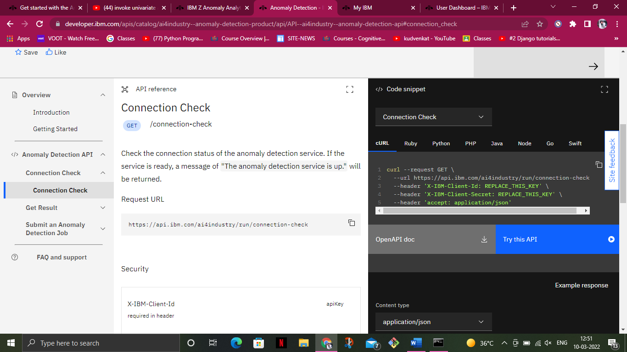

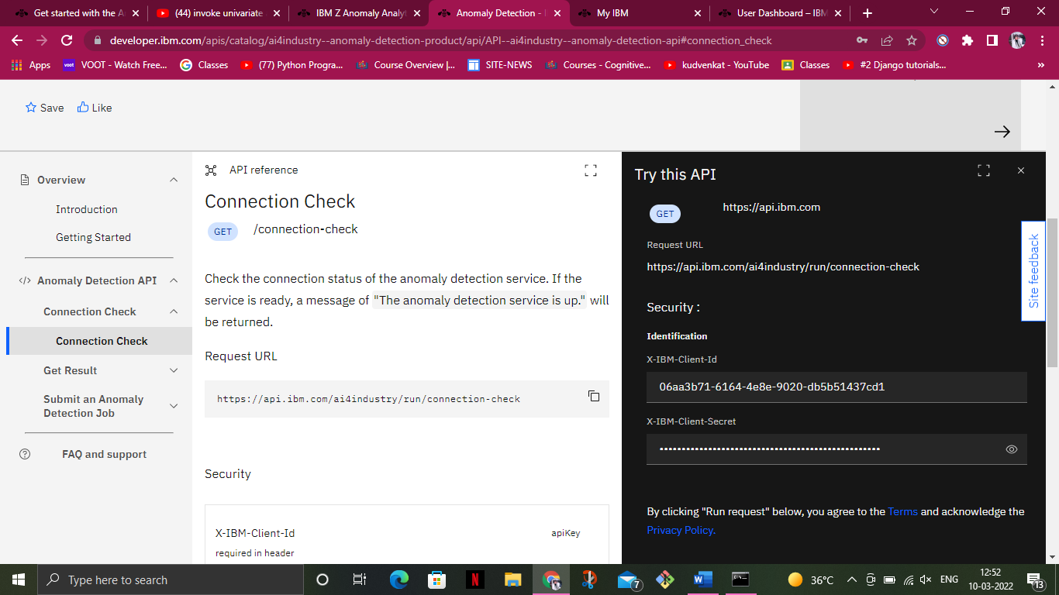

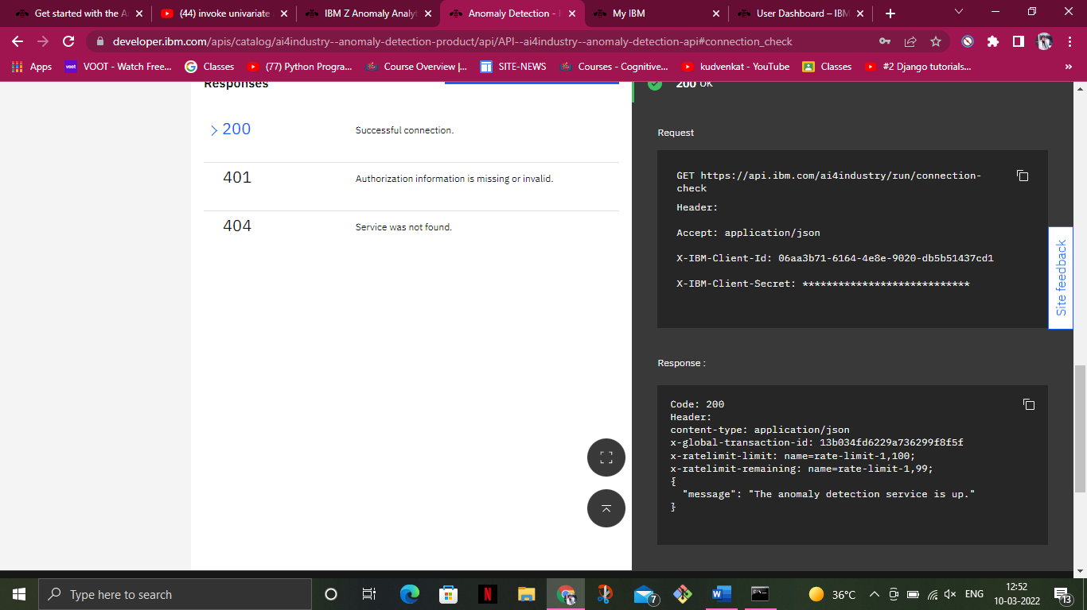

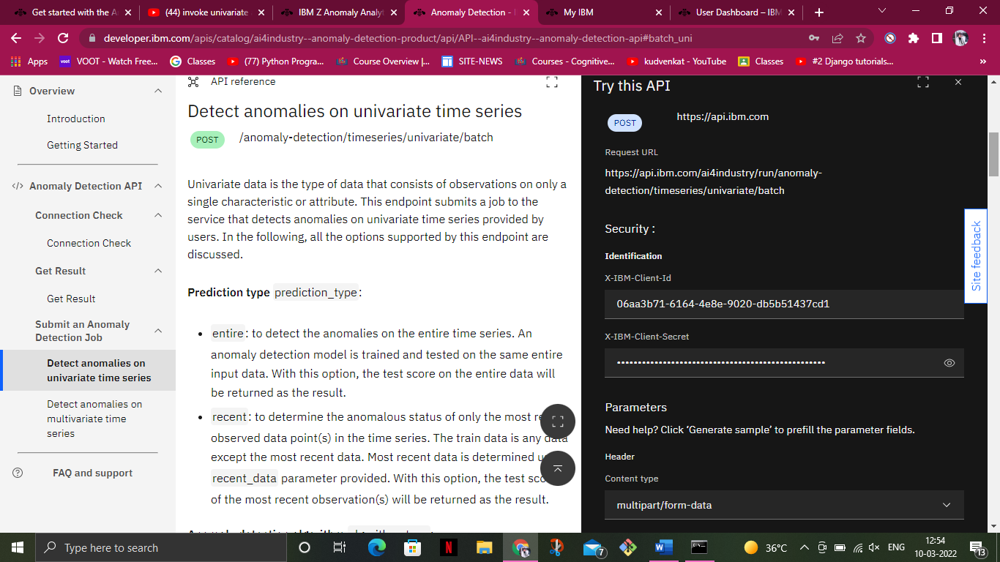

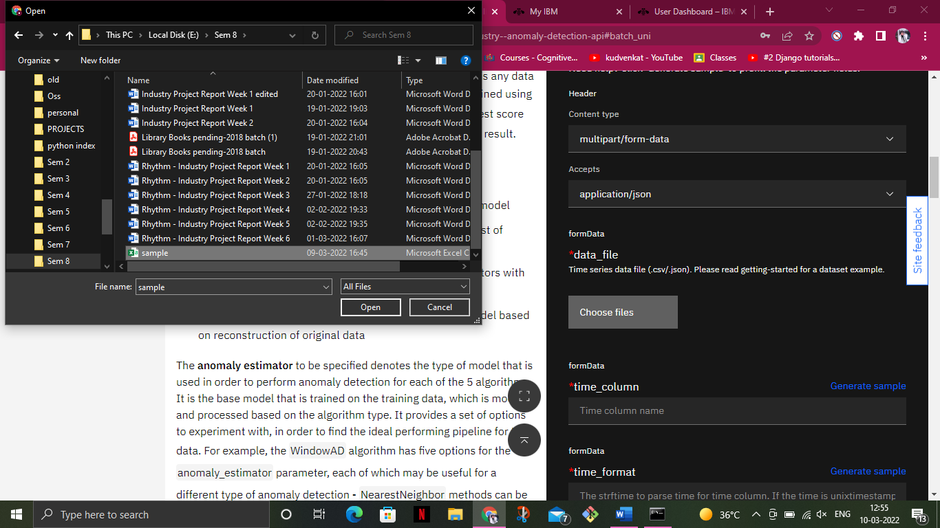

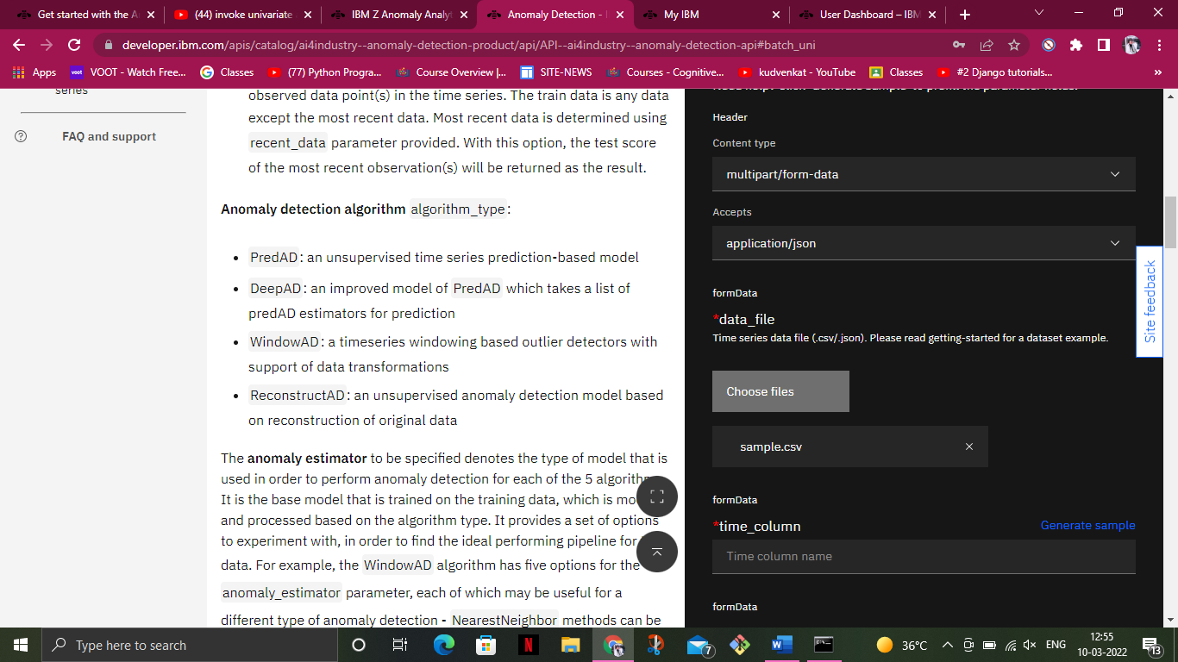

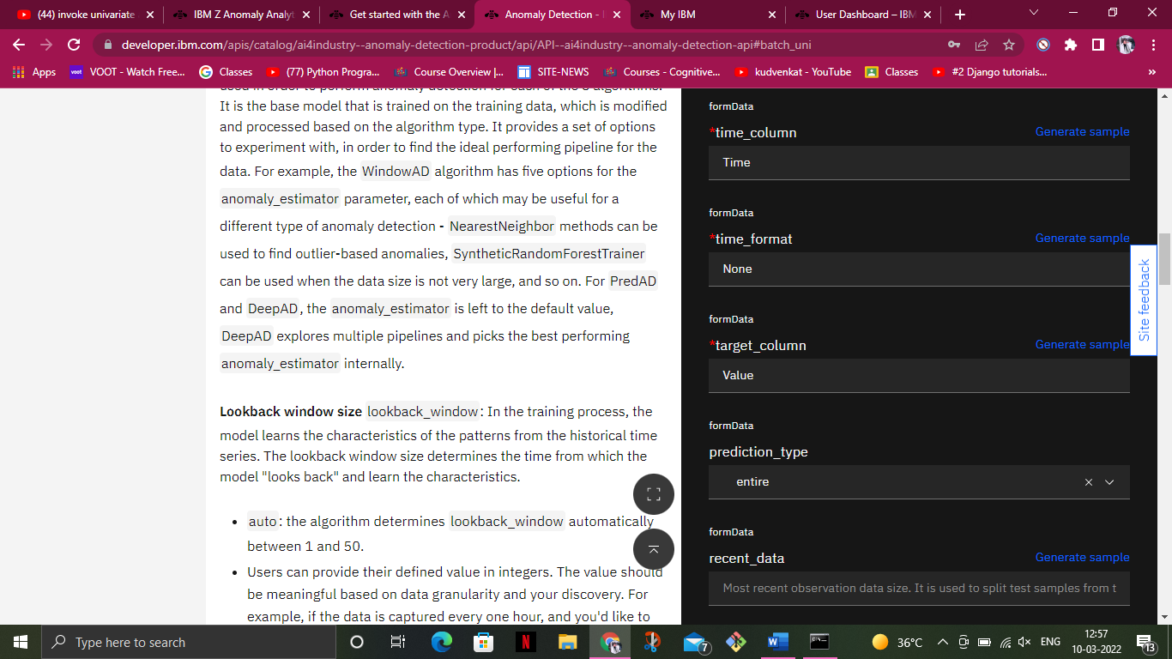

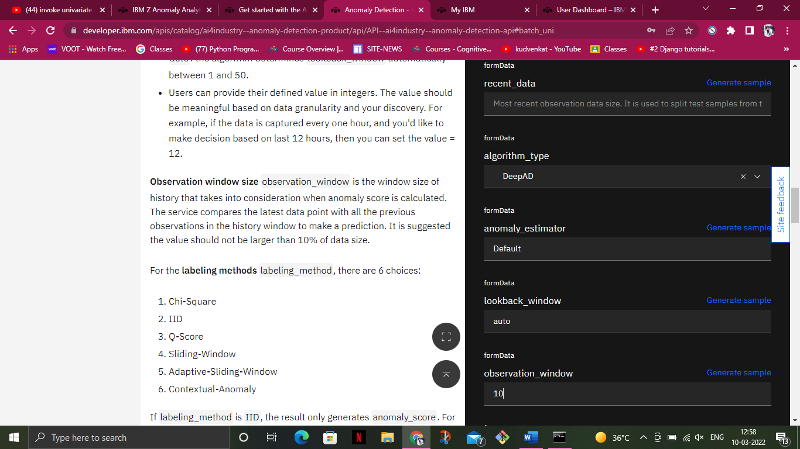

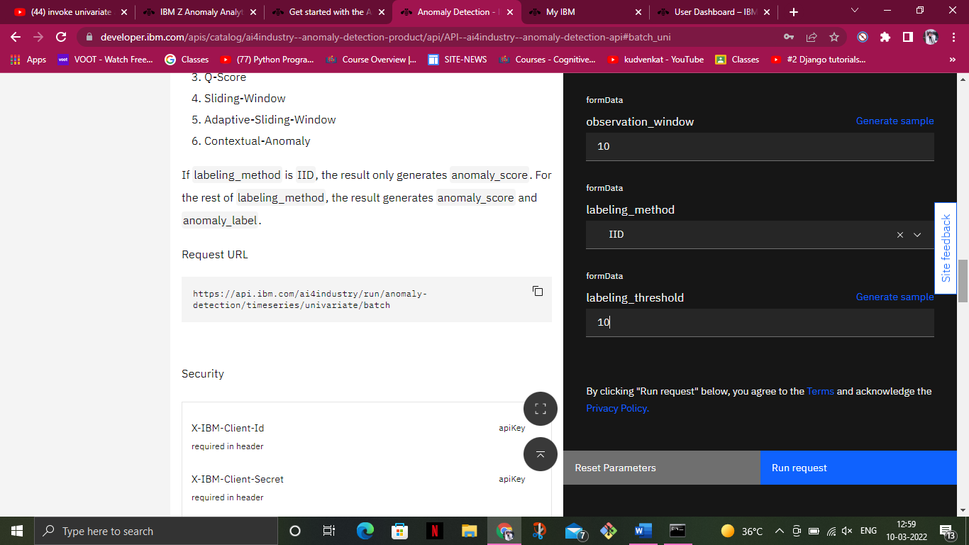

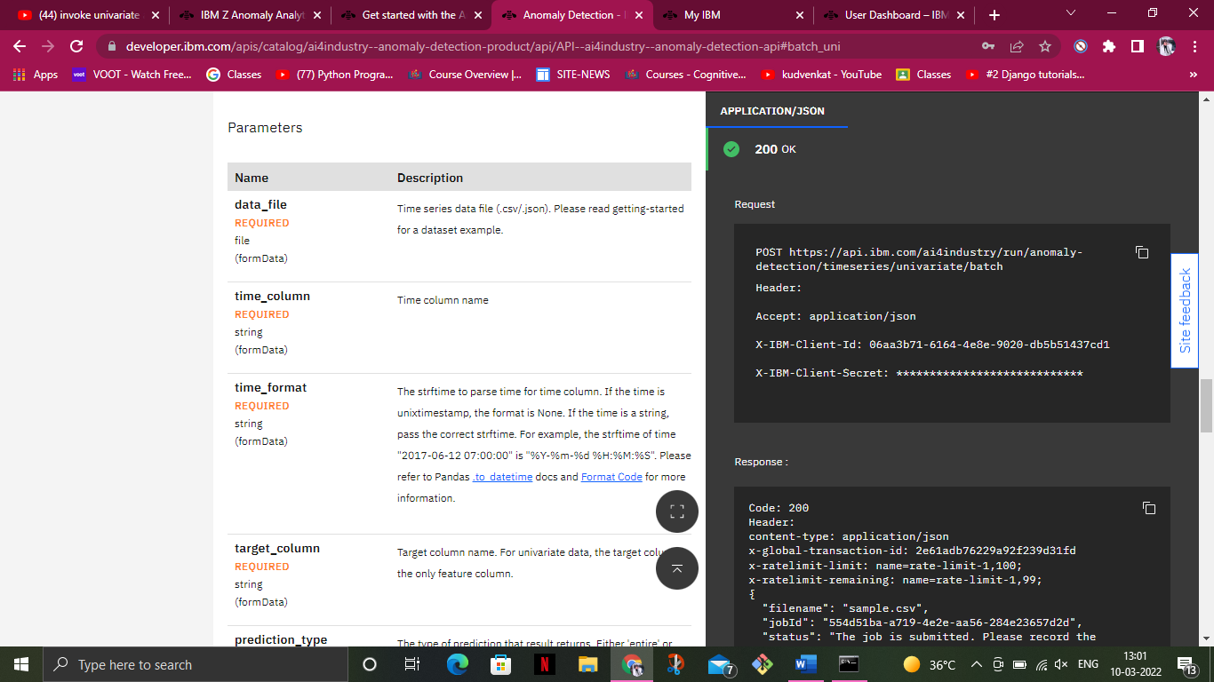

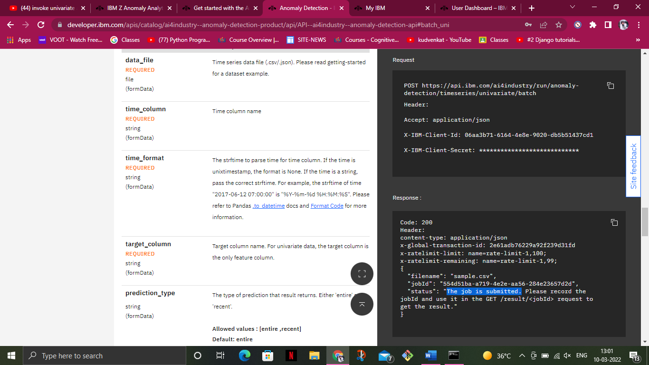

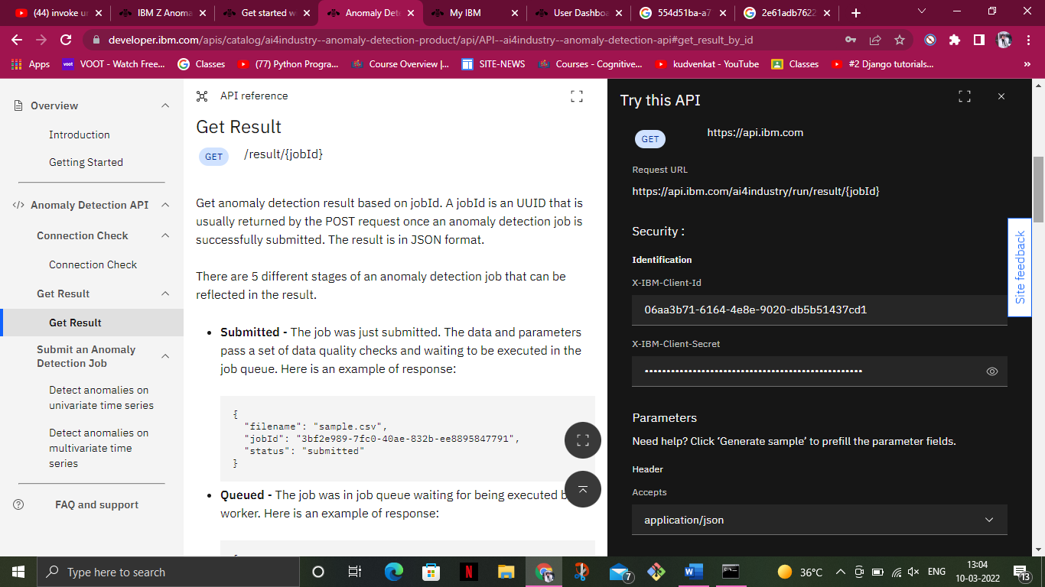 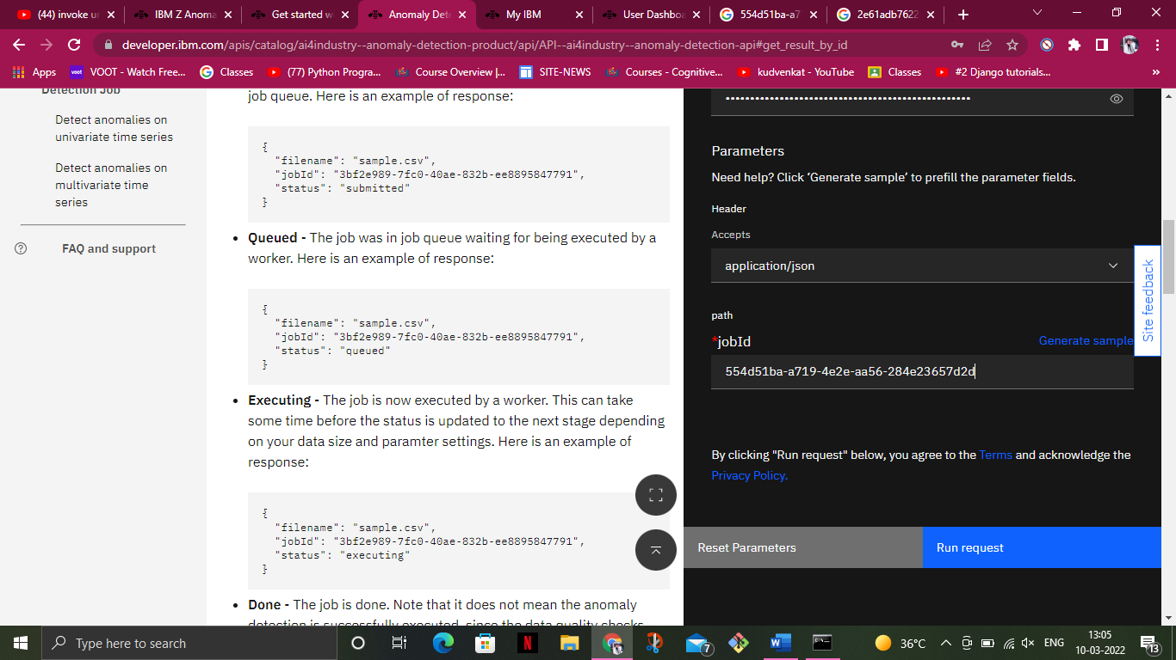

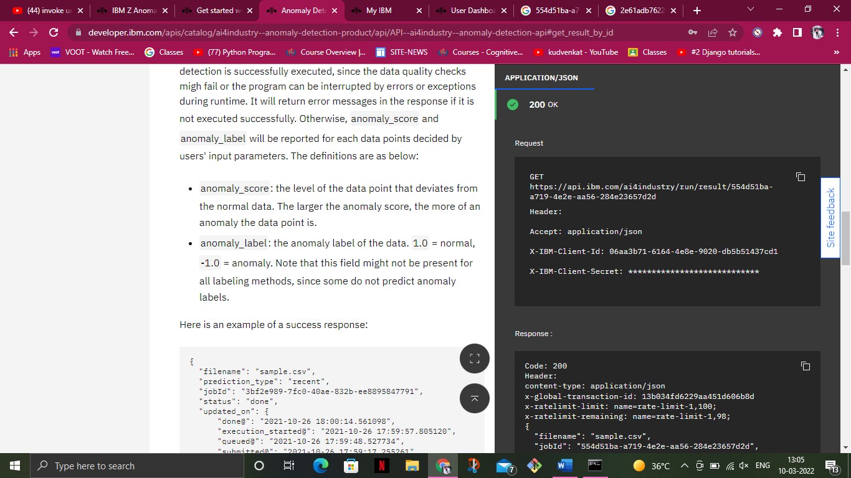

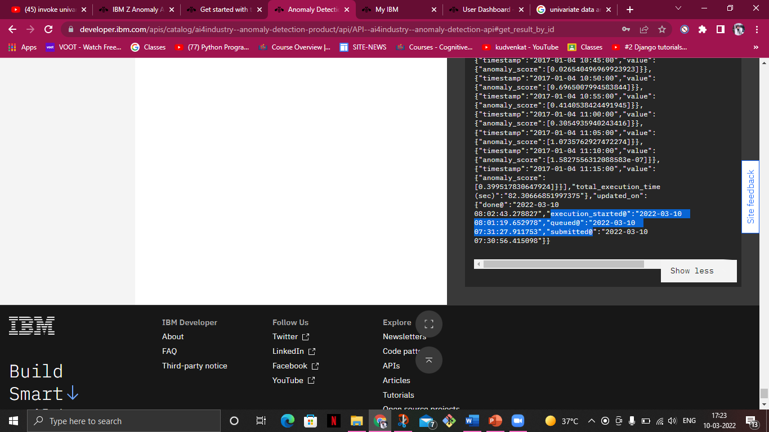

**Trying to generate logs in IBM cloud using IBM LOG ANALYSIS**

**Steps 🡪**

1. Login to your IBM account.
2. Click on catalog and you will see the services available in ibm cloud.
3. Now in services search for logging and monitoring category.
4. Now click on IBM log analysis block.
5. The following screen will be visible, so select the region, select the lite plan and give the name of the service.
6. To provision the IBM Log Analysis service in the IBM Cloud selected resource group, click create.
7. Then the IBM log analysis dashboard opens.
8. Go to the menu icon  > observability to access the Observability dashboard.
9. Click on logs 🡪 options and then edit platform.
10. Select a region from the drop down list.
11. Select the instance you created 🡪 Click select
12. Open ibm cloud cli or command prompt and login to you’re ibm account.
13. Give commands 🡪 ibmcloud login, give mail id and password, and select the account you want to use.
14. Select the region
15. Set the resource group which is there in your instance, in this case it is default
16. Switch to IBM cloud tab and search for cloud foundry.
17. Click on create a cloud foundry app.
18. Select the location, give the name to the app and click on create.
19. After that we will try to connect the cloud foundry app to the IBM log analysis service.

**SOME SCREENSHOTS OF EXECUTION OF THE STEPS**

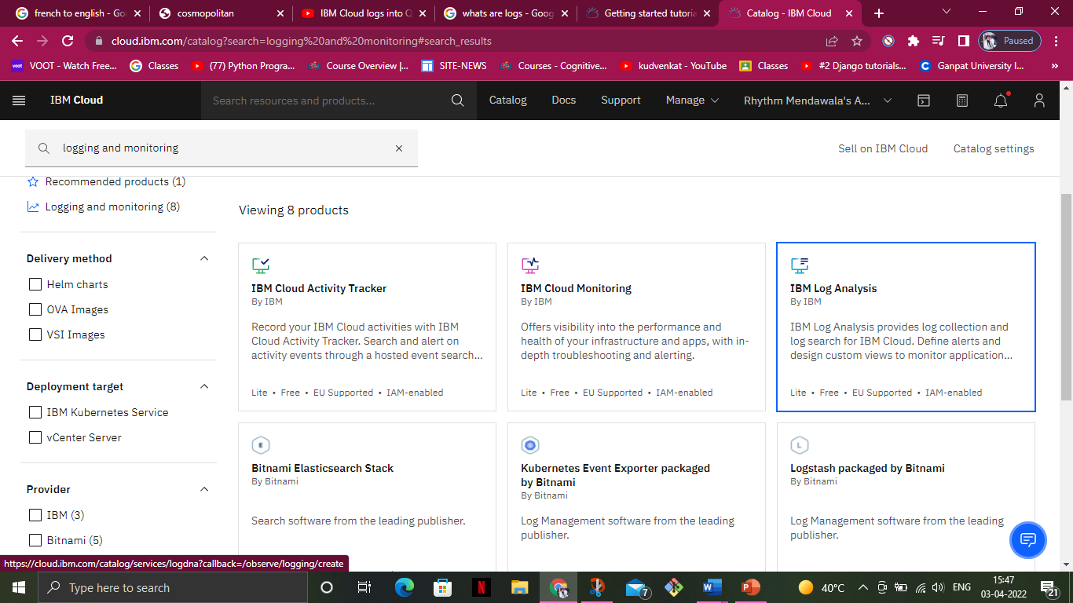

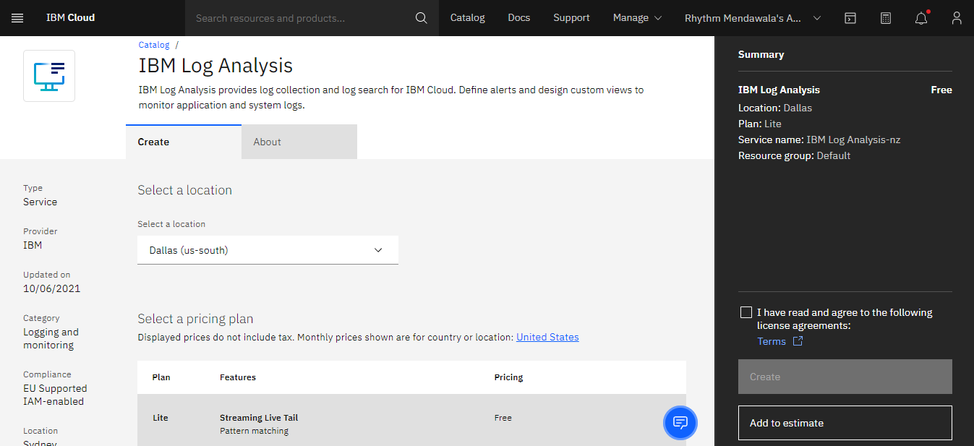

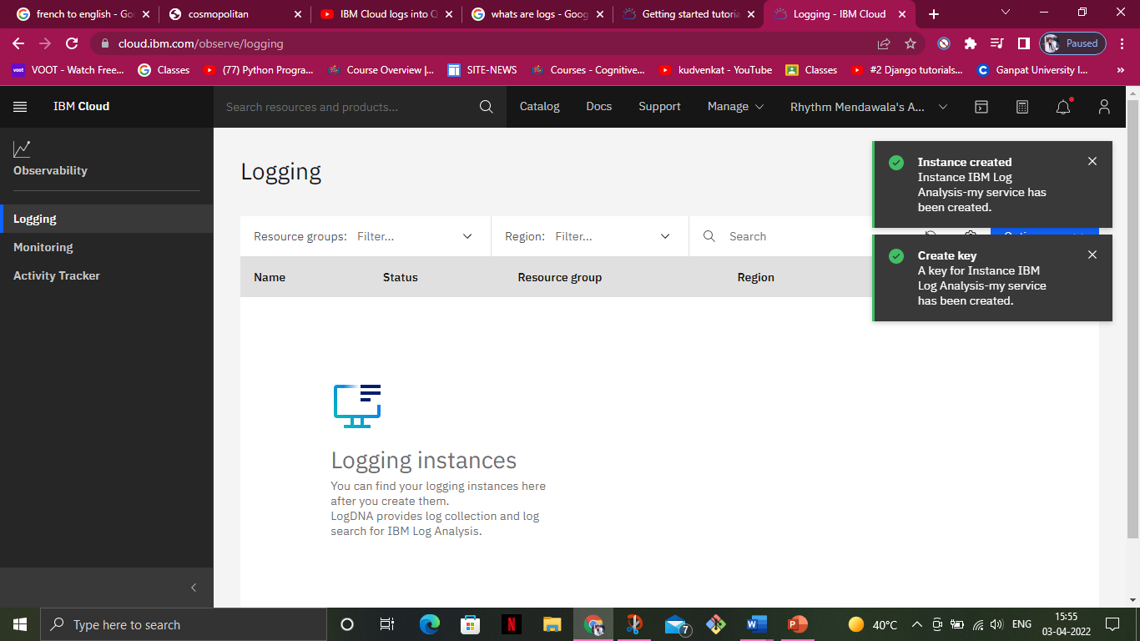

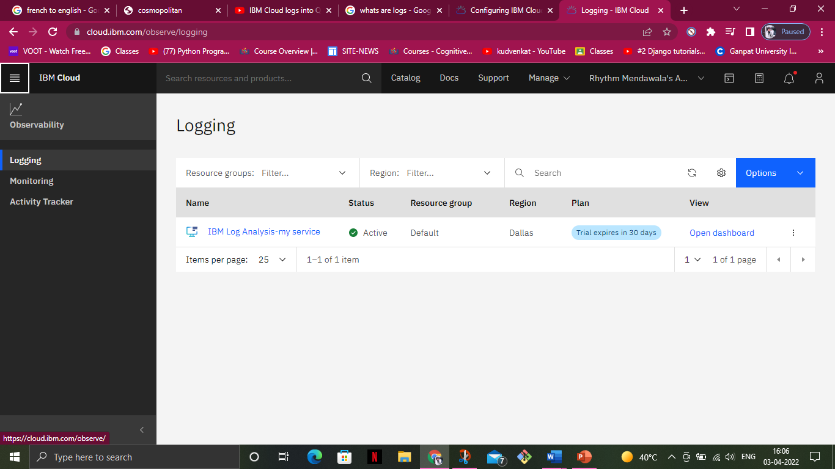

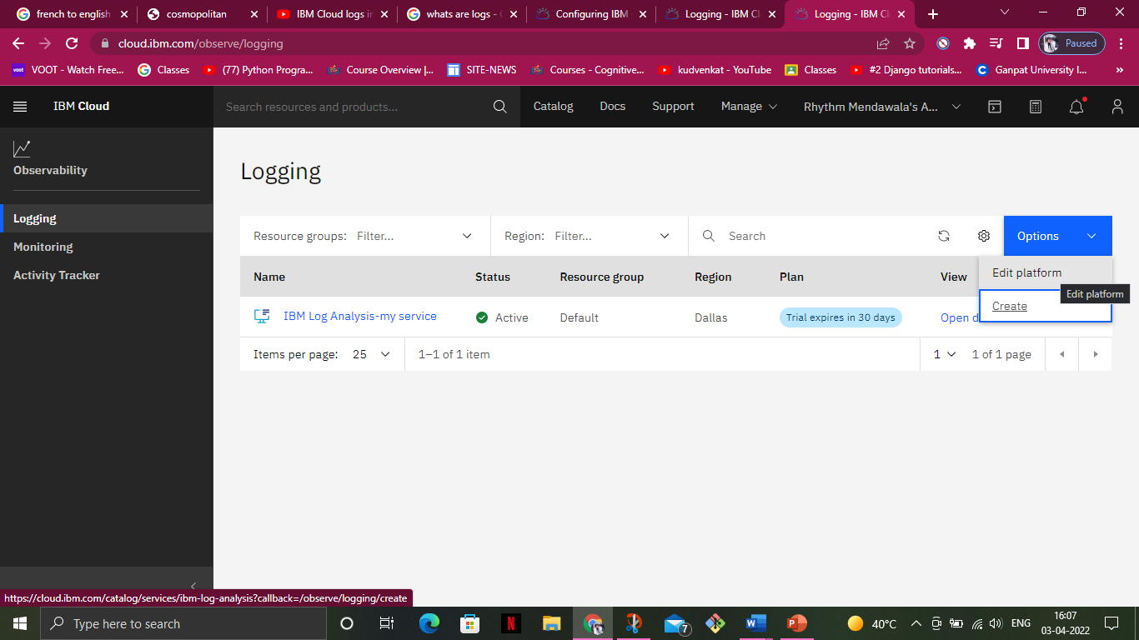

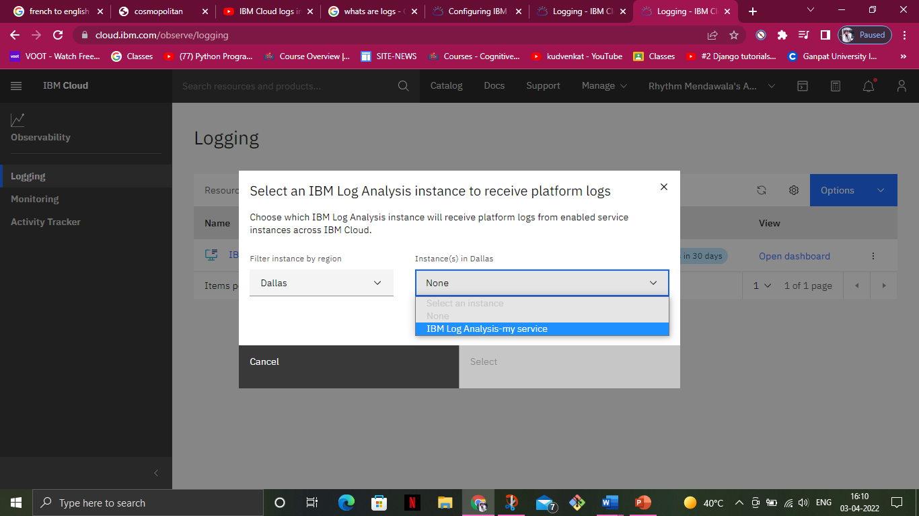

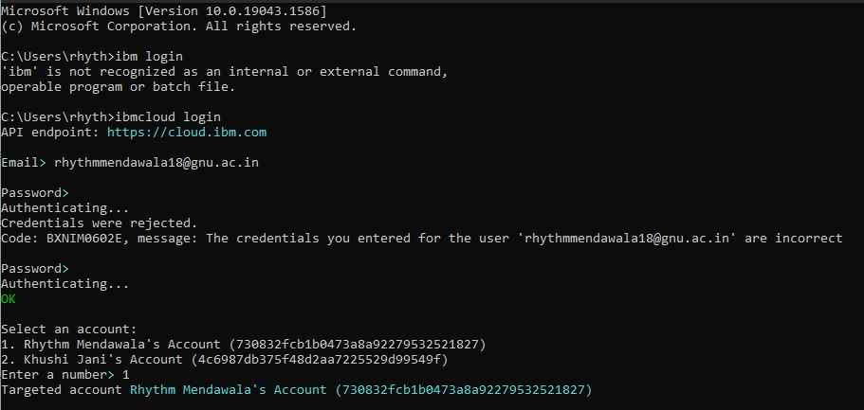

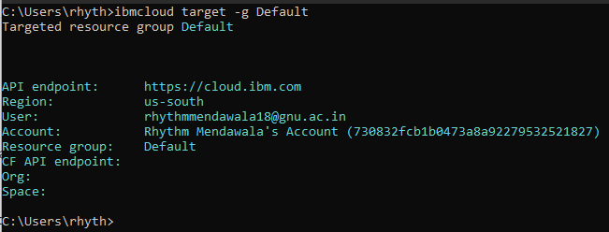

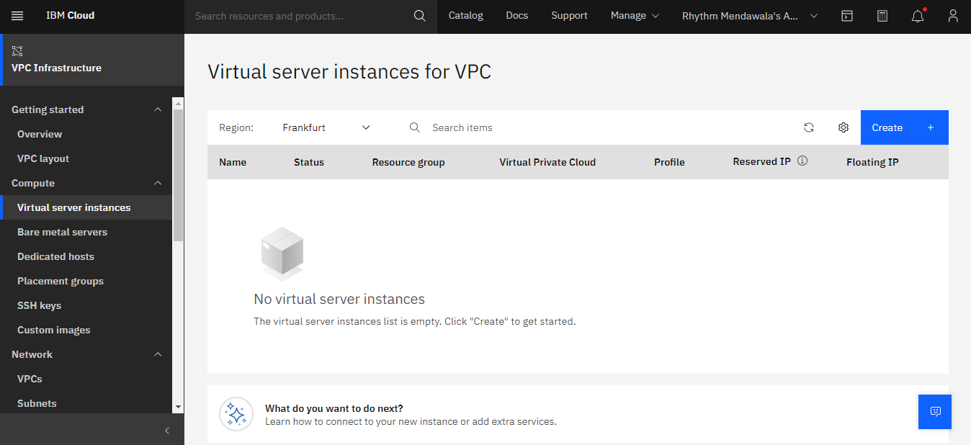

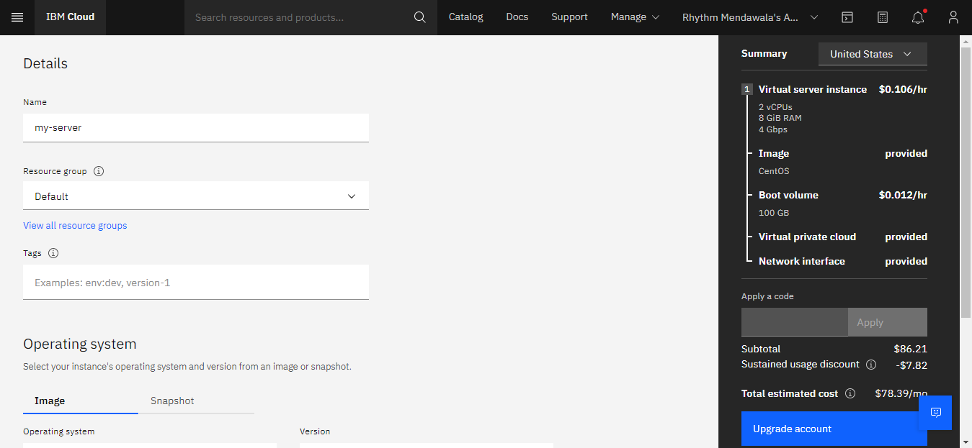

Here as we can see that it is asking to upgrade the account, the further steps cannot be performed.

**6.5 Anomaly Detection in AWS Cloud**

* EC2 Service 🡪

1. Full form of EC2 is Amazon Elastic Compute Cloud.
2. Amazon EC2 is a web service in AWS cloud which helps to achieve resizable compute capacity.
3. Previously if you need to work on a server, you need to purchase it, get all the wirings done and then switch on the server, make some basic instalments which is very time-consuming process. EC2 service of cloud has provided you with a benefit of creating virtual servers in the cloud which is not at all time consuming plus its very beneficial as no complex tasks need to be done for switching on the server.

* IAM Service 🡪

1. Full form for IAM is Identity Access Management.
2. IAM is very beneficial for managing users in the AWS cloud. It also takes care about what people can access what services in the cloud.
3. It also helps to set permissions, roles and users in the cloud. Basically, it allows the user to access some different parts of the AWS cloud.
4. AWS IAM is an amazing web service which allows AWS users to manage the users and also the user permissions in the AWS Cloud.

* CloudWatch Service 🡪

1. AWS CloudWatch is service in AWS which allows the user to monitor and manage the service that provides data. Generating logs of an instance is a useful thing which this service can provide.
2. AWS CloudWatch is a kind of metrics repository.
3. An AWS service such as AWS EC2 can add the metric into a repository and then you can retrieve those statistics from those metrics. You can also customize those metrics and retrieve the statistics based on those metrics.

**Steps 🡪**

1. Login to you AWS management console.
2. In search bar, search for IAM service and open it.
3. Let the IAM dashboard open, then click on policies section to create policies.
4. Click on create policy and write the following code in json.
5. Give the name to the policy, review all the settings and click on create policy.
6. Once the policy is created, check whether it appears in the list of the policies.
7. Now go to roles section, and click on create role for creating a new role.
8. Select entity type as AWS service, use case as EC2 and click on next.
9. Now in permissions sections we need to select the policy which we created recently.
10. In step 3, give the name of the role and review the other settings and click on create.
11. The role will be created.
12. Next we will create EC2 instance whose logs are to be collected.
13. Click on instances and then launch instances.
14. Choose AMI as Amazon Linux AMI, click on next, select family as t2.micro and click on next.
15. In step number 3, keep all the settings as default.
16. In user data, write the following script.
17. In step number 4, keep everything as default, click next and give tags.
18. Create a new security group having protocol SSH and source as my IP, then click on review and launch.
19. Click on create a new key pair, give the name of the key pair and then download it so that you can easily login in that instance.
20. As you can see the instance is created, wait for its status to become running.
21. Once the status turns to running, select your instance and go to actions 🡪 security 🡪 modify IAM role.
22. Choose the IAM role which you just recently created and click on save.
23. Now select the instance and click on connect for logging into the instance, go to SSH client tab.
24. Open git bash, go to the folder where the downloaded key was saved and give the following commands 🡪 chmod 400 key name 🡪 copy the command given in the SSH tab and paste it in the gitbash.
25. Now we need to connect this instance to the cloudwatch log service so, some installations needs to be performed. For that give the command “sudo yum install – y awslogs”
26. Then give the command sudo vim/etc/awslogs/awscli.conf
27. Then do the following changes the the vim file. Select the region as given below or you can also select the region where you want these logs to be stored.
28. Region = ap-south-1
29. The give the following command 🡪 sudo vim/atc/awslogs/awslogs.conf
30. Do the following edits in the vim file, save the file and exit the vim file..

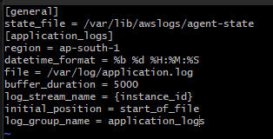

1. Next give the command 🡪 Sudo service awslogsd start
2. Give command 🡪 cd /var/log 🡪 sudo su 🡪 ls and you will see the list of existing files in that folder.
3. Create a dummy file containing dummy data as logs. Now if everything is well we should see this data in the cloudWatch service.
4. Go to CloudWatch service tab and in logs section go to log groups. You will see that the dummy log file which you just created is now shown here.
5. Open it, and you will see the log stream, click on it and open it.
6. You will see that the data you entered in the dummy file is now shown here.
7. Now enter some more messages to see is it working live or not.
8. And you will see that it is working live.
9. Now we will create a metric filter, for this you need to select your log group 🡪 actions 🡪 create metric filter.
10. Select filter pattern as ERROR to check weather the data contains error message or not.
11. Give the name of the filter according to your choice.
12. Give the metric name and leave all other settings as default.
13. Review it and click on create.
14. You will see that metric filter is already created.
15. Select it and click on create alarm to get a notification each time there is a error in the system.
16. Give the metric name, threshold type as static and give the alarm setting as greater than threshold value 0, then click on next.
17. In step 2, keep alarm state trigger as in alarm and select an SNS topic as create new topic, give the name of the new topic and give the email ID in which you want to get the notifications.
18. In step 3, give the alarm name and click on next. Review all the settings and click on create.
19. As you can see that the alarm is created, now for getting email notifications you need to go to SNS service, select your topic and click on confirm subscription and go to mail and click on confirm subscription.
20. Now it is showing that the data is insufficient, so we will add some more lines to our log file and also add some error files to see if it gives the notification and alarm or not.
21. As you can see that all the data is added in the cloudWatch service including the error messages.
22. Go to alarm section and you will see that it is showing the state in alarm, it is because we have added the error messages in the log file.
23. You can also see that it has send the email to the selected mail id that the CloudWatch service is in alarming state.

**Execution of the above Steps 🡪**

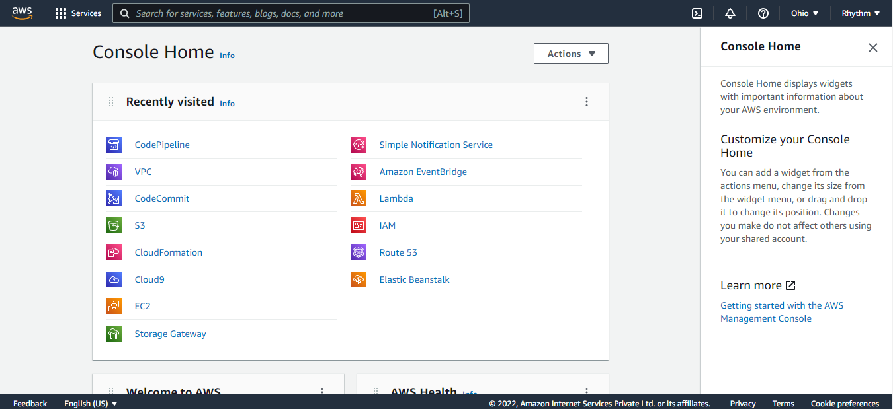

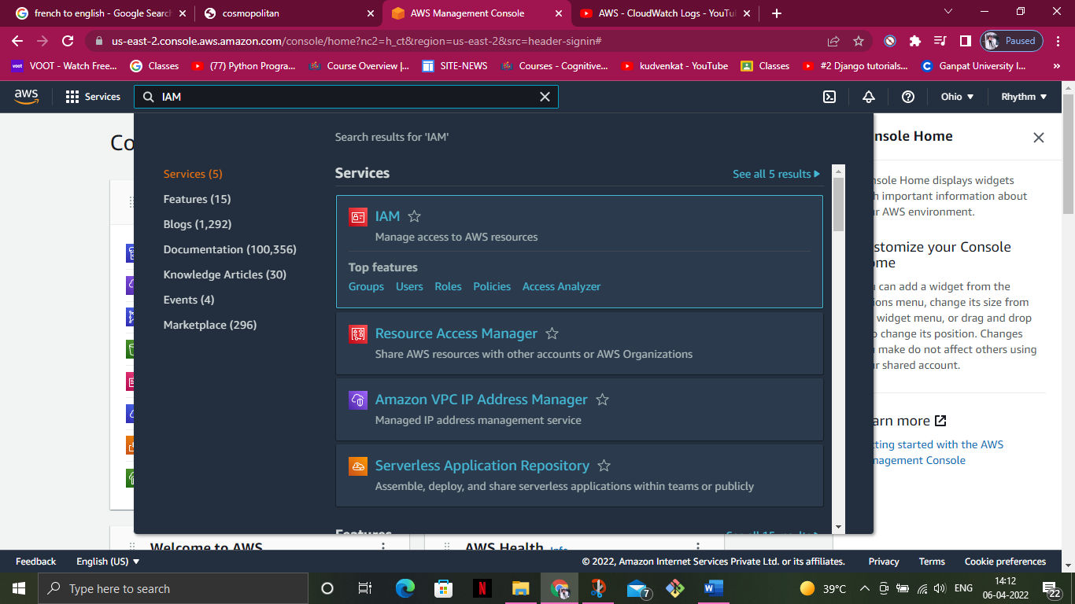

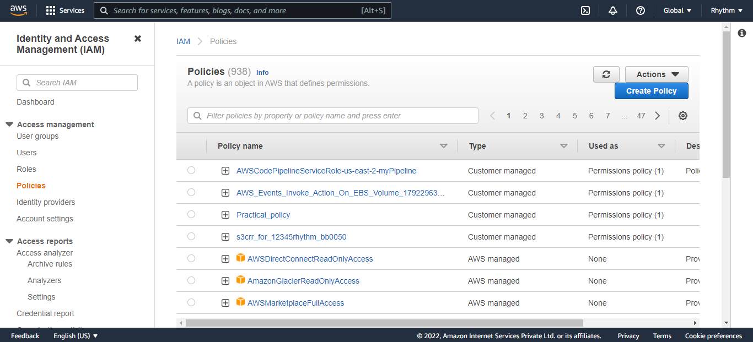

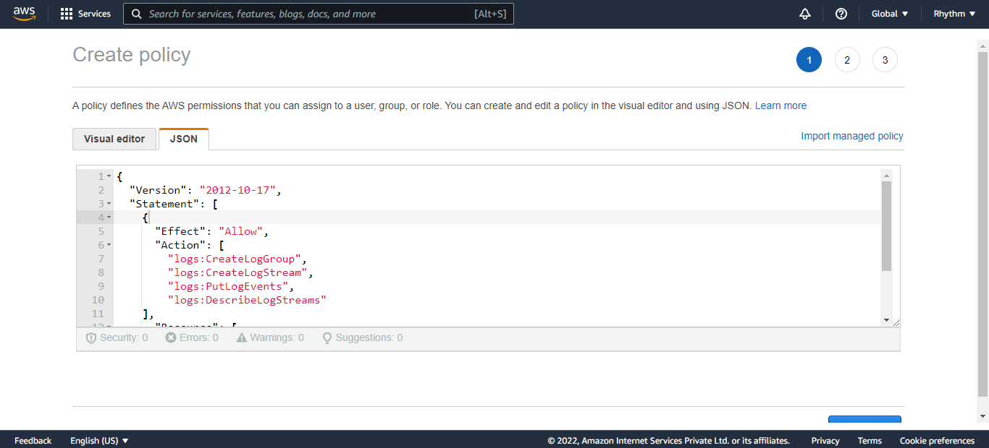

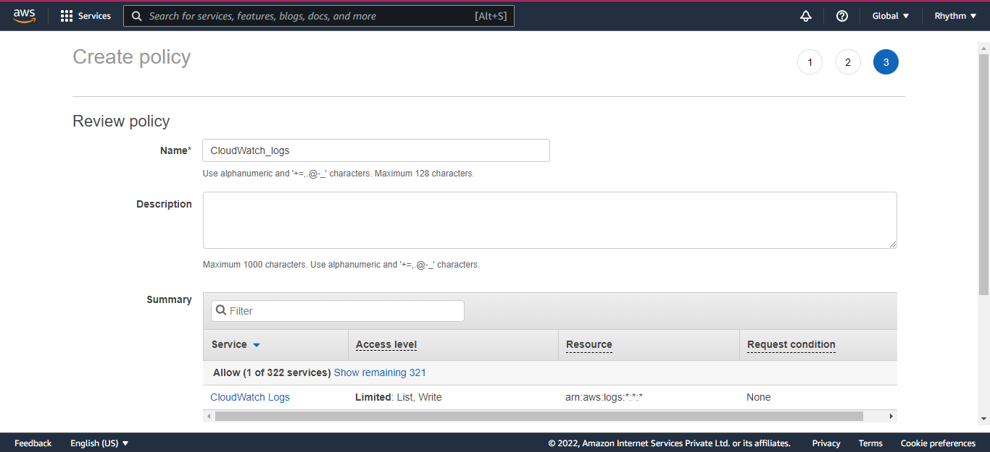

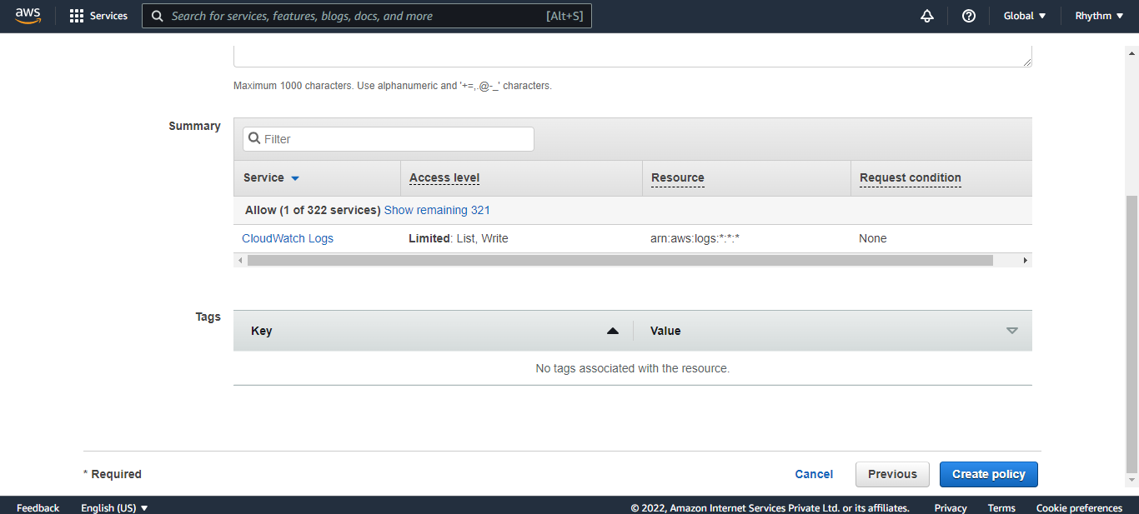

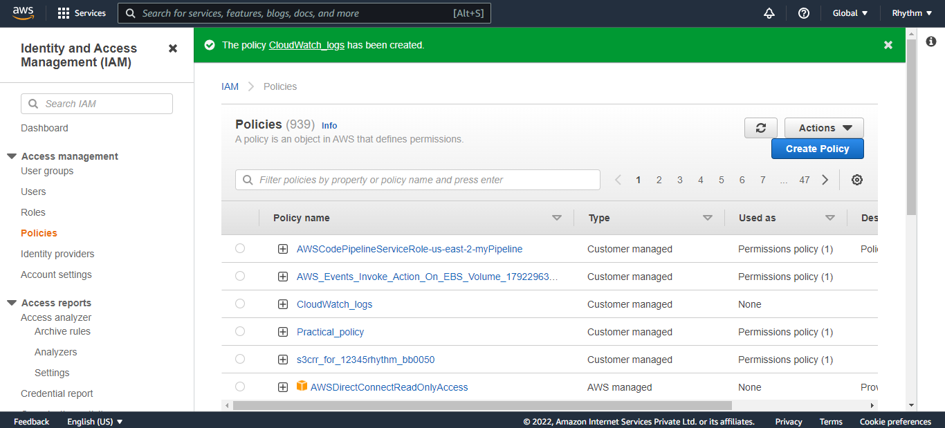

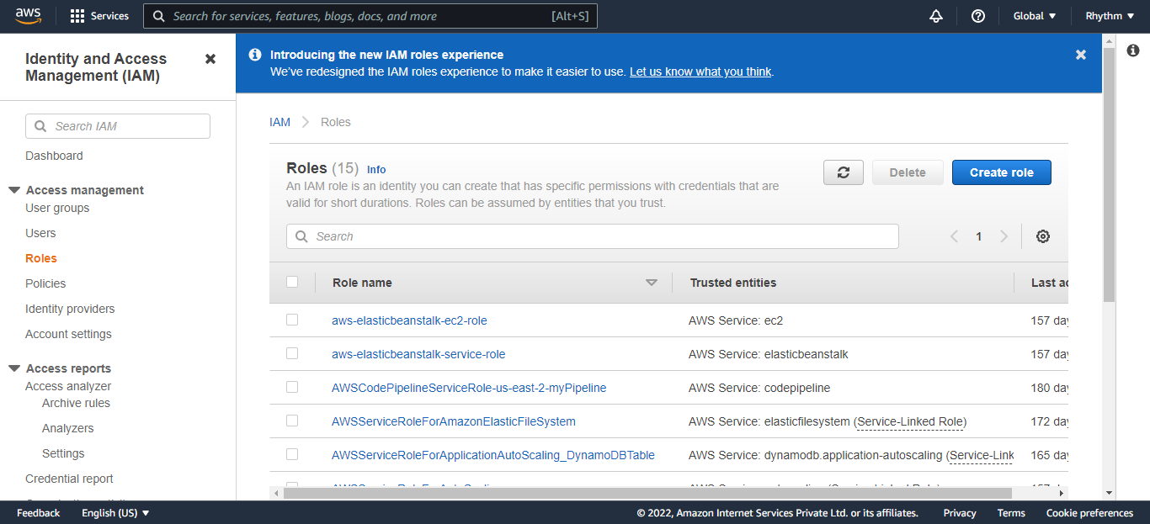

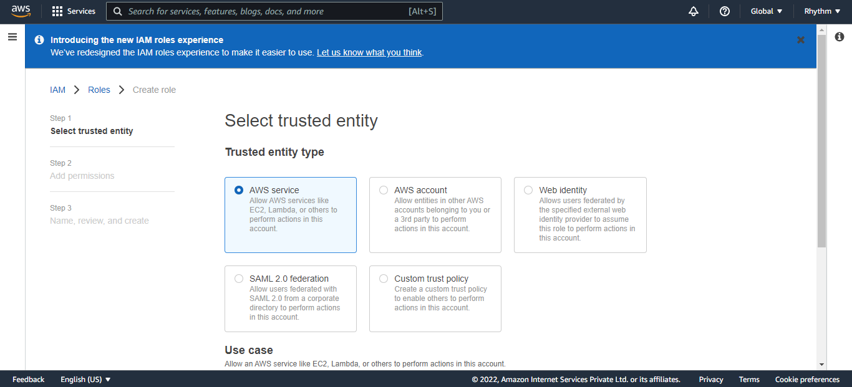

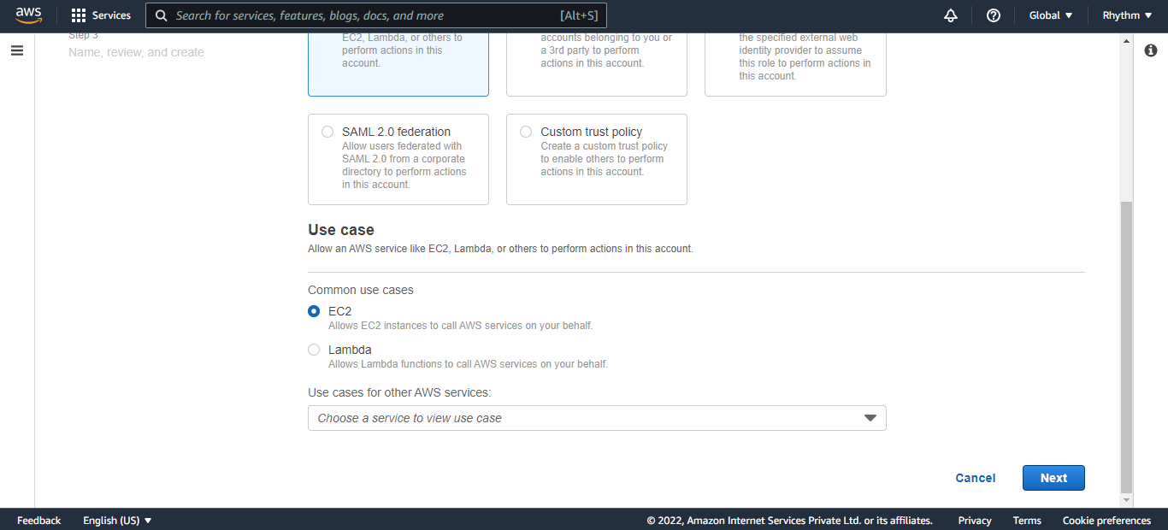

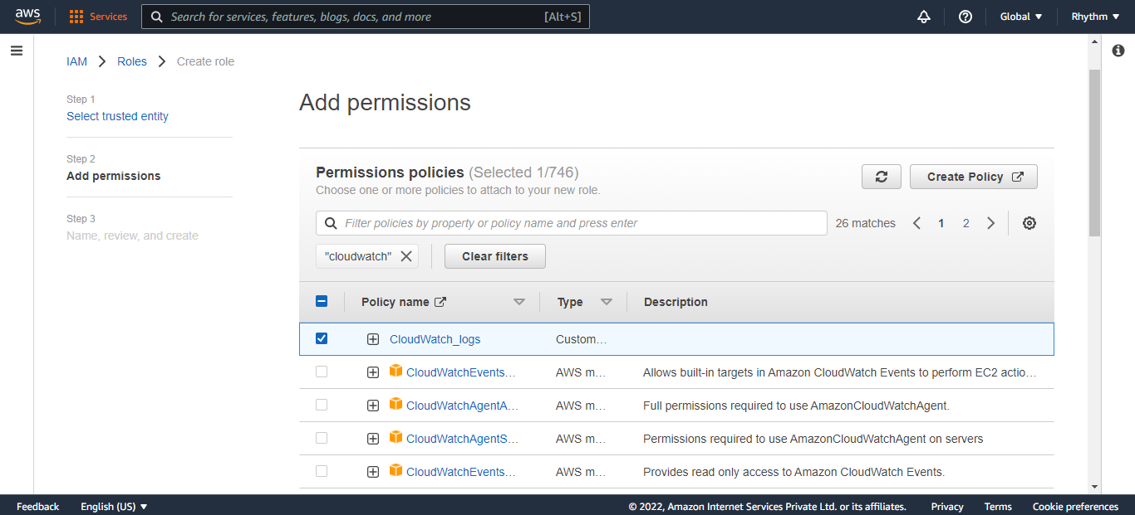

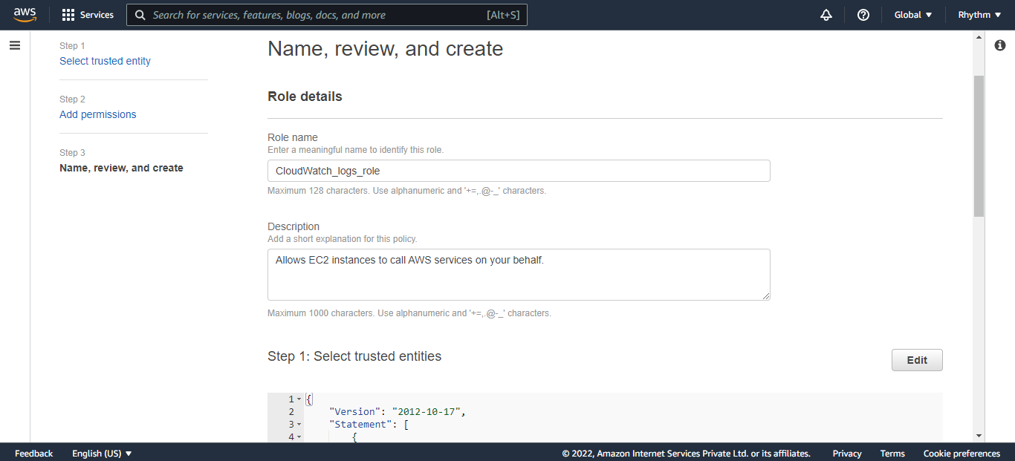

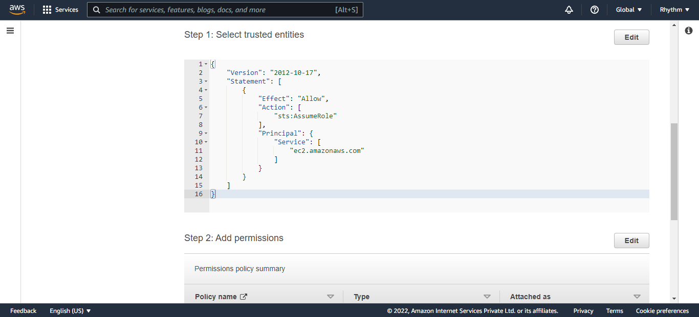

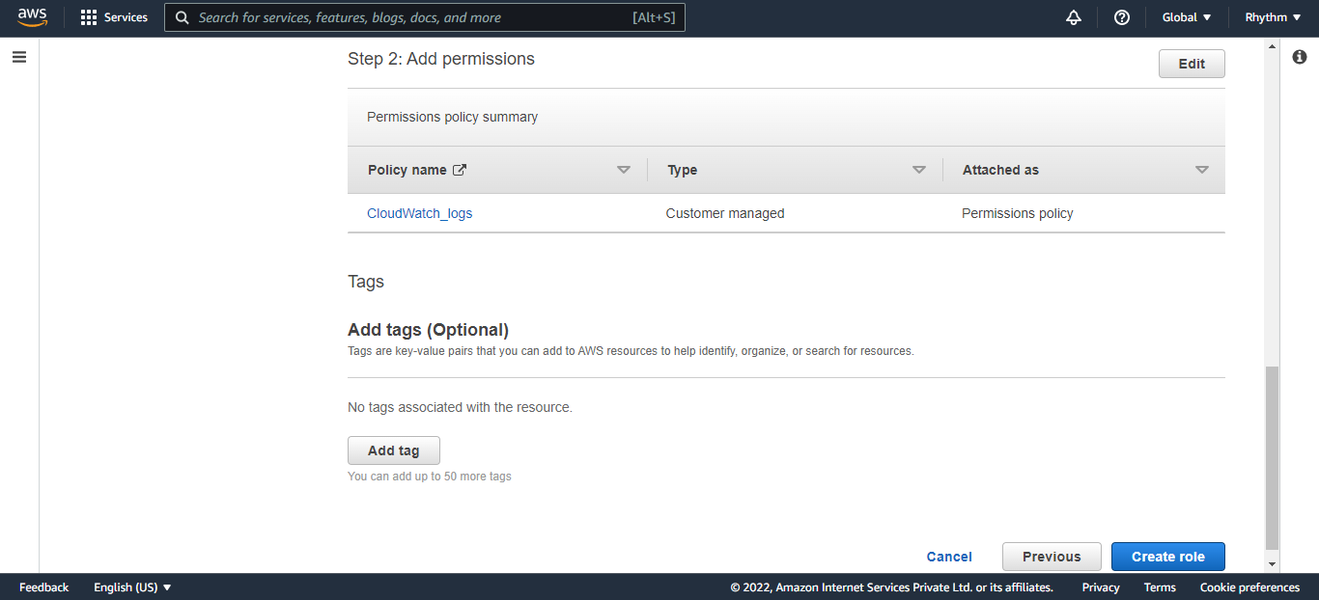

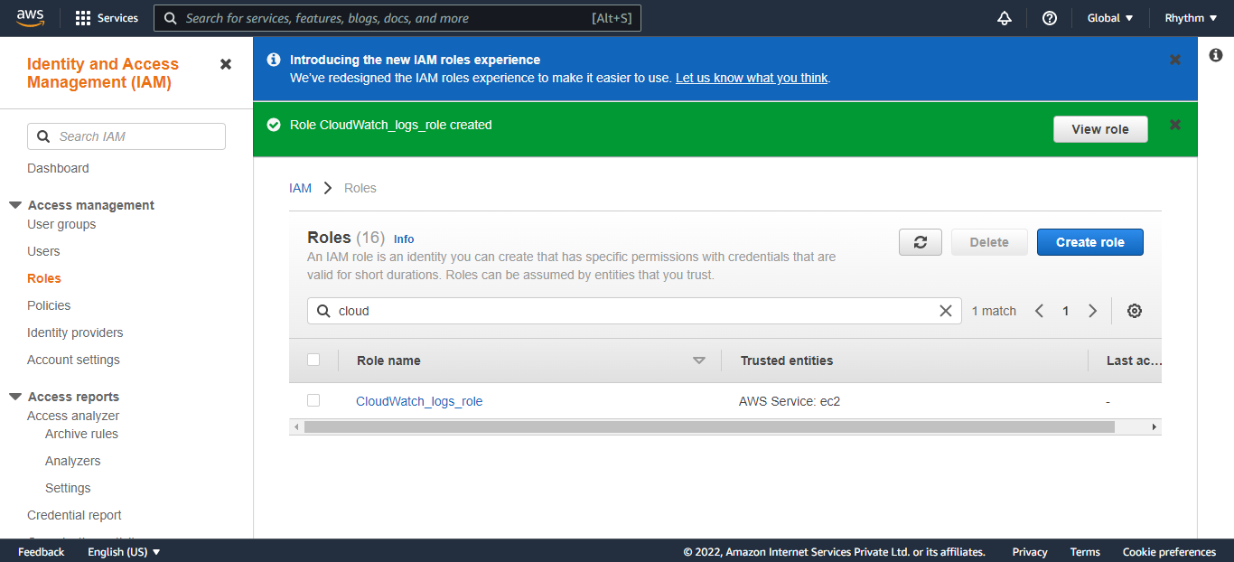

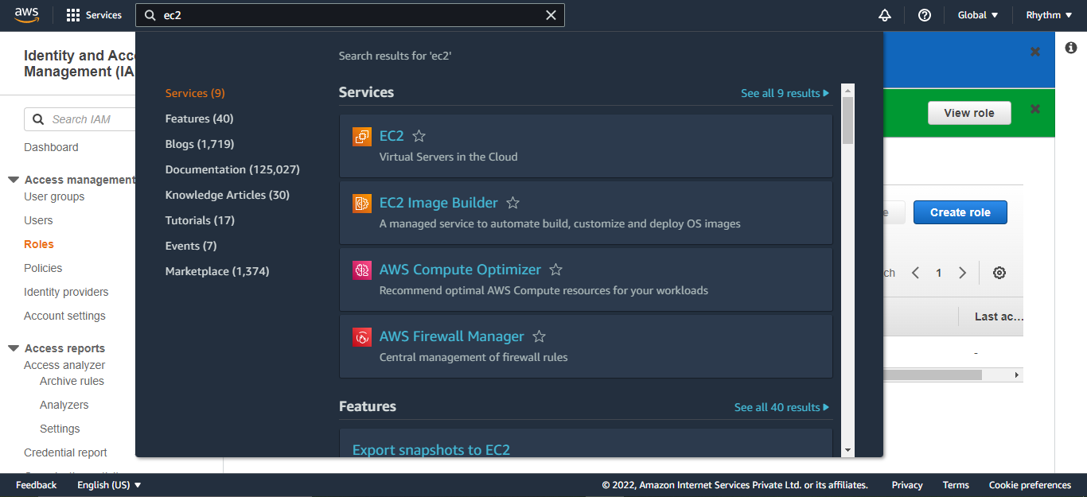

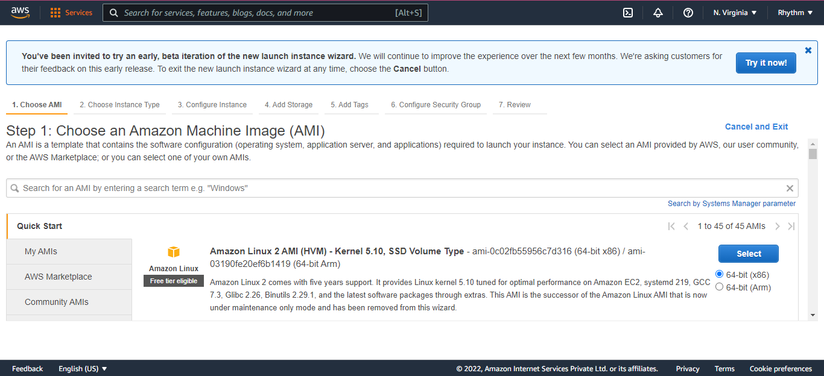

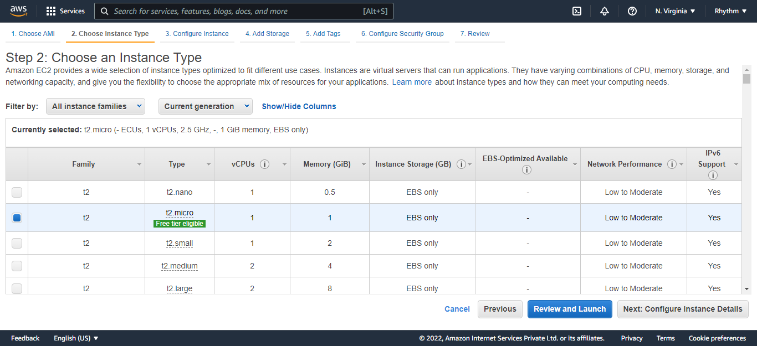

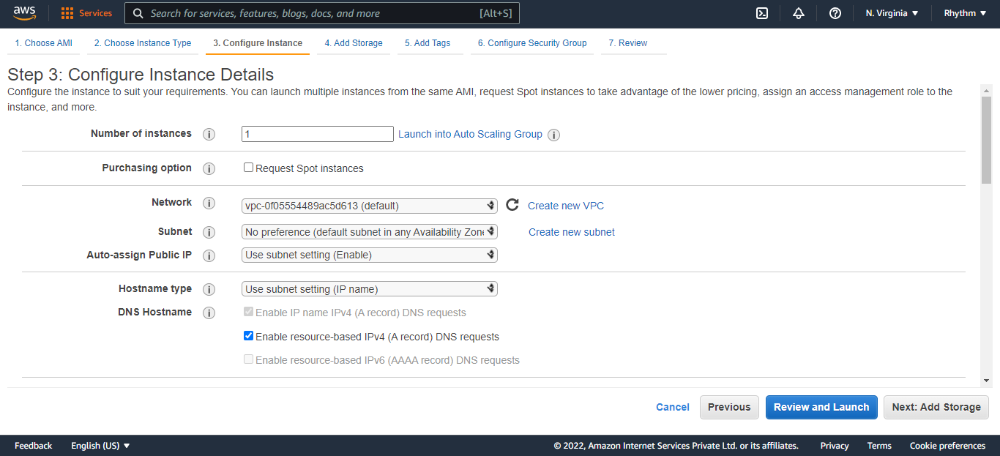

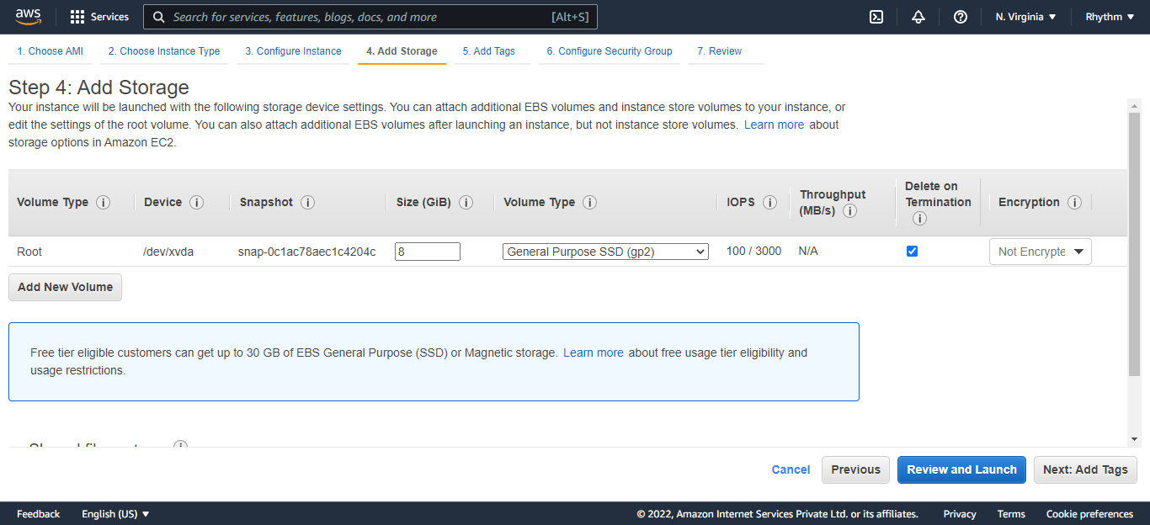

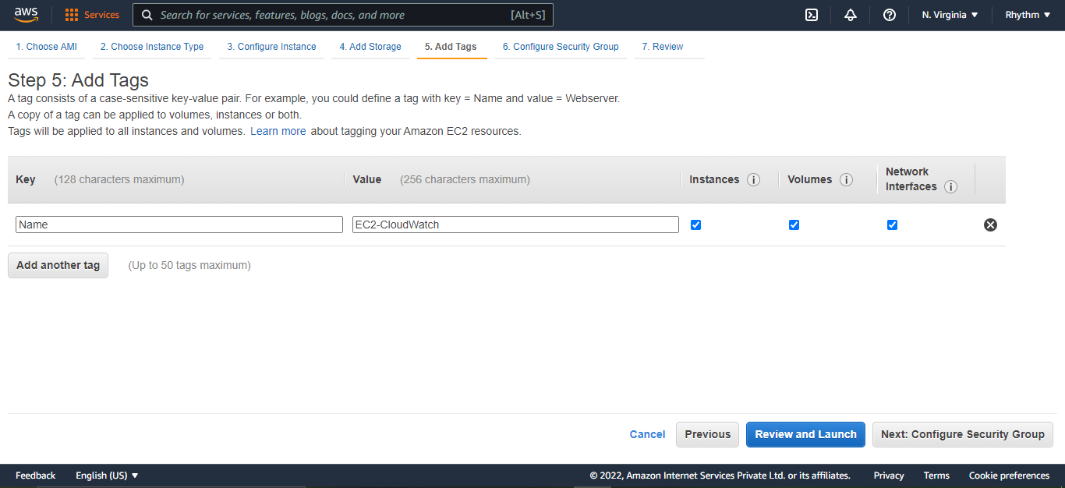

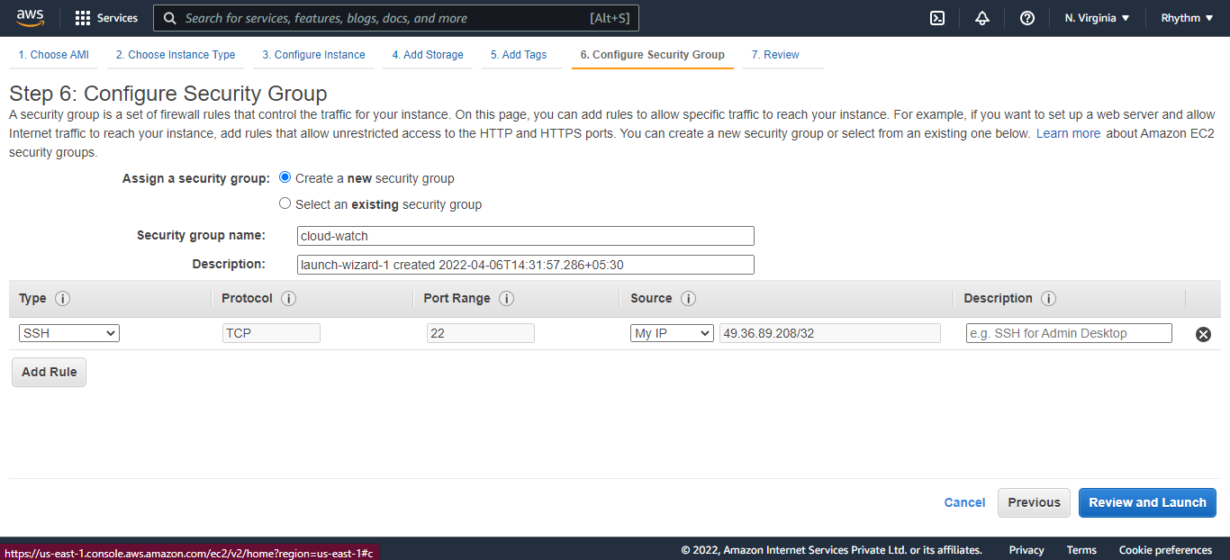

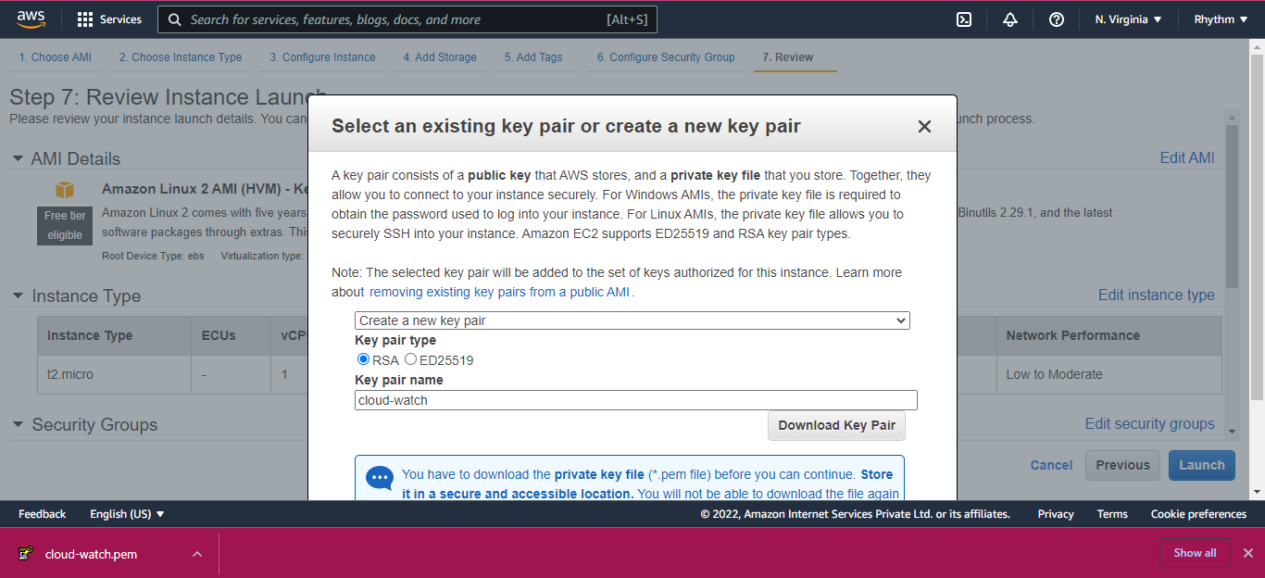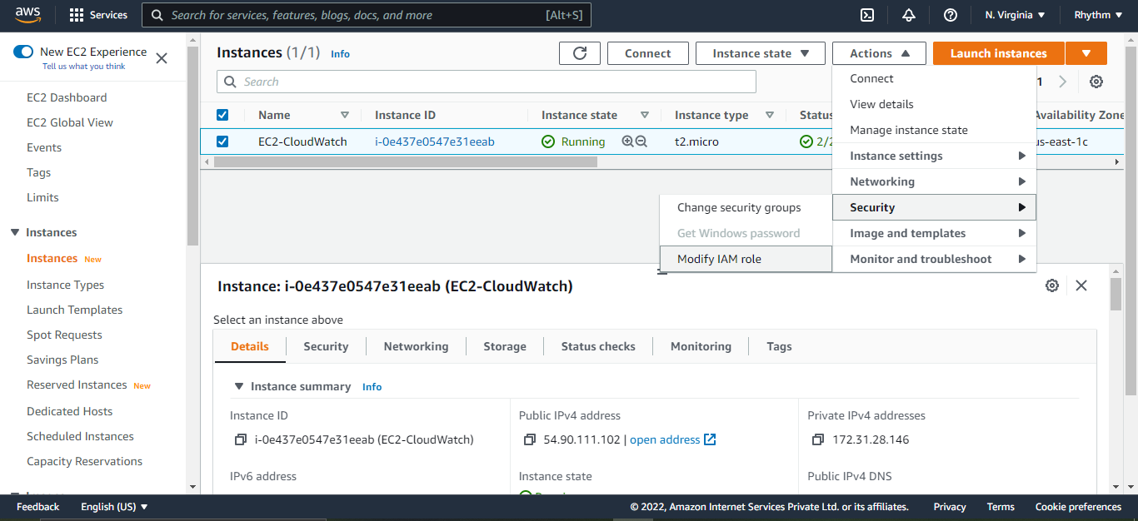

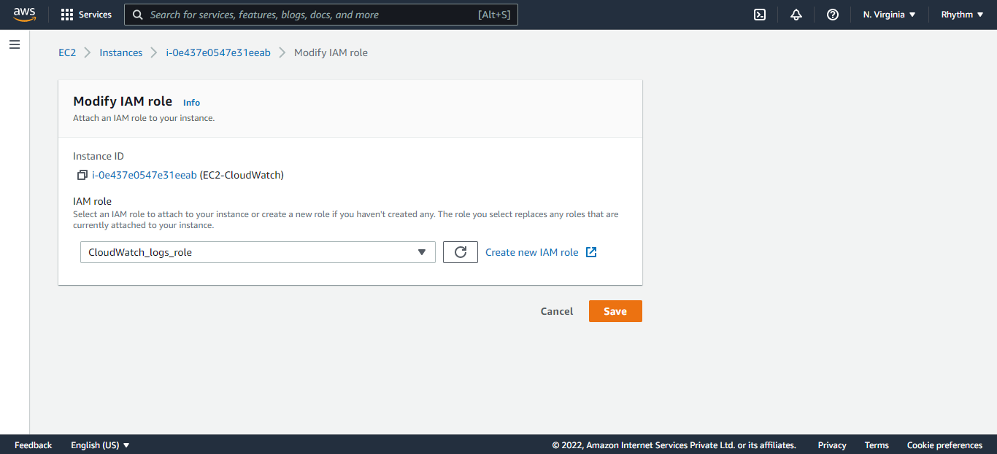

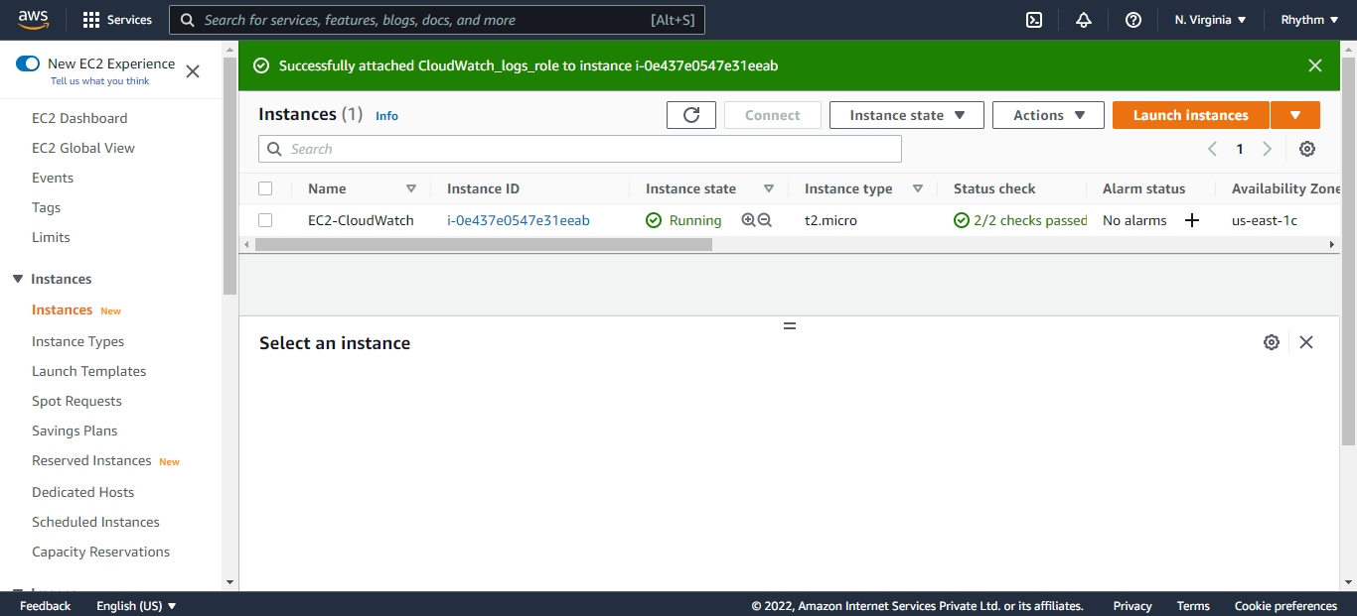

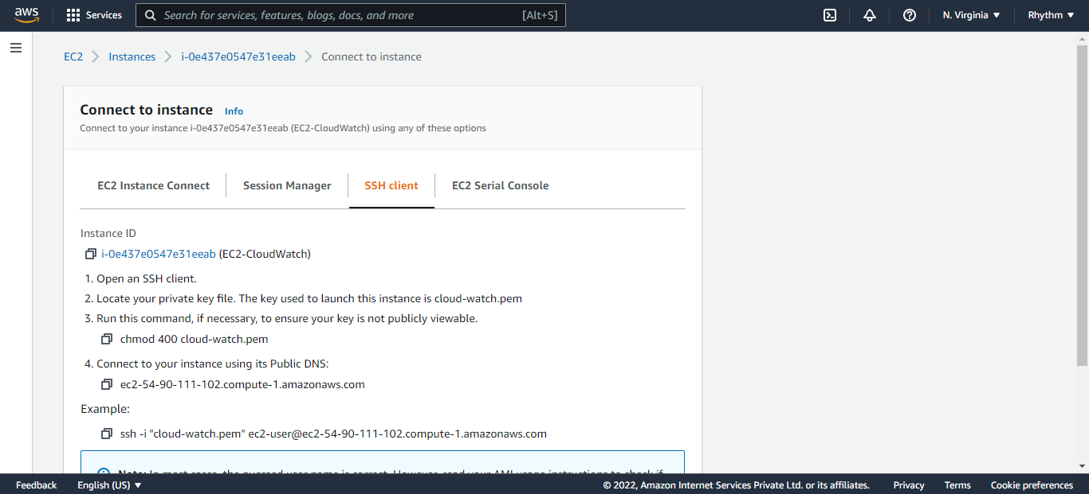

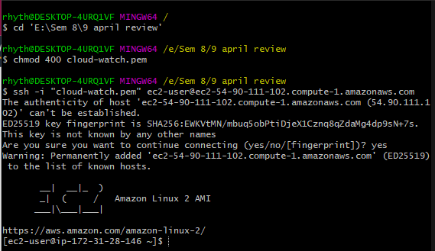

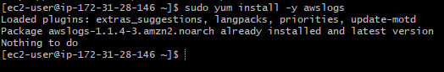







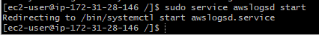

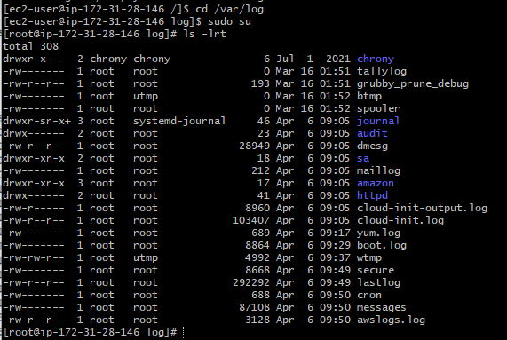

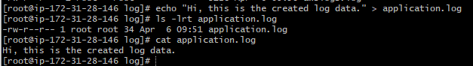

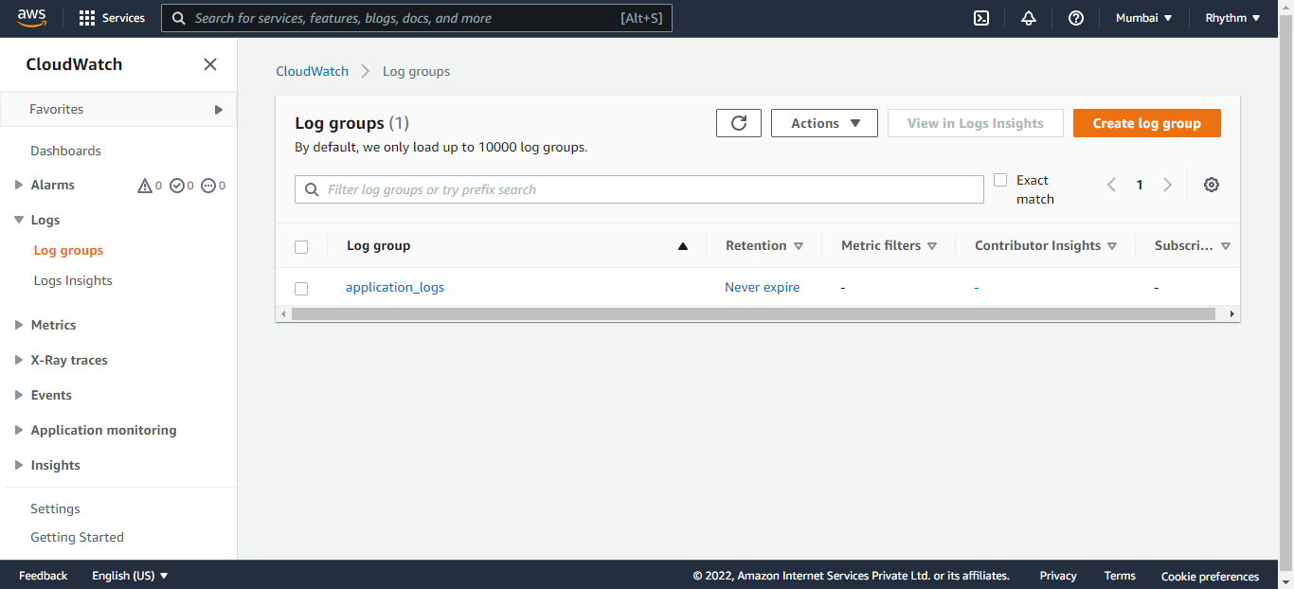

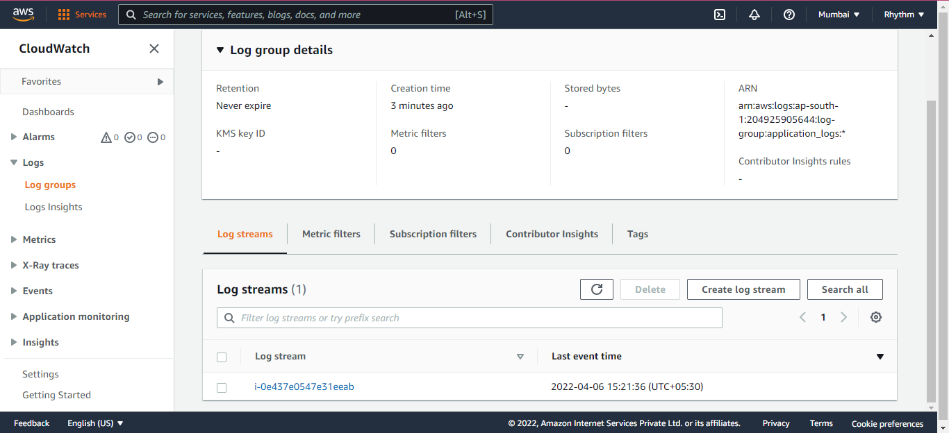

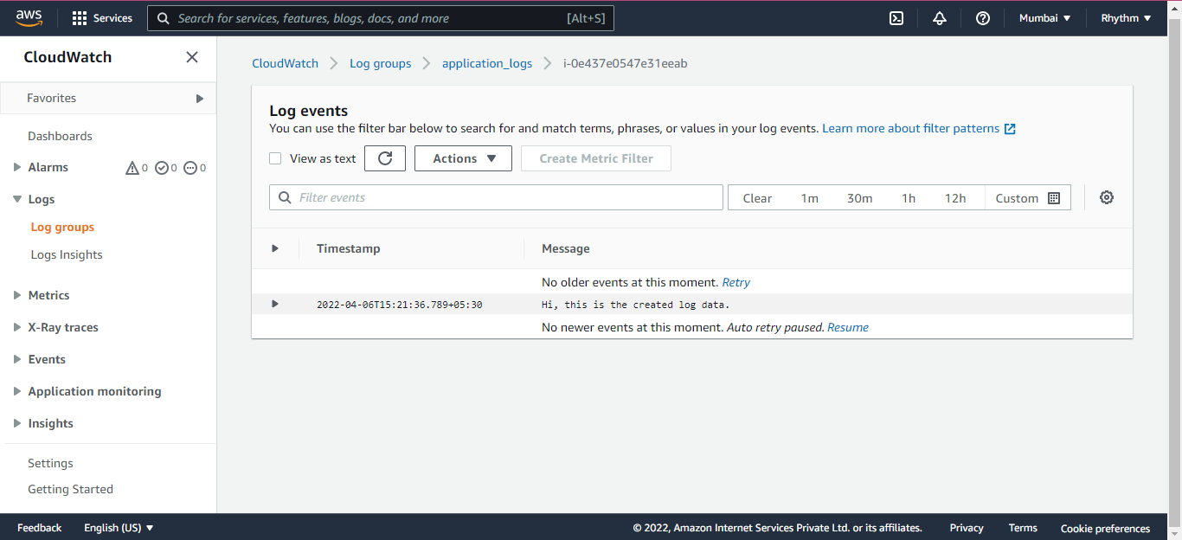

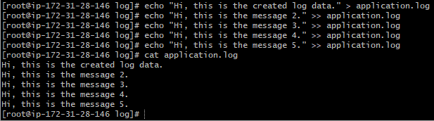

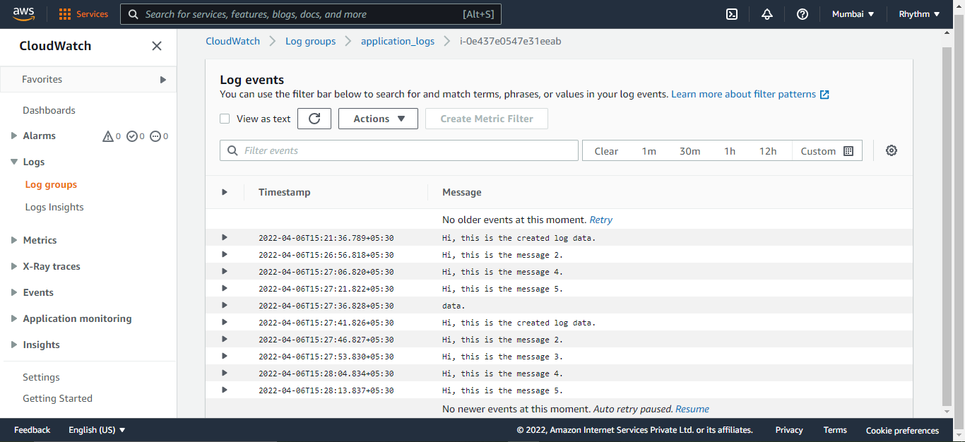

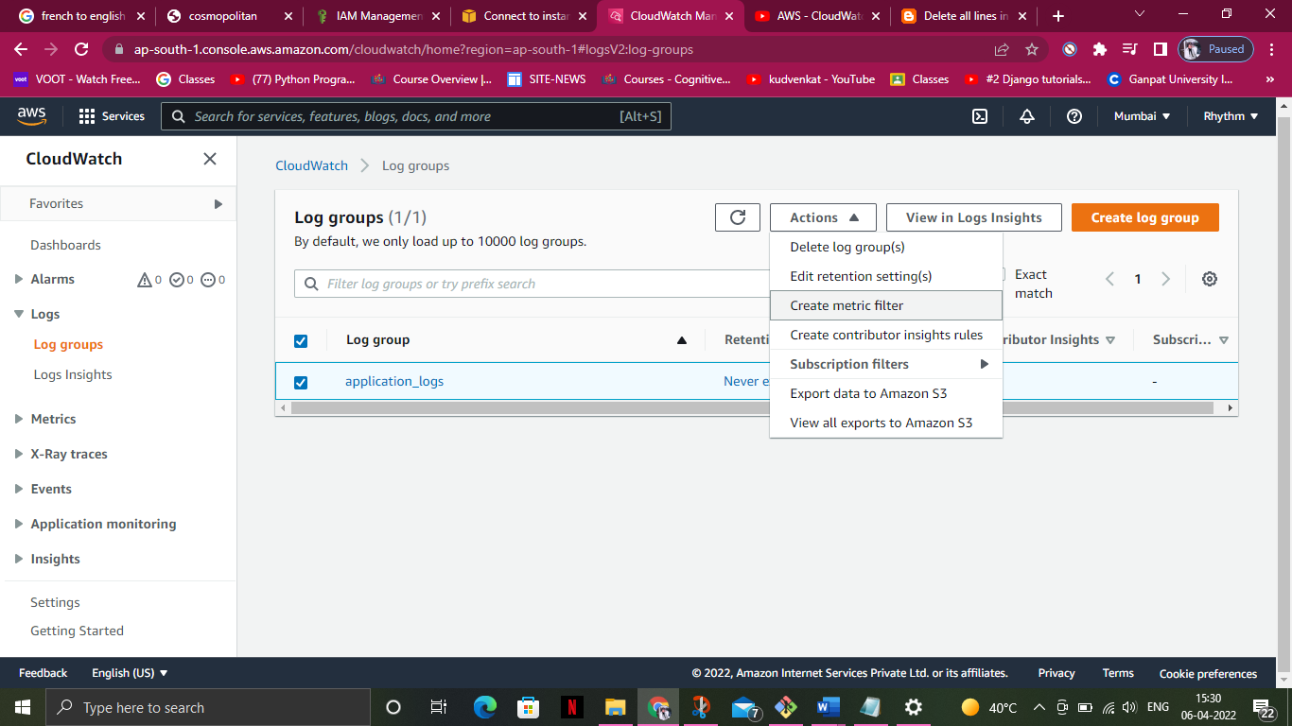

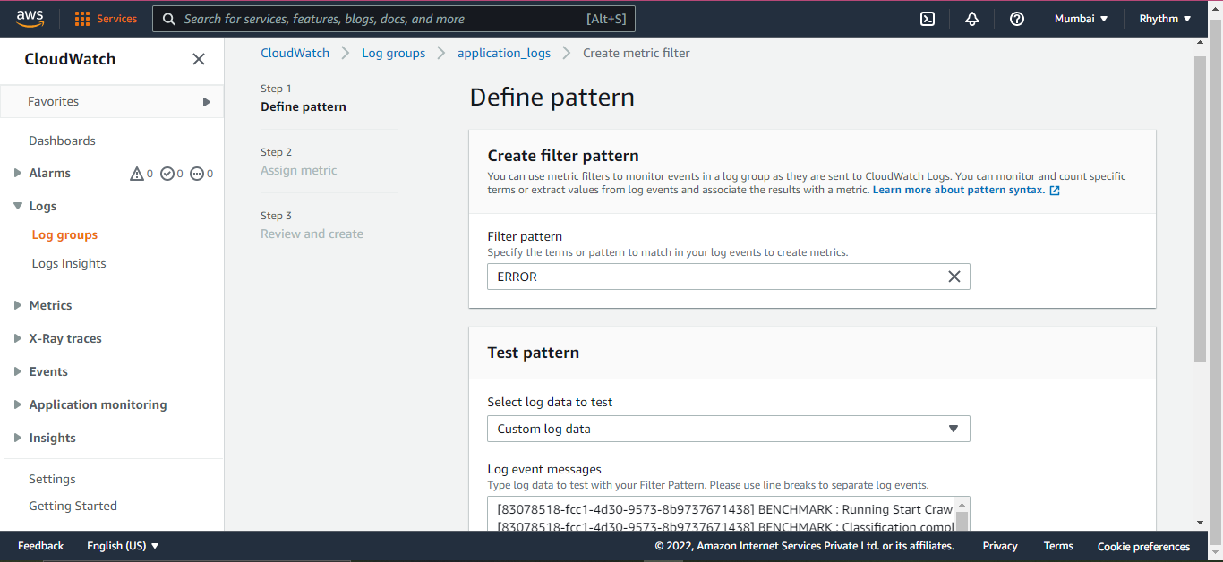

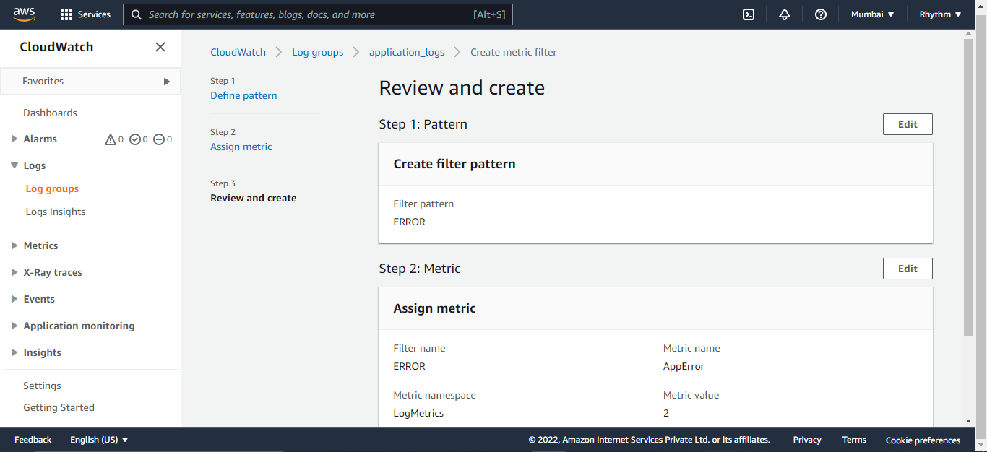

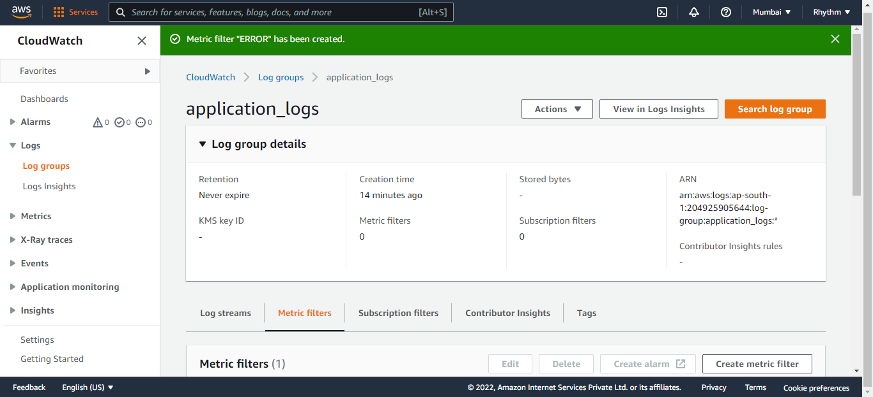

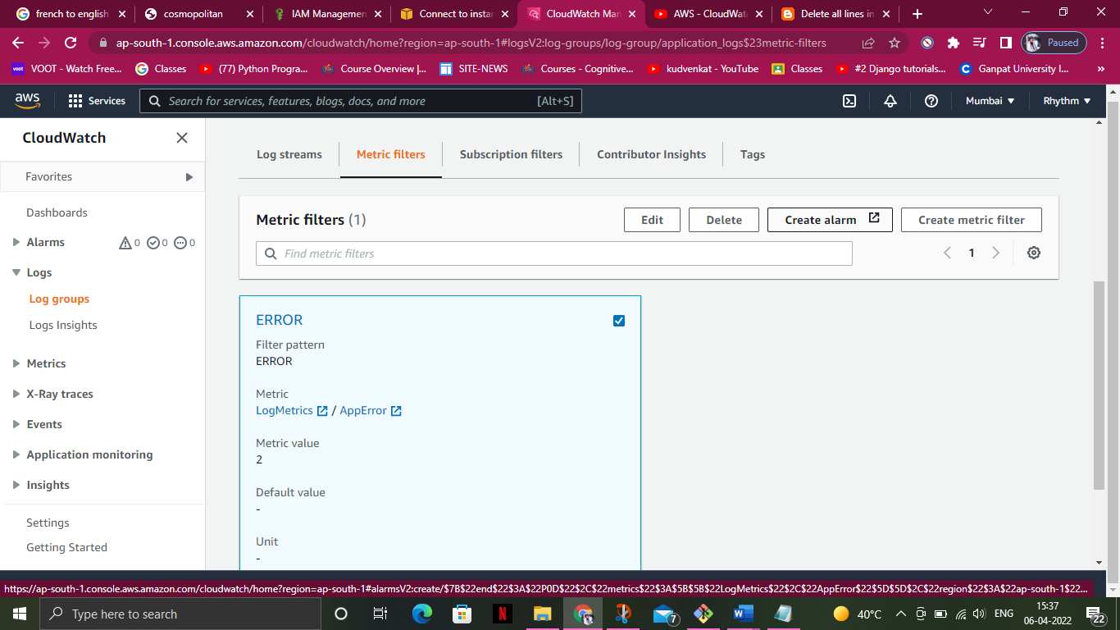

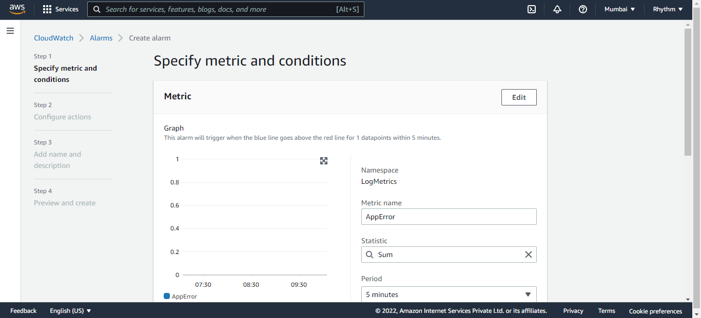

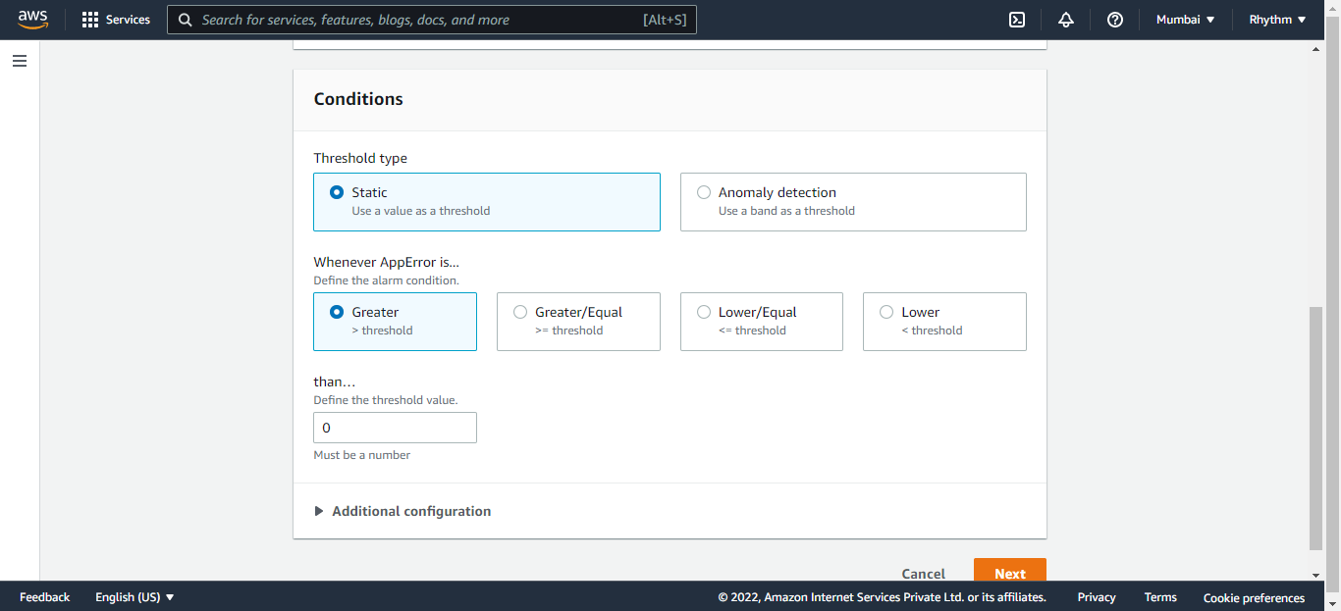

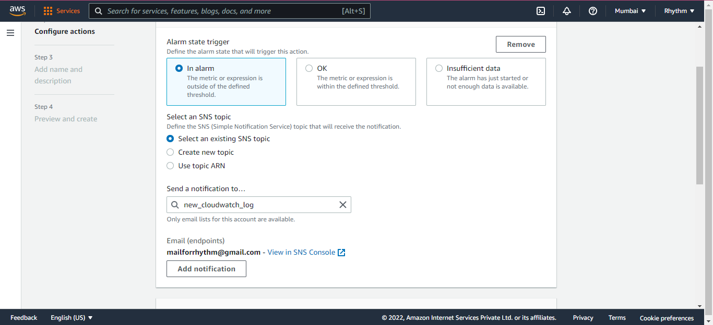

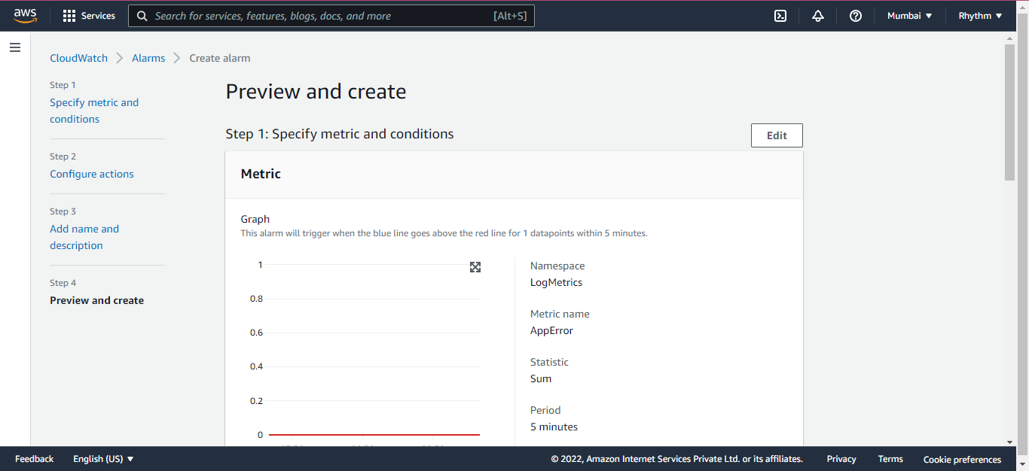

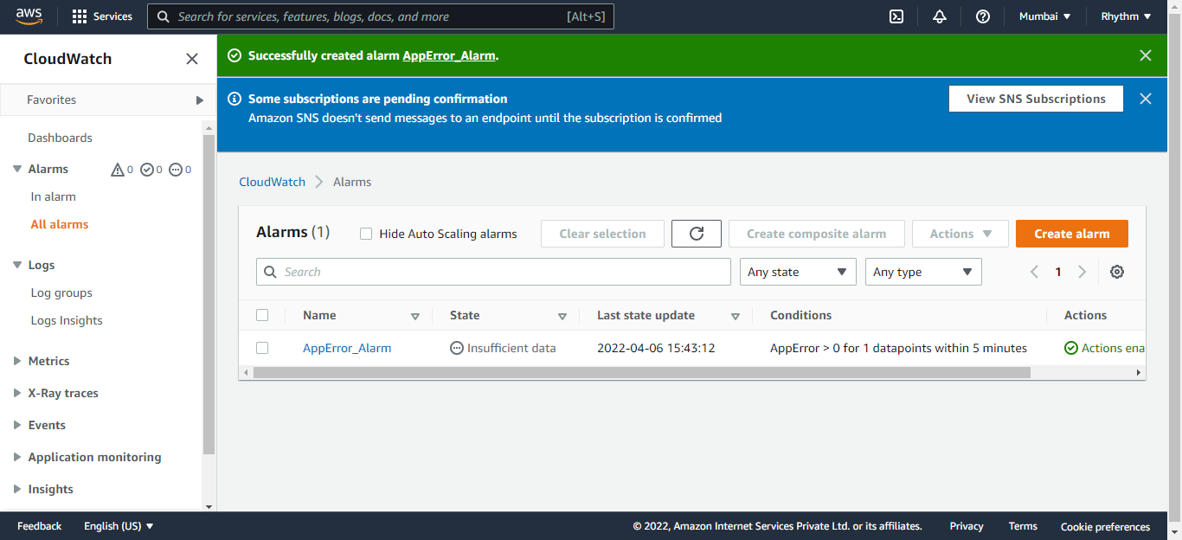

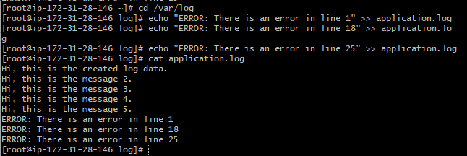

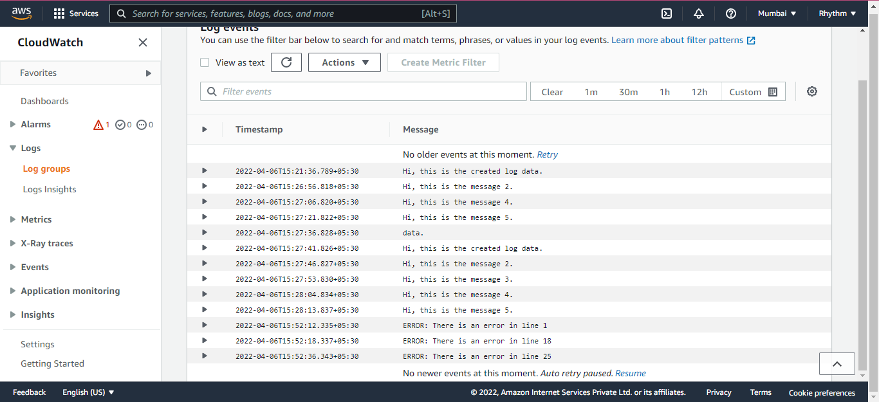

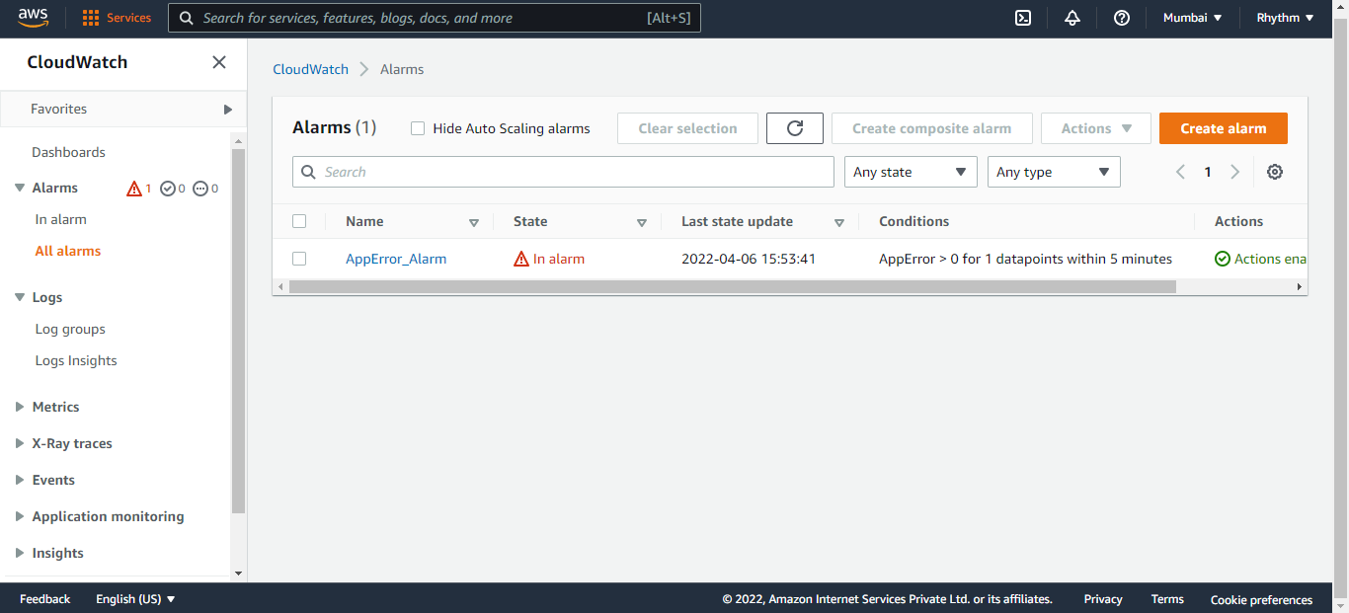

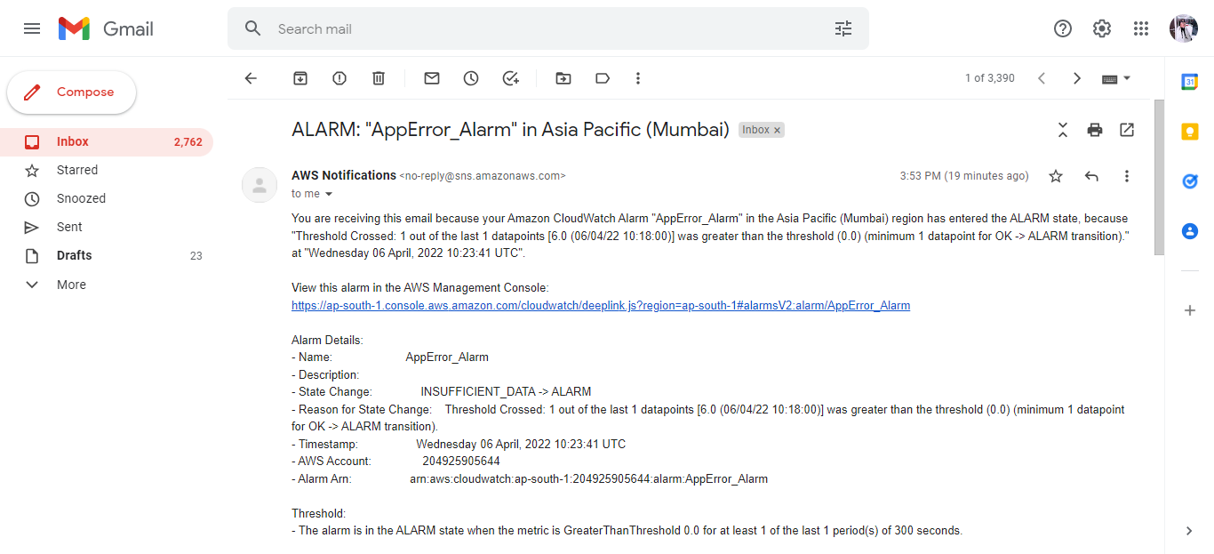

* 1. **Anomaly Detection in AWS for CPU Utilization**
* In this task we will perform the same anomaly detection, but this time the data used as logs will not be in the form of a text data rather it will be in the form of a graph of the CPU Utilization.
* Steps for the same are as follows 🡪

1. Login to your AWS console and go to EC2 service.
2. Create an EC2 instance with Amazon Linux AMI, instance type as t2.micro, other instance details as default, add tags and add a security group involving SSH protocol.
3. Click on Review and launch and it will provide you with a key pair, download it and save it as a place for later use and click on launch.
4. You will see that the instance is created, wait for the status to turn to running.
5. Once the instance is running, click on the instance and click on connect.
6. Open the git bash and give the respective commands to login to your instance.
7. Now go to the AWS console and click on CloudWatch service. Go to the metrics tab.
8. At the bottom of the page click on EC2 to connect it to an EC2 instance and click on per-instance metrics.
9. Select anomaly detection for CPU Utilization and let it collect the data.
10. Now click on alarm button to create an alarm to get a notification whenever the CPU utilization increases to a particular extent.
11. Give the metric name, select threshold type as anomaly detection, and select the condition of CPU utilization as per your convenience.
12. Set anomaly detection threshold as 2. Click on next. Select alarm state trigger as ‘in alarm’ and select an existing SNS topic or create one if it is not available.
13. Click on create new topic, give it a name, give the mail ID on which you need to get the alarm notification. Once the topic is created, go to your mail and confirm the subscription.
14. Then give the alarm name and click on create.
15. Once the alarm is successfully created, all you need to do is gather some amount of data so that the system is able to detect the anomaly from that data.
16. So next we will login to our instance and install some packages and give some commands to put some major amount of stress on CPU.
17. We will leave the instance working for a few hours in order to gather required amount of data.
18. Once the graph of the CPU utilization will find an anomaly it will show an alarm and also it will give a mail notification that CPU utilization has exceeded the given limit.

**Execution of the above Steps 🡪**

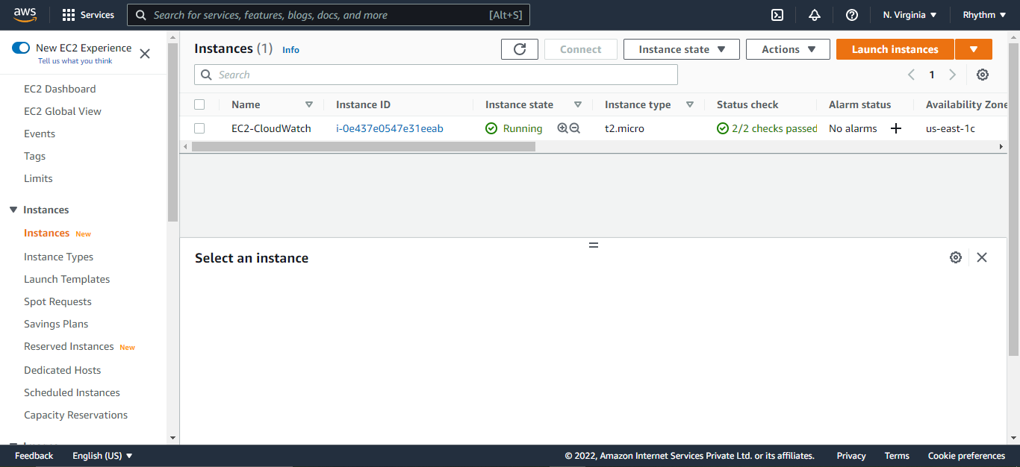

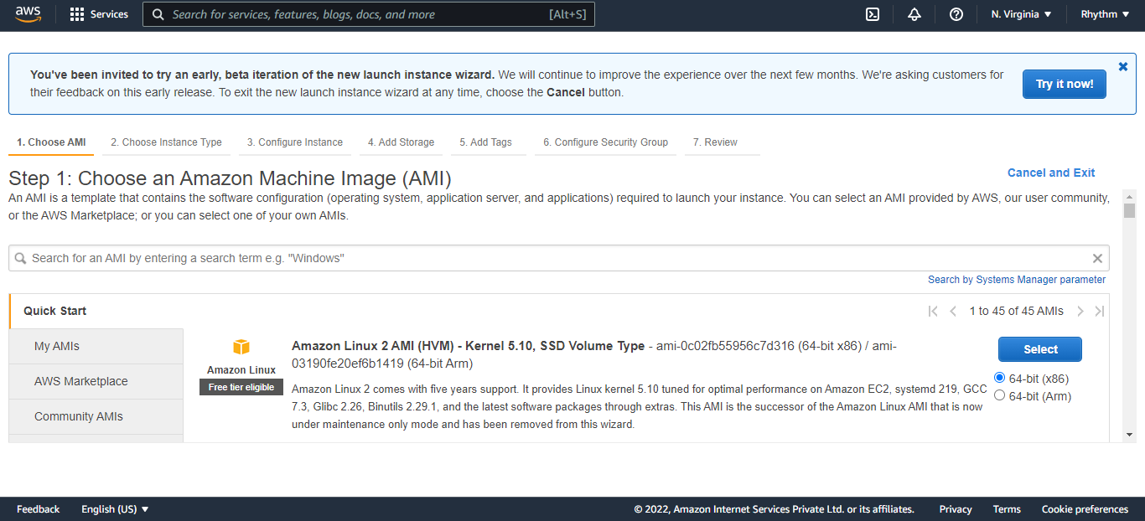

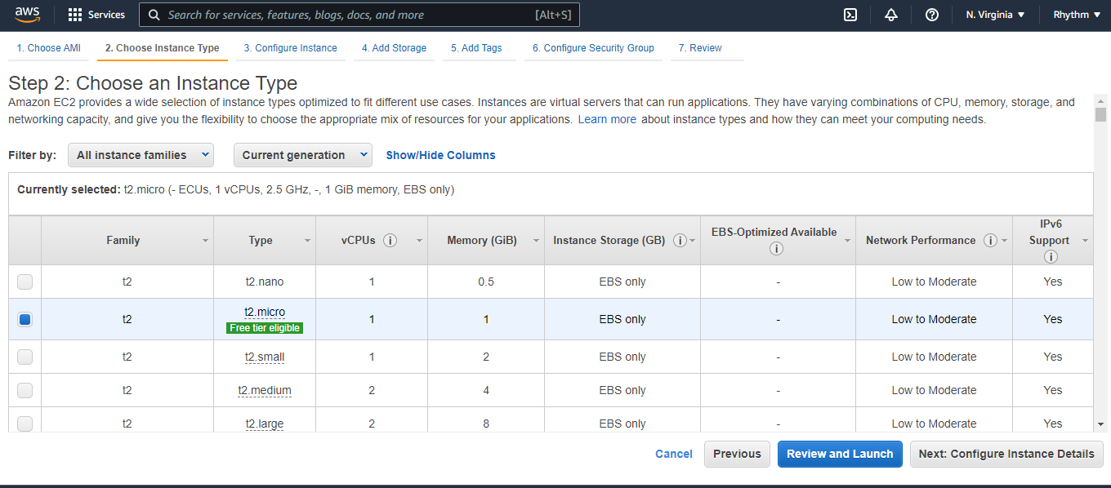

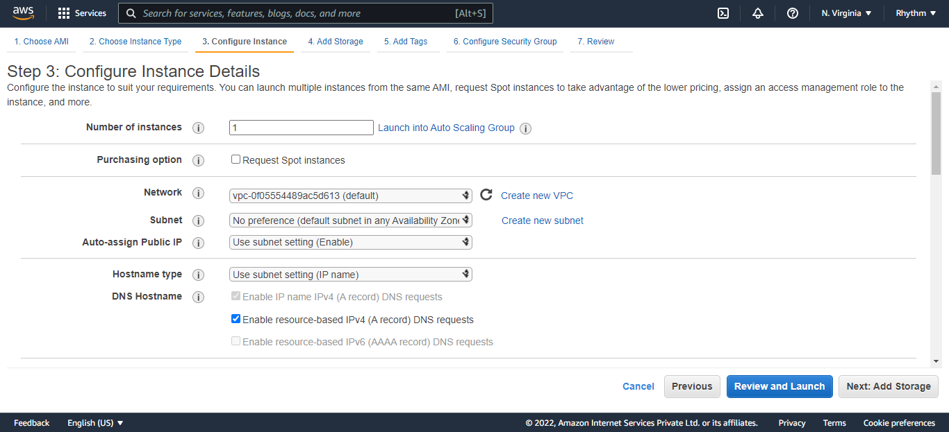

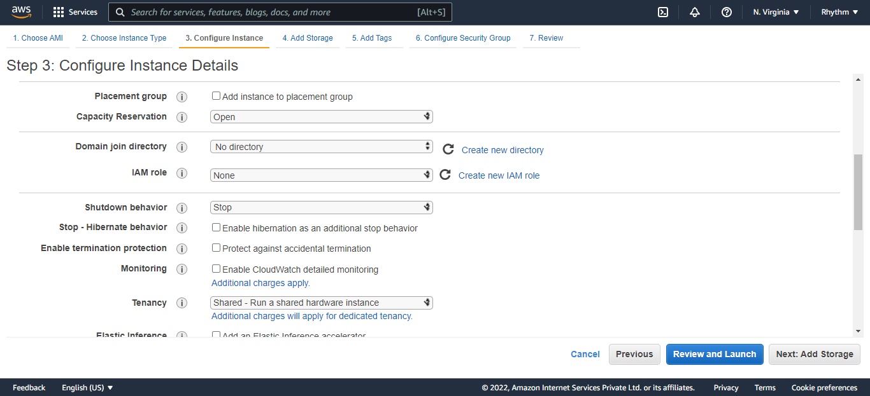

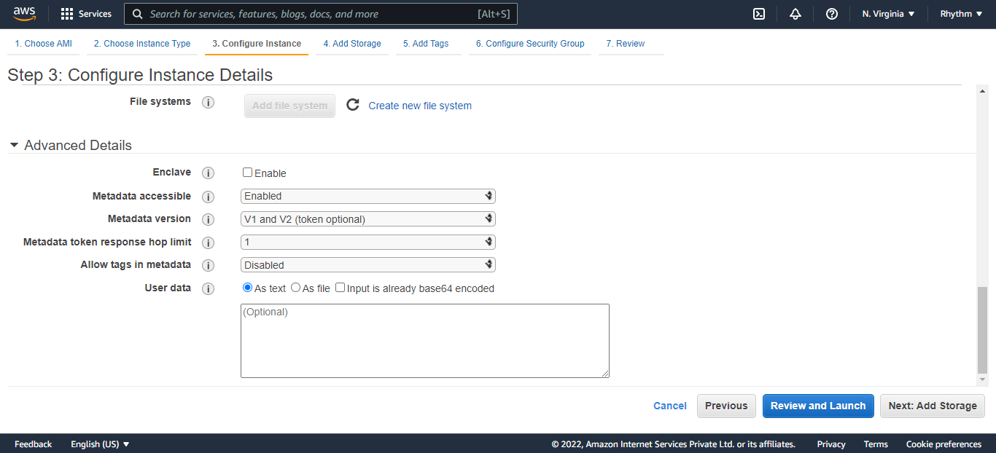

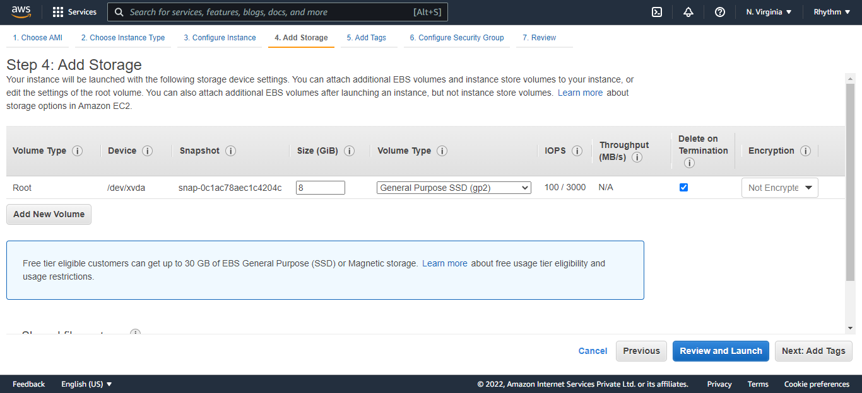

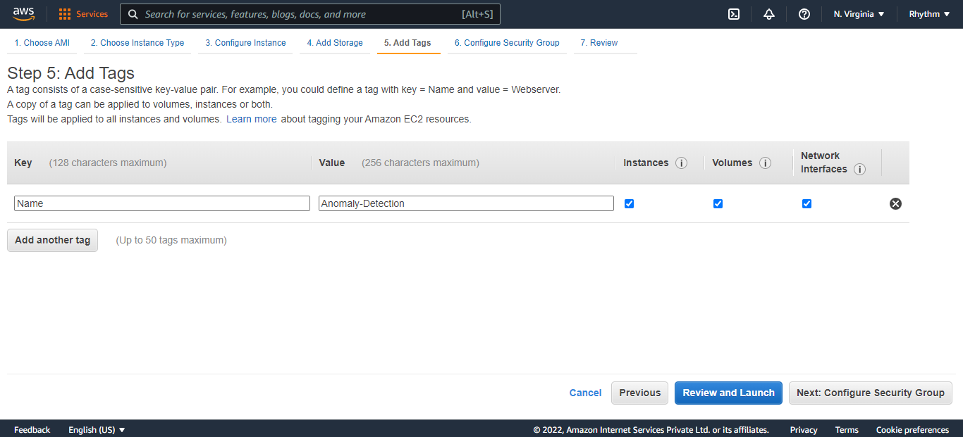

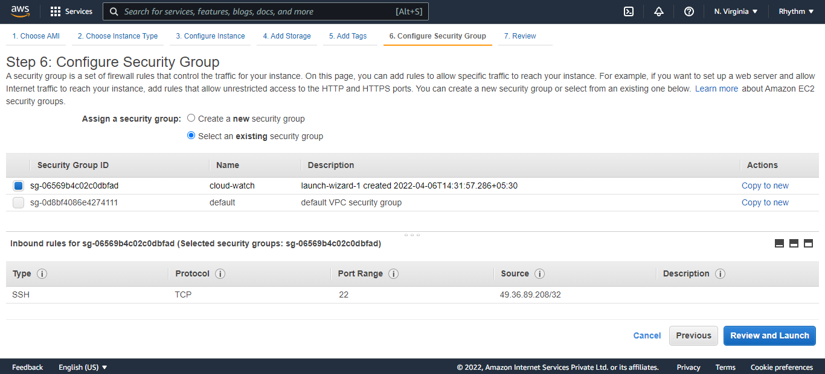

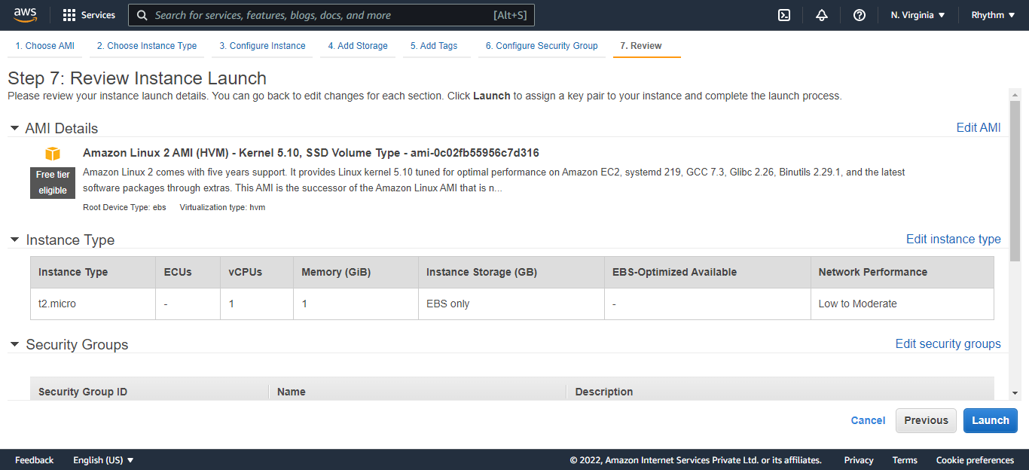

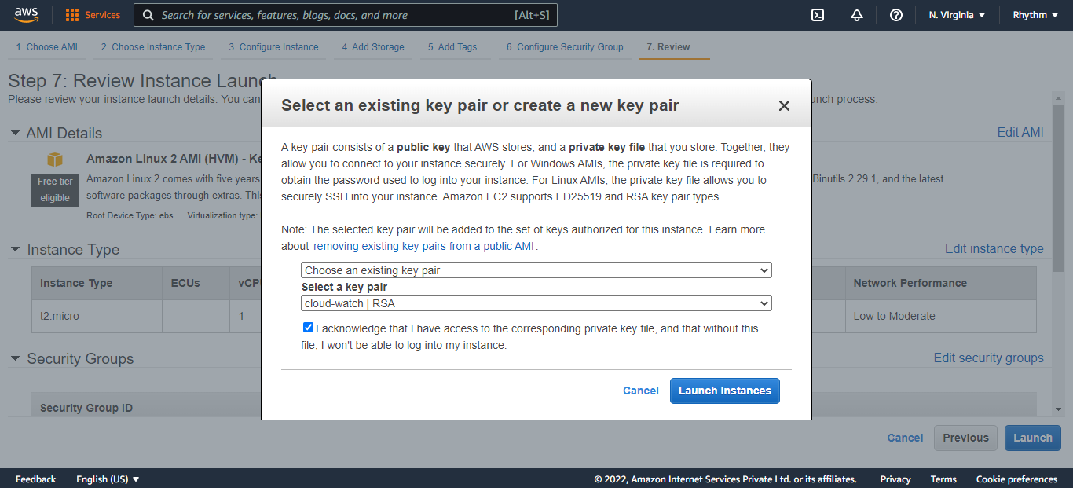

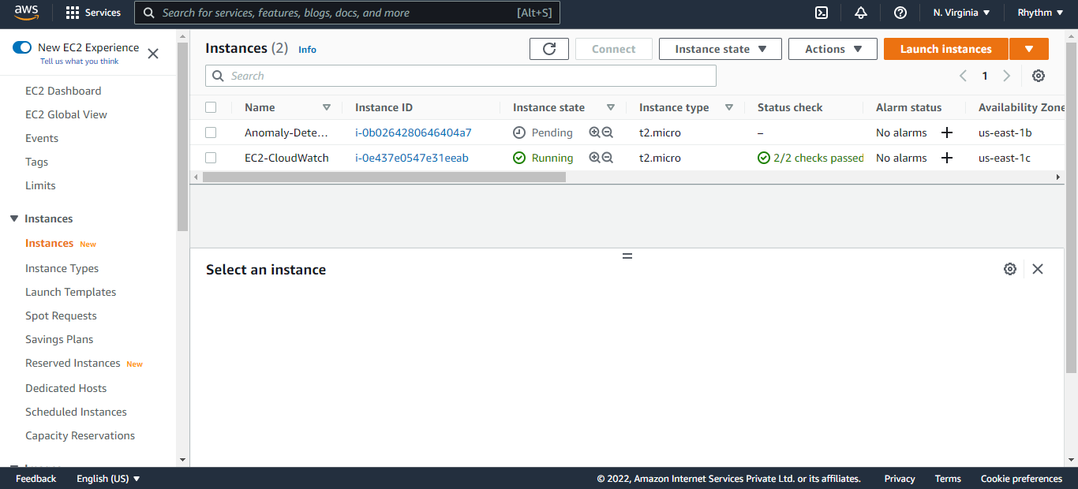

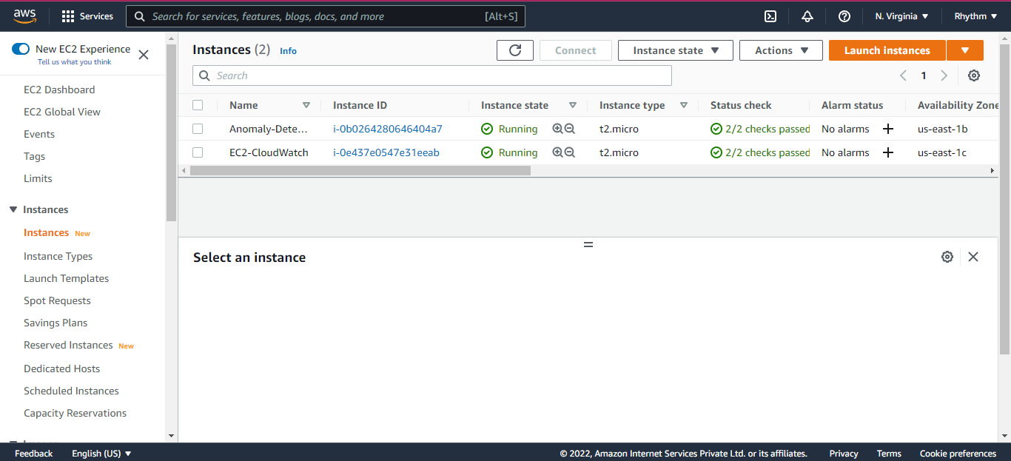

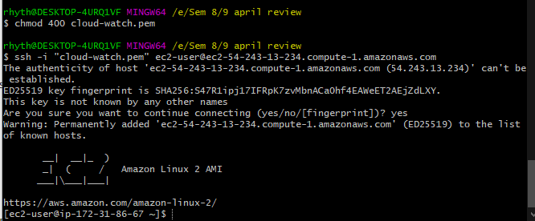

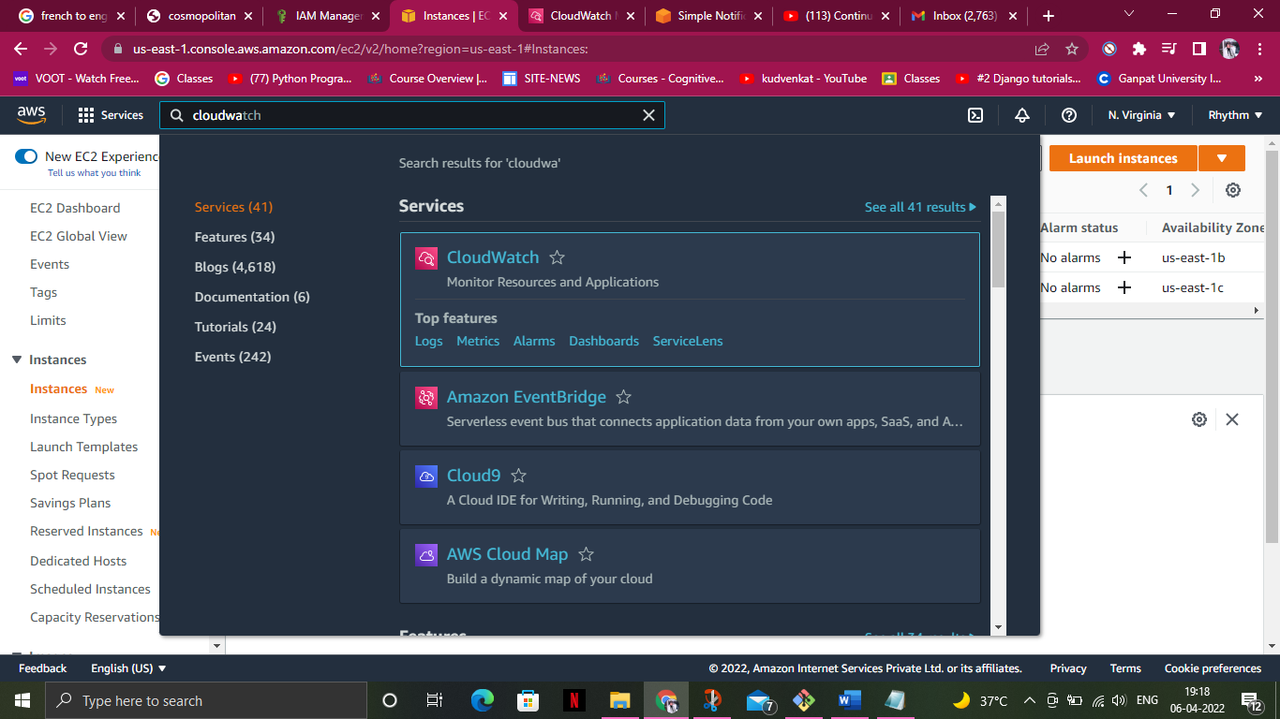

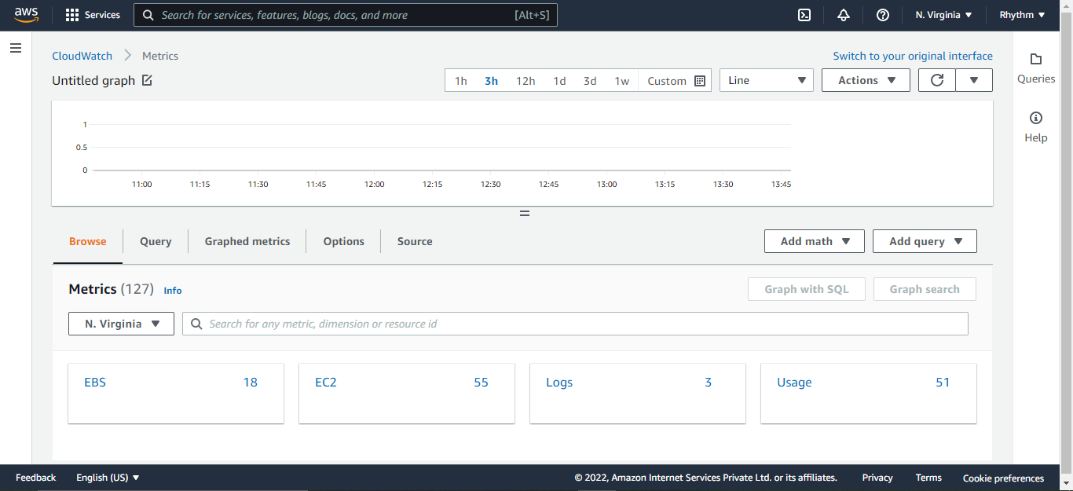

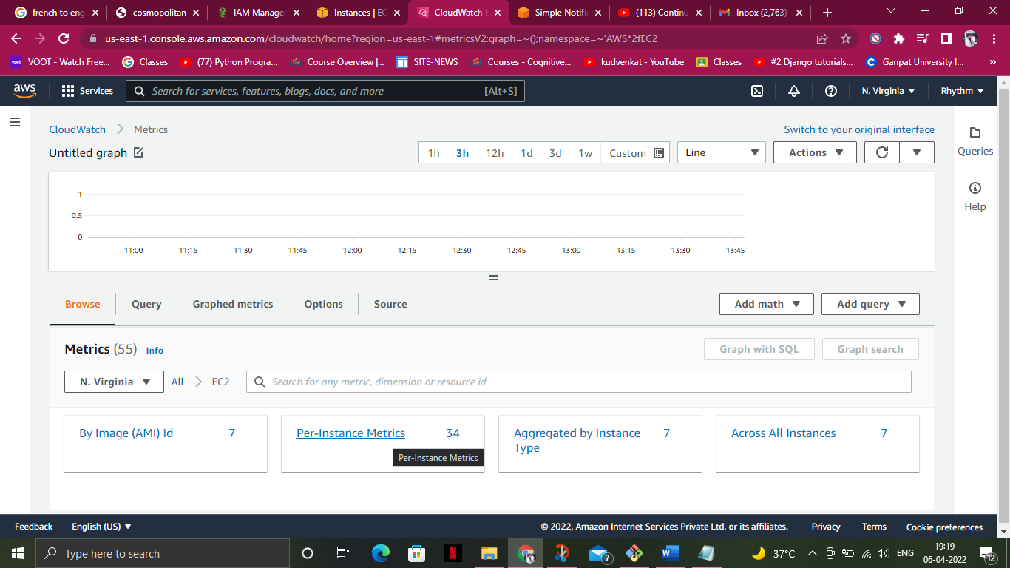

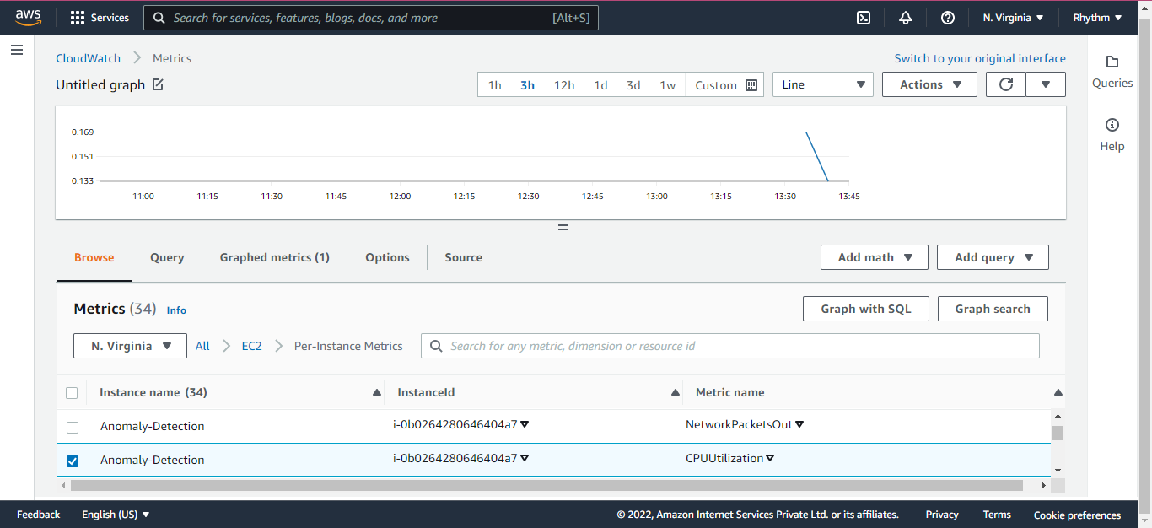

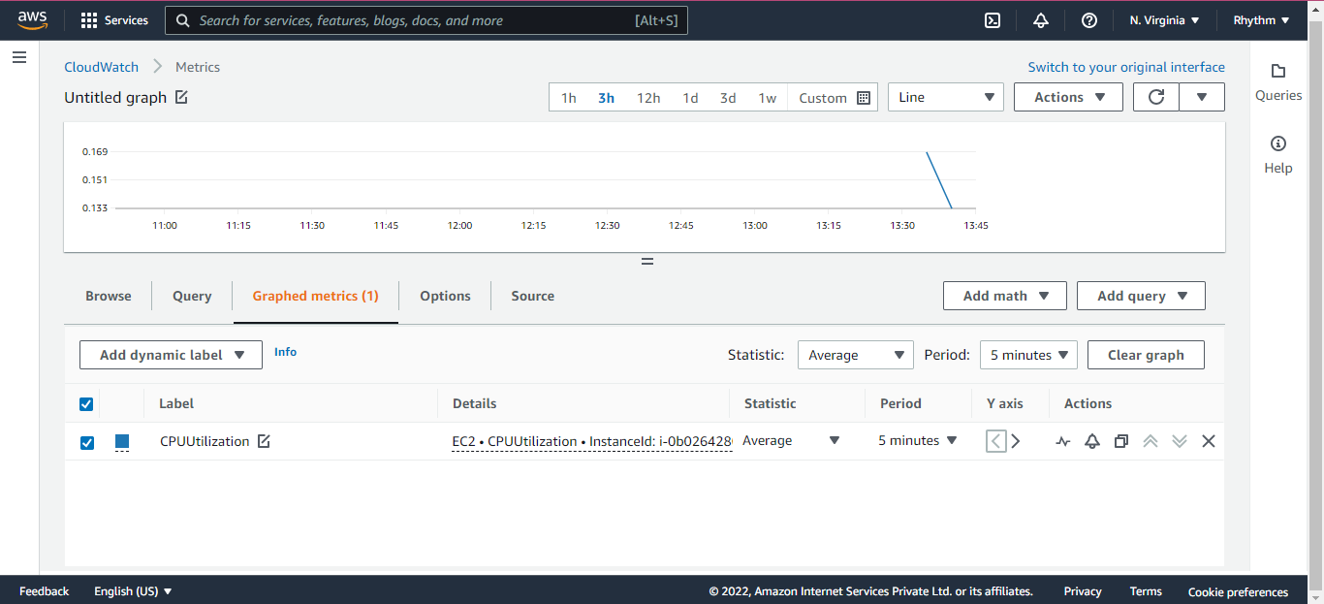

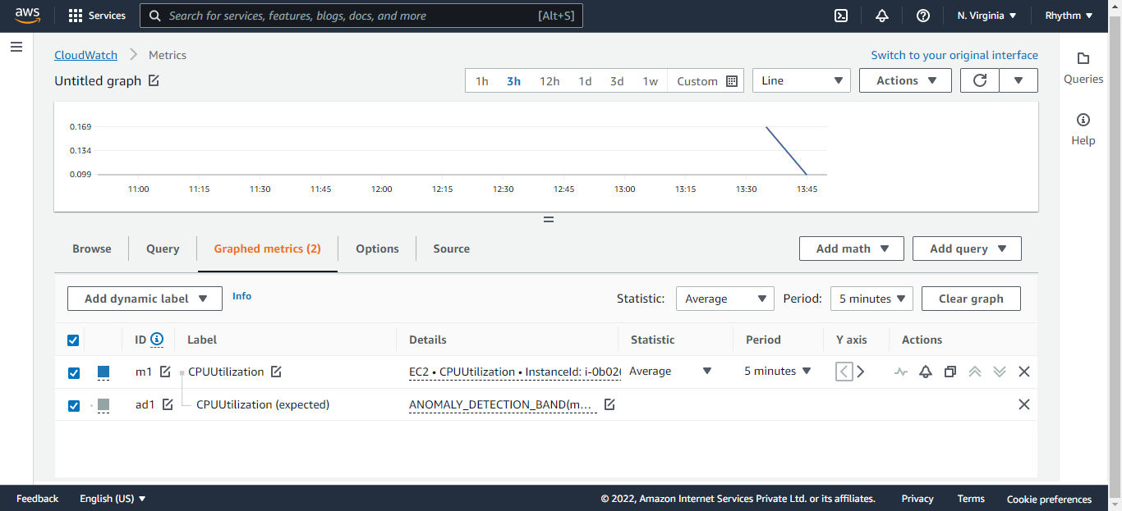

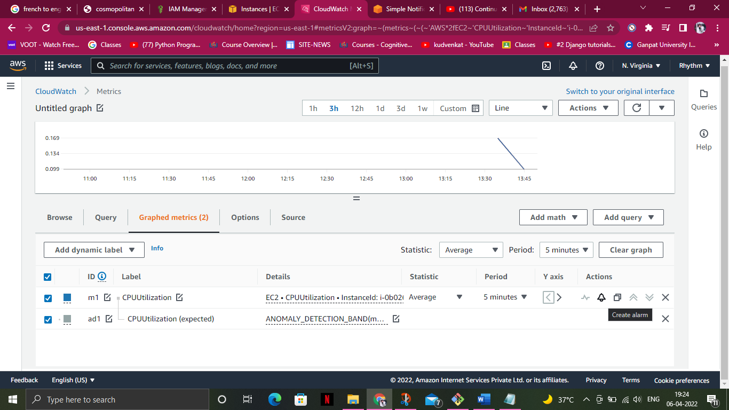

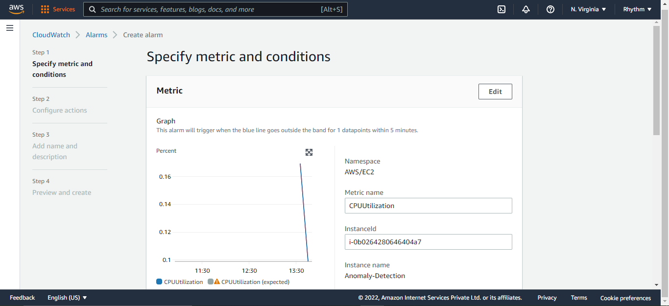

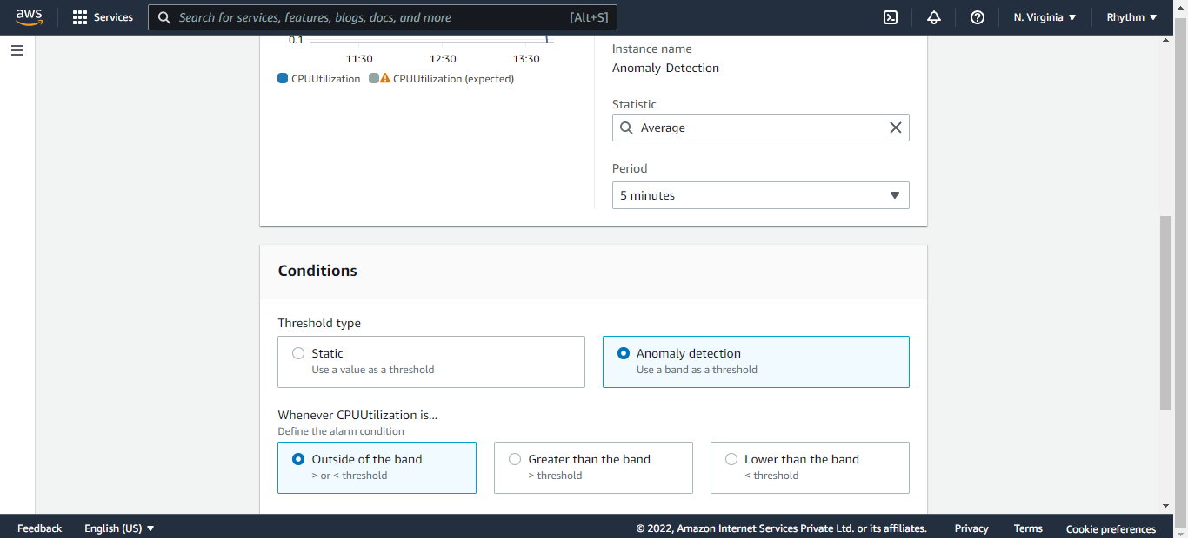

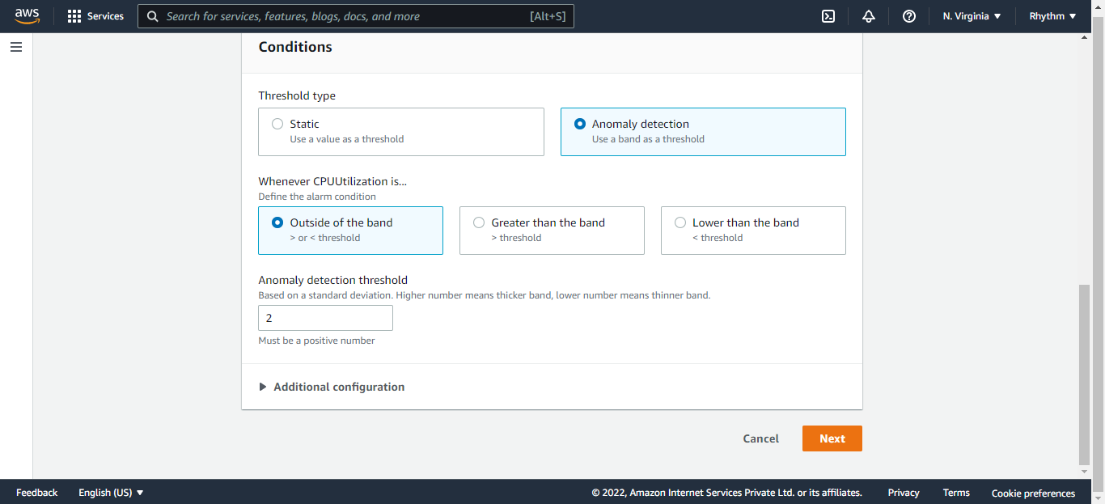

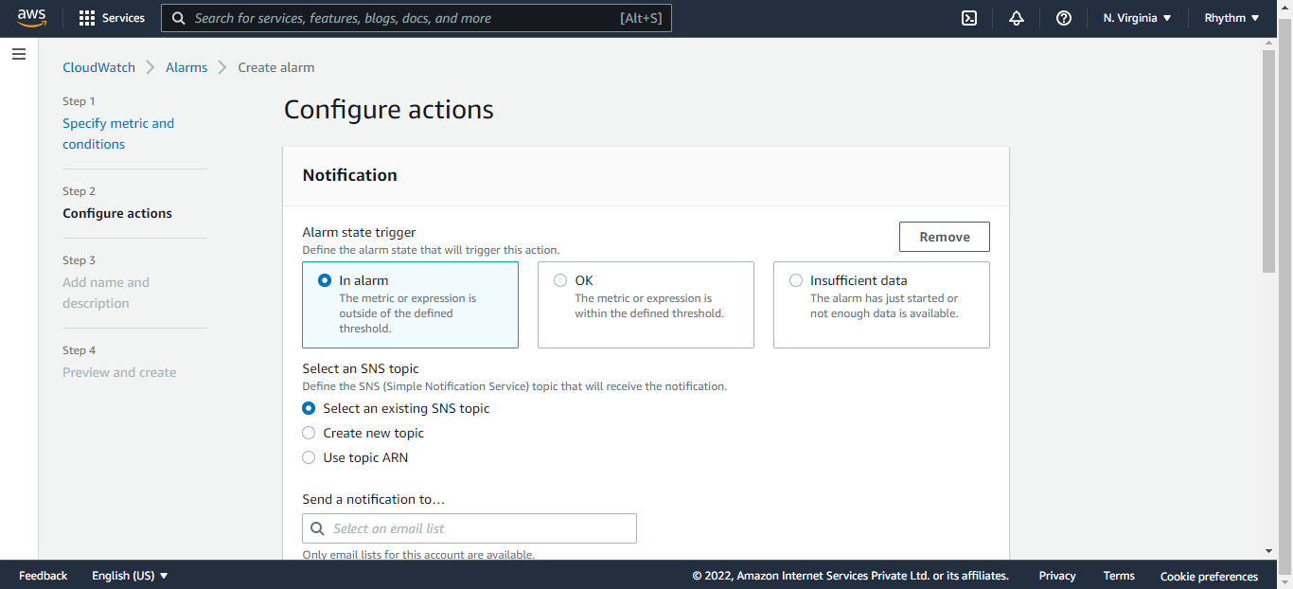

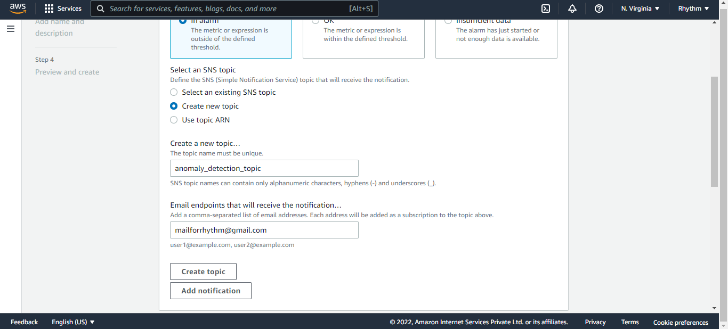

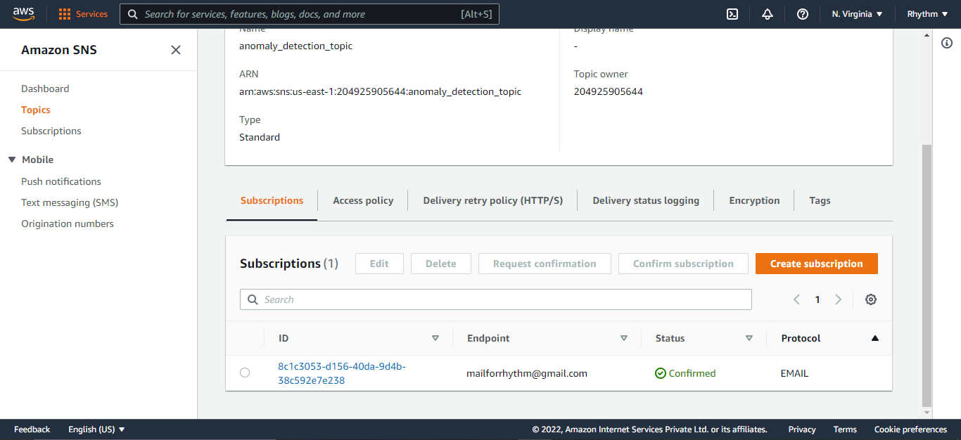

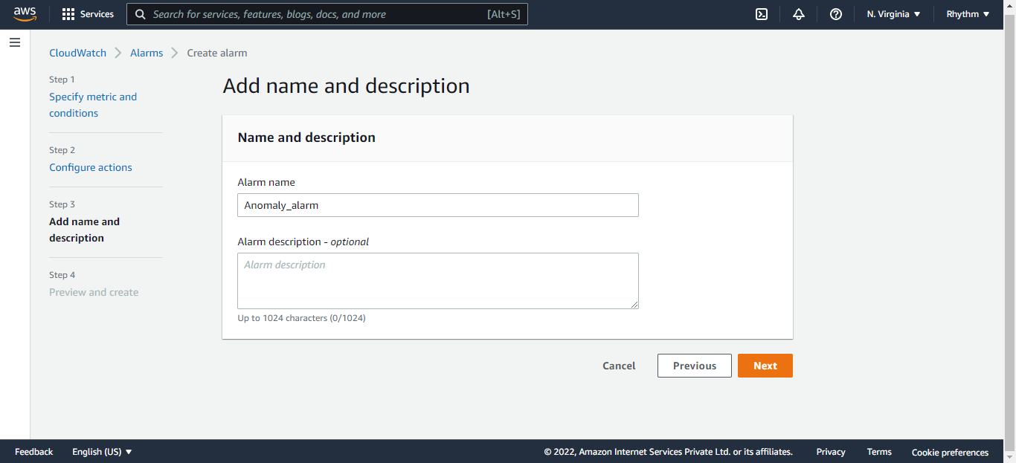

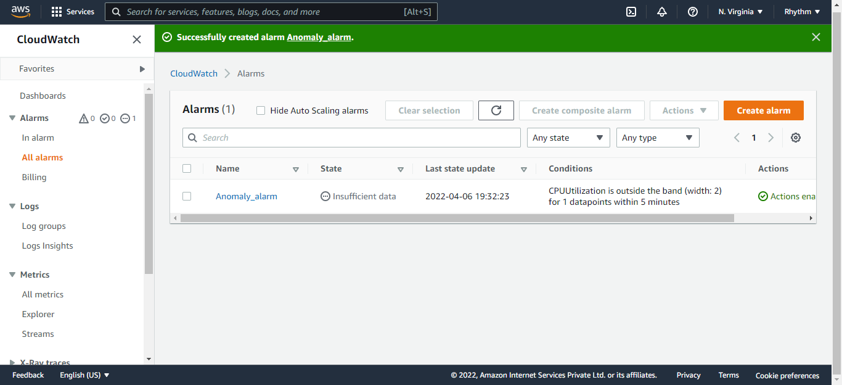

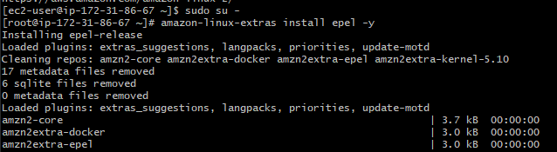

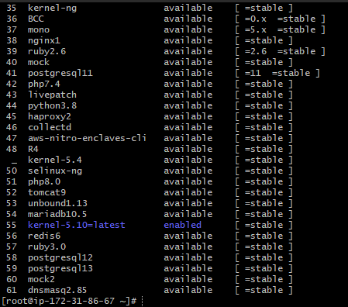

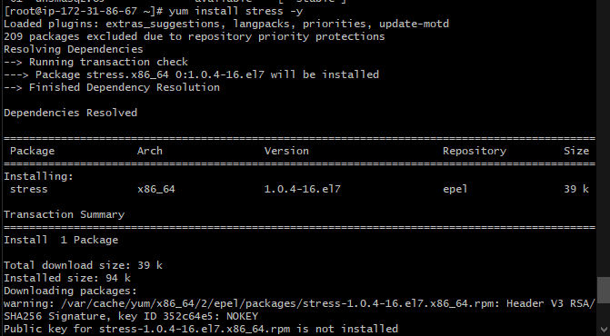

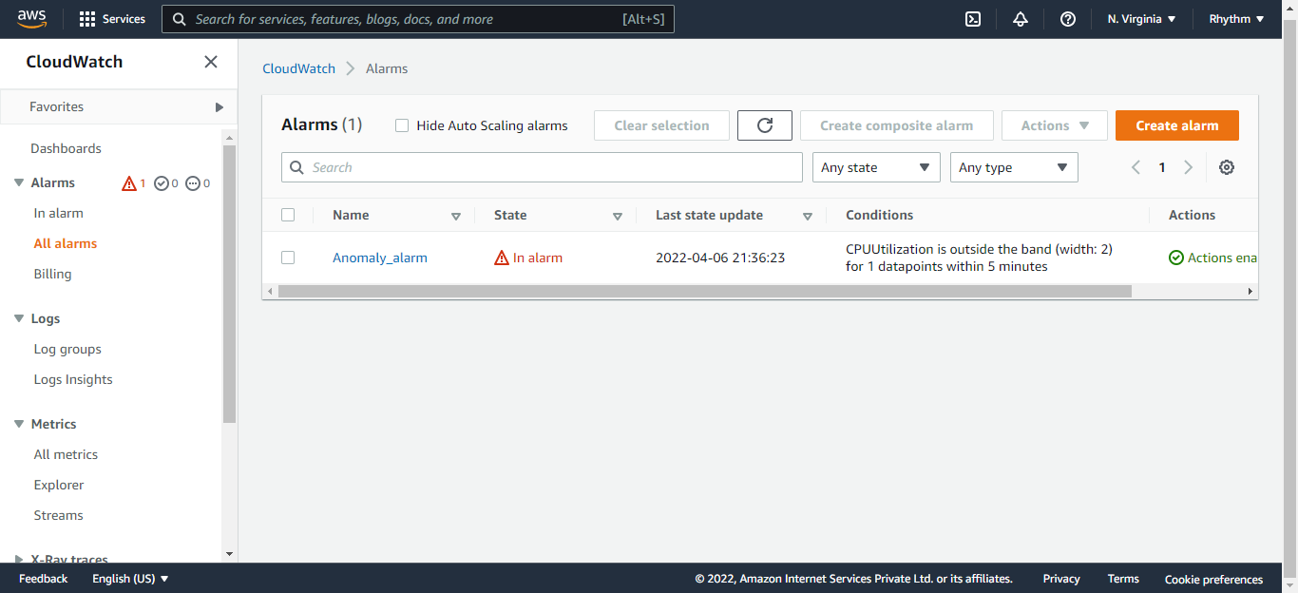

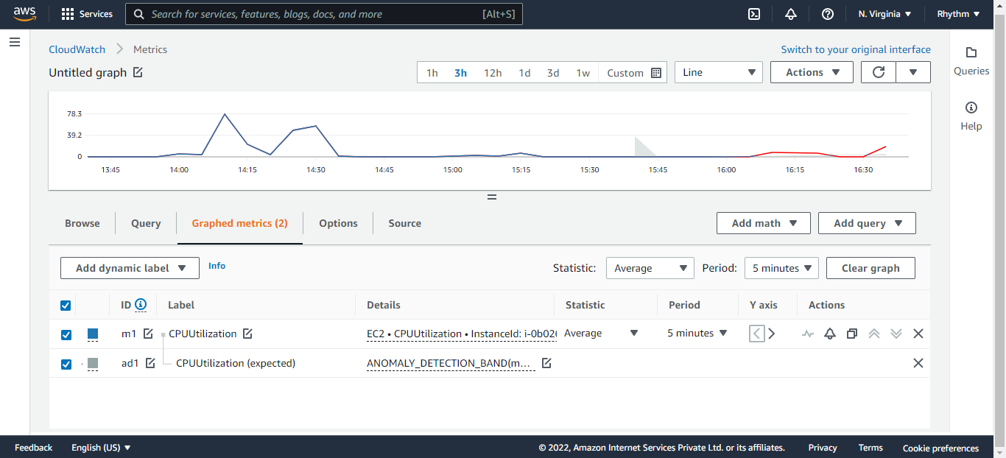

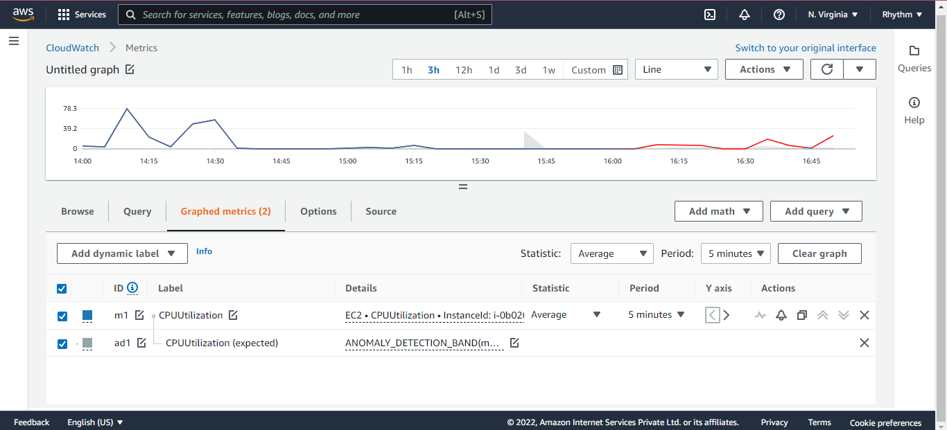

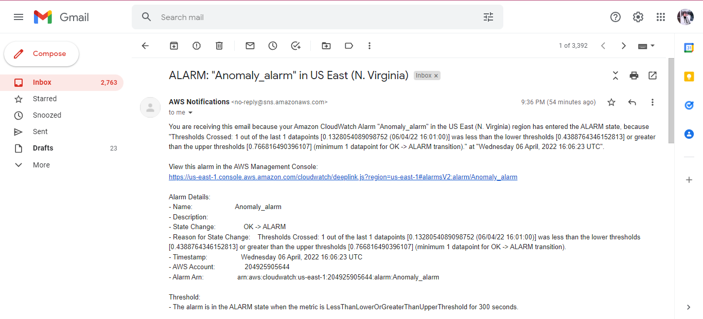

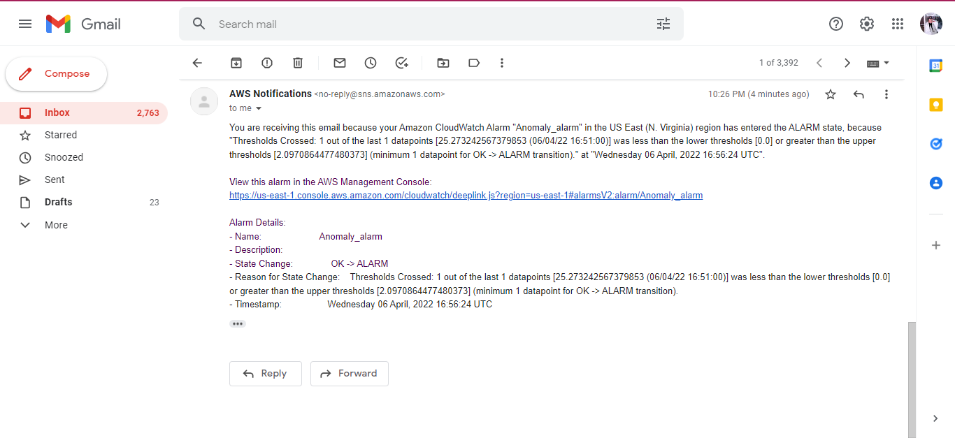

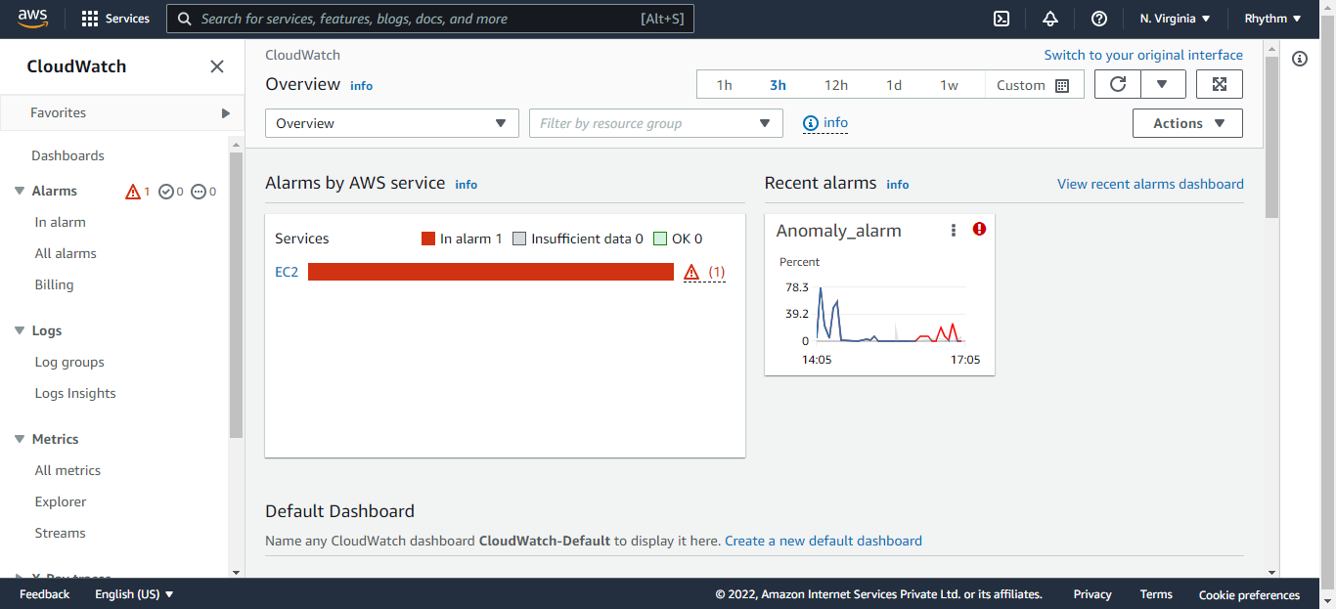

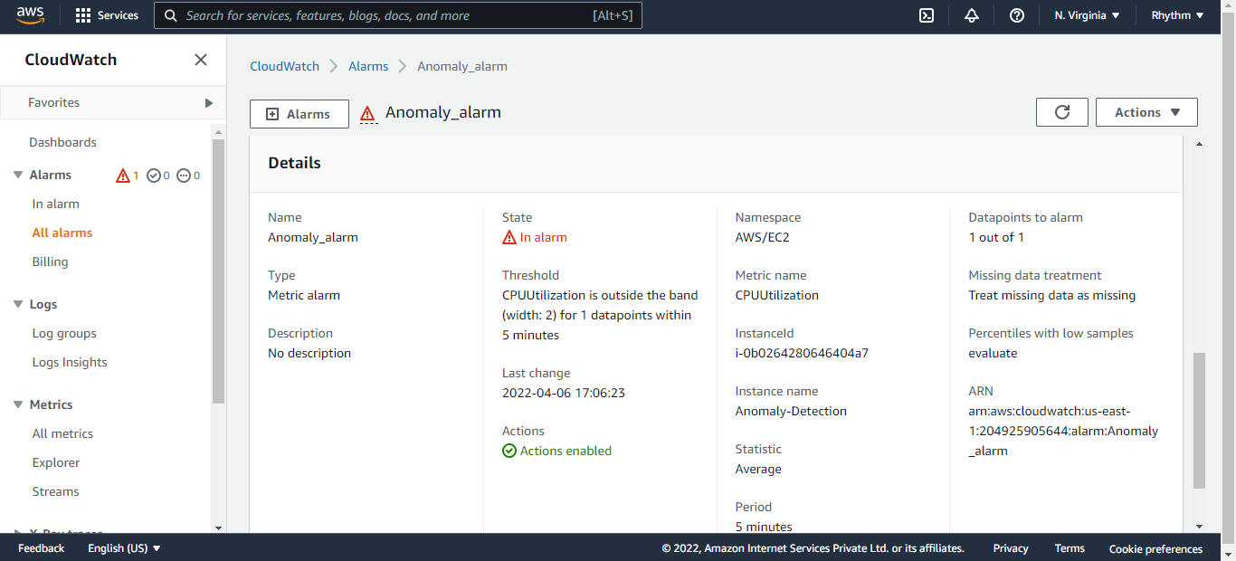

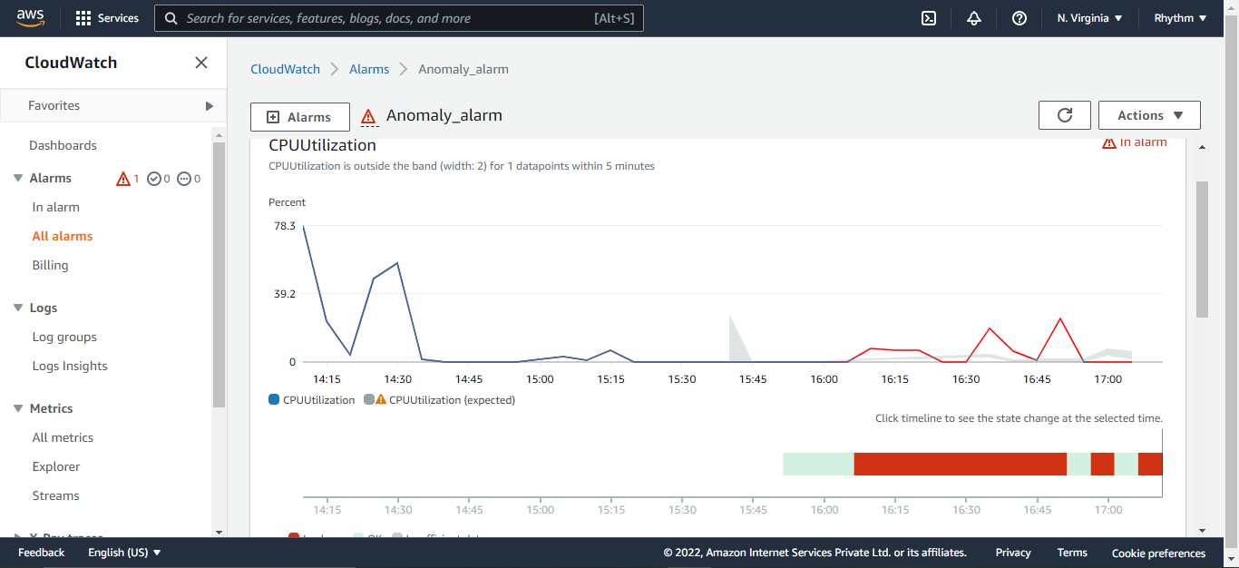

**CHAPTER: 7 CONCLUSION AND FUTURE WORK**

### CHAPTER 7 CONCLUSION AND FUTURE WORK

**Conclusion**

In this project we have generated different types of logs and analysed it using analysing tool. From this we are understanding the logs and try to analysed it.

### Future work

We can try to generate logs of system data of company and analyze it.

# CHAPTER: 8 REFERENCES

### CHAPTER 8 REFERENCES

1. <https://docs.microsoft.com/en-us/virtualization/hyper-v-on-windows/quick-start/enable-hyper-v>
2. <https://www.cs.utah.edu/~lifeifei/papers/deeplog.pdf>
3. [https://www.dnsstuff.com/free-siem-tools#splunk-free](https://www.dnsstuff.com/free-siem-tools)
4. <https://cybersecurity.att.com/products/ossim>
5. <https://www.splunk.com/en_us/download.html> : Splunk Enterprise
6. <https://www.splunk.com/en_us/download/universal-forwarder.html> : Splunk Forwarded
7. <https://www.snort.org/> : snort
8. Security Information and Event Management SIEM Implementation Network (Book)